UNITED STATES
SECURITIES AND EXCHANGE COMMISSION
Washington, D.C. 20549

FORM 10-Q

(Mark one)
☒ QUARTERLY REPORT PURSUANT TO SECTION 13 OR 15(d) OF THE SECURITIES EXCHANGE ACT OF 1934

For the quarterly period ended June 30, 2025

OR

☐ TRANSITION REPORT PURSUANT TO SECTION 13 OR 15(d) OF THE SECURITIES EXCHANGE ACT OF 1934
For the transition period from __________ to __________

Commission File Number: 001-38701

SI-BONE, INC.
(Exact Name of Registrant as Specified in its Charter)

Delaware |  |  |  |  |  | 26-2216351
(State or Other Jurisdiction of  Incorporation or Organization) |  |  |  |  |  | (I.R.S. Employer  Identification Number)
471 El Camino Real, Suite 101, Santa Clara, California |  |  |  |  |  | 95050
(Address of principal executive offices) |  |  |  |  |  | (Zip Code)
Registrant's telephone number, including area code: (408) 207-0700
Securities registered pursuant to Section 12(b) of the Act:
Title of each class |  |  | Trading Symbol(s) |  |  | Name of each exchange on which registered
Common Stock, par value $0.0001 per share |  |  | SIBN |  |  | The Nasdaq Global Market

Indicate by check mark whether the registrant (1) has filed all reports required to be filed by Section 13 or 15(d) of the Securities Exchange Act of 1934 during the preceding 12 months (or for such shorter period that the registrant was required to file such reports), and (2) has been subject to such filing requirements for the past 90 days. Yes x No o
Indicate by check mark whether the registrant has submitted electronically every Interactive Data File required to be submitted pursuant to Rule 405 of Regulation S-T (§232.405 of this chapter) during the preceding 12 months (or for such shorter period that the registrant was required to submit such files). Yes x No o
Indicate by check mark whether the registrant is a large accelerated filer, an accelerated filer, a non-accelerated filer, a smaller reporting company or an emerging growth company. See the definitions of “large accelerated filer,” “accelerated filer,” “smaller reporting company” and “emerging growth company” in Rule 12b-2 of the Exchange Act.

Large accelerated filer |  |  | ☐ |  |  |  |  |  | Accelerated filer |  |  | ☒ |  |  |  |  |  | Non-accelerated filer |  |  | ☐
Smaller reporting company |  |  | ☐ |  |  |  |  |  | Emerging growth company |  |  | ☐
If an emerging growth company, indicate by check mark if the registrant has elected not to use the extended transition period for complying with any new or revised financial accounting standards provided pursuant to Section 7(a)(2)(B) of the Securities Act. ☐
Indicate by check mark whether the registrant is a shell company (as defined in Rule 12b-2 of the Exchange Act). Yes ☐ No x
The number of shares outstanding of the registrant’s Common Stock was 43,140,936 as of July 31, 2025.

TABLE OF CONTENTS
 |  |  |  |  |  |  |  |  | Page
 |  |  |  |  |  | PART I-FINANCIAL INFORMATION
Item 1. |  |  |  |  |  | Financial Statements |  |  | 4
 |  |  |  |  |  | Condensed Consolidated Balance Sheets (Unaudited) |  |  | 4
 |  |  |  |  |  | Condensed Consolidated Statements of Operations and Comprehensive Loss (Unaudited) |  |  | 5
 |  |  |  |  |  | Condensed Consolidated Statements of Changes in Stockholders' Equity (Unaudited) |  |  | 6
 |  |  |  |  |  | Condensed Consolidated Statements of Cash Flows (Unaudited) |  |  | 8
 |  |  |  |  |  | Notes to Condensed Consolidated Financial Statements (Unaudited) |  |  | 9
Item 2. |  |  |  |  |  | Management’s Discussion and Analysis of Financial Condition and Results of Operations |  |  | 21
Item 3. |  |  |  |  |  | Quantitative and Qualitative Disclosures About Market Risk |  |  | 32
Item 4. |  |  |  |  |  | Controls and Procedures |  |  | 33
 |  |  |  |  |  | PART II-OTHER INFORMATION
Item 1. |  |  |  |  |  | Legal Proceedings |  |  | 33
Item 1A. |  |  |  |  |  | Risk Factors |  |  | 34
Item 2. |  |  |  |  |  | Unregistered Sales of Equity Securities and Use of Proceeds |  |  | 36
Item 3. |  |  |  |  |  | Defaults Upon Senior Securities |  |  | 36
Item 4. |  |  |  |  |  | Mine Safety Disclosures |  |  | 37
Item 5. |  |  |  |  |  | Other Information |  |  | 37
Item 6. |  |  |  |  |  | Exhibits |  |  | 38
SIGNATURES |  |  |  |  |  |  |  |  | 39

1

SPECIAL NOTE REGARDING FORWARD-LOOKING STATEMENTS

This Quarterly Report on Form 10-Q contains forward-looking statements. All statements other than statements of historical facts contained in this Quarterly Report, including statements regarding our future results of operations and financial position, business strategy, prospective products and product candidates, sales force expansion, physician adoption, reimbursement determinations, clinical trial results, and U.S. Food and Drug Administration ("FDA") approvals, are forward-looking statements.

These statements involve known and unknown risks, uncertainties and other important factors that may cause our actual results, performance or achievements to be materially different from any future results, performance or achievements expressed or implied by the forward-looking statements.

In some cases, you can identify forward-looking statements by terms such as “may,” “will,” “should,” “expect,” “plan,” “anticipate,” “could,” “intend,” “target,” “project,” “contemplate,” “believe,” “estimate,” “predict,” “potential” or “continue” or the negative of these terms or other similar expressions, although not all forward-looking statements contain these identifying words. These forward-looking statements speak only as of the date of this Quarterly Report and are subject to a number of risks, uncertainties and assumptions, including those described under the sections in this Quarterly Report titled “Risk Factors” and “Management’s Discussion and Analysis of Financial Condition and Results of Operations.” These forward-looking statements include, but are not limited to, statements about the following:
•our expectation that a significant portion of our revenue will be derived from sales of similar products addressing the sacropelvic anatomy;
•our ability to develop and commercialize additional revenue opportunities, including new indications for use and new products;
•our ability to retain and grow our sales team, including our third-party sales agents, based on the demand for our products;
•our ability to identify, train, and retain physicians to perform procedures using our products;
•our ability to obtain and maintain favorable coverage and reimbursement determinations from third-party payors;
•our estimates of our market opportunity;
•our expectations regarding the scope of protection from intellectual property rights covering our products;
•developments or disputes concerning our intellectual property or other proprietary rights;
•timing of and results from our clinical trials and other studies;
•marketing clearances and authorization from the FDA and regulators in other jurisdictions and CE Certificates of Conformity from Notified Bodies;
•timing of regulatory filings and feedback;
•competition in the markets we serve;
•our expectations of the reliability and performance of our products;
•our expectations of the benefits of our products to patients, providers, and payors;
•the impact of proposed tariffs on our business, including the impact on gross margins related to our international product sales and the impact of resulting economic uncertainty on demand for our products;
•factors impacting the supply chains we rely on, including tariffs and the availability of raw materials and skilled labor serving our suppliers, and the cost of these factors of production which may in turn impact the prices we pay for our devices;
•our reliance on a limited number of suppliers, including sole source suppliers, which may impact the availability of instruments and materials;
•our ability to sustain or increase demand for our products;
•our estimates regarding our costs and risks associated with our international operations and expansion;
•our expectations regarding our ability to retain and recruit key personnel;
2

•our ability to attract and retain employees, including those with specialized skills and experience;
•our expectations regarding acquisitions and strategic operations;
•our ability to access capital markets;
•our ability to fund our working capital requirements;
•our compliance with, and the cost of, federal, state, and foreign regulatory requirements;
•the factors that may impact our financial results; and
•anticipated trends and challenges in our business and the markets in which we operate.

Forward-looking statements are based on management’s current expectations, estimates, forecasts, and projections about our business and the industry in which we operate, and management’s beliefs and assumptions are not guarantees of future performance or development and involve known and unknown risks, uncertainties, and other factors that are in some cases beyond our control. As a result, any or all of our forward-looking statements in this report may turn out to be inaccurate. Furthermore, if the forward-looking statements prove to be inaccurate, the inaccuracy may be material. In light of the significant uncertainties in these forward-looking statements, you should not regard these statements as a representation or warranty by us or any other person that we will achieve our objectives and plans in any specified time frame, or at all. In addition, statements that “we believe” and similar statements reflect our beliefs and opinions on the relevant subject. These statements are based upon information available to us as of the date of this Quarterly Report on Form 10-Q, and while we believe such information forms a reasonable basis for such statements, such information may be limited or incomplete, and our statements should not be read to indicate that we have conducted an exhaustive inquiry into, or review of, all potentially available relevant information. These statements are inherently uncertain and investors are cautioned not to unduly rely upon these statements.

Factors that may cause actual results to differ materially from current expectations include, among other things, those listed under “Risk Factors” in our Annual Report on Form 10-K for the year ended December 31, 2024, together with any updates in the section titled “Risk Factors” in this Quarterly Report on Form 10-Q. These statements, like all statements in this report, speak only as of their date. We caution investors that our business and financial performance are subject to substantial risks and uncertainties. Except as required by law, we assume no obligation to update or revise these forward-looking statements for any reason, even if new information becomes available in the future, except as may be required by law.

3

PART I-FINANCIAL INFORMATION

Item 1. Financial Statements

SI-BONE, INC.
CONDENSED CONSOLIDATED BALANCE SHEETS
(In thousands, except share and per share amounts)
(Unaudited)

 |  |  | June 30, 2025 |  |  |  |  |  | December 31, 2024
ASSETS
Current assets:
Cash and cash equivalents |  |  | $ | 34,150 |  |  |  |  | $ | 34,948
Short-term investments |  |  | 111,394 |  |  |  |  |  | 115,094
Accounts receivable, net of allowance for credit losses of $911 and $588, respectively |  |  | 24,371 |  |  |  |  |  | 27,459
Inventory |  |  | 34,245 |  |  |  |  |  | 27,074
Prepaid expenses and other current assets |  |  | 3,289 |  |  |  |  |  | 3,204
Total current assets |  |  | 207,449 |  |  |  |  |  | 207,779
Property and equipment, net |  |  | 21,701 |  |  |  |  |  | 20,374
Operating lease right-of-use assets |  |  | 1,465 |  |  |  |  |  | 1,984
Other non-current assets |  |  | 306 |  |  |  |  |  | 300
TOTAL ASSETS |  |  | $ | 230,921 |  |  |  |  | $ | 230,437
LIABILITIES AND STOCKHOLDERS’ EQUITY
Current liabilities:
Accounts payable |  |  | $ | 7,495 |  |  |  |  | $ | 6,488
Accrued liabilities and other |  |  | 16,149 |  |  |  |  |  | 19,492
Operating lease liabilities, current portion |  |  | 1,106 |  |  |  |  |  | 1,152
Total current liabilities |  |  | 24,750 |  |  |  |  |  | 27,132
Long-term borrowings |  |  | 35,510 |  |  |  |  |  | 35,452
Operating lease liabilities, net of current portion |  |  | 318 |  |  |  |  |  | 879
Other long-term liabilities |  |  | — |  |  |  |  |  | 10
TOTAL LIABILITIES |  |  | 60,578 |  |  |  |  |  | 63,473
Commitments and contingencies (Note 6)
STOCKHOLDERS’ EQUITY
Preferred stock, $0.0001 par value; 5,000,000 shares authorized; no shares issued and outstanding |  |  | — |  |  |  |  |  | —
Common stock, $0.0001 par value; 100,000,000 shares authorized; 43,014,093 and 42,086,477 shares issued and outstanding, respectively |  |  | 4 |  |  |  |  |  | 4
Additional paid-in capital |  |  | 613,727 |  |  |  |  |  | 598,070
Accumulated other comprehensive income |  |  | 660 |  |  |  |  |  | 244
Accumulated deficit |  |  | (444,048) |  |  |  |  |  | (431,354)
TOTAL STOCKHOLDERS’ EQUITY |  |  | 170,343 |  |  |  |  |  | 166,964
TOTAL LIABILITIES AND STOCKHOLDERS’ EQUITY |  |  | $ | 230,921 |  |  |  |  | $ | 230,437

The accompanying notes are an integral part of these unaudited condensed consolidated financial statements.

4

SI-BONE, INC.
CONDENSED CONSOLIDATED STATEMENTS OF OPERATIONS AND COMPREHENSIVE LOSS
(In thousands, except share and per share amounts)
(Unaudited)

 |  |  | Three Months Ended  June 30, |  |  |  |  |  |  |  |  |  |  |  |  |  | Six Months Ended June 30,
 |  |  | 2025 |  |  |  |  |  | 2024 |  |  |  |  |  |  |  |  |  | 2025 |  |  |  |  |  | 2024
Revenue |  |  | $ | 48,630 |  |  |  |  | $ | 39,969 |  |  |  |  |  |  |  |  | $ | 95,920 |  |  |  |  | $ | 77,836
Cost of goods sold |  |  | 9,823 |  |  |  |  |  | 8,393 |  |  |  |  |  |  |  |  |  | 19,418 |  |  |  |  |  | 16,395
Gross profit |  |  | 38,807 |  |  |  |  |  | 31,576 |  |  |  |  |  |  |  |  |  | 76,502 |  |  |  |  |  | 61,441
Operating expenses:
Sales and marketing |  |  | 30,781 |  |  |  |  |  | 28,970 |  |  |  |  |  |  |  |  |  | 61,462 |  |  |  |  |  | 58,357
Research and development |  |  | 4,309 |  |  |  |  |  | 4,352 |  |  |  |  |  |  |  |  |  | 8,843 |  |  |  |  |  | 8,697
General and administrative |  |  | 10,721 |  |  |  |  |  | 8,332 |  |  |  |  |  |  |  |  |  | 20,681 |  |  |  |  |  | 16,508
Total operating expenses |  |  | 45,811 |  |  |  |  |  | 41,654 |  |  |  |  |  |  |  |  |  | 90,986 |  |  |  |  |  | 83,562
Loss from operations |  |  | (7,004) |  |  |  |  |  | (10,078) |  |  |  |  |  |  |  |  |  | (14,484) |  |  |  |  |  | (22,121)
Interest and other income (expense), net:
Interest income |  |  | 1,520 |  |  |  |  |  | 2,015 |  |  |  |  |  |  |  |  |  | 3,112 |  |  |  |  |  | 4,128
Interest expense |  |  | (666) |  |  |  |  |  | (880) |  |  |  |  |  |  |  |  |  | (1,328) |  |  |  |  |  | (1,761)
Other income (expense) |  |  | (2) |  |  |  |  |  | 4 |  |  |  |  |  |  |  |  |  | 6 |  |  |  |  |  | (89)
Net loss |  |  | $ | (6,152) |  |  |  |  | $ | (8,939) |  |  |  |  |  |  |  |  | $ | (12,694) |  |  |  |  | $ | (19,843)
Other comprehensive income (loss):
Changes in foreign currency translation |  |  | 369 |  |  |  |  |  | (31) |  |  |  |  |  |  |  |  |  | 526 |  |  |  |  |  | (2)
Unrealized loss on marketable securities |  |  | (29) |  |  |  |  |  | (8) |  |  |  |  |  |  |  |  |  | (110) |  |  |  |  |  | (106)
Comprehensive loss |  |  | $ | (5,812) |  |  |  |  | $ | (8,978) |  |  |  |  |  |  |  |  | $ | (12,278) |  |  |  |  | $ | (19,951)
Net loss per share, basic and diluted |  |  | $ | (0.14) |  |  |  |  | $ | (0.22) |  |  |  |  |  |  |  |  | $ | (0.30) |  |  |  |  | $ | (0.48)
Weighted-average number of common shares used to compute basic and diluted net loss per share |  |  | 42,788,123 |  |  |  |  |  | 41,317,627 |  |  |  |  |  |  |  |  |  | 42,564,158 |  |  |  |  |  | 41,126,009

The accompanying notes are an integral part of these unaudited condensed consolidated financial statements.

5

SI-BONE, INC.
CONDENSED CONSOLIDATED STATEMENTS OF CHANGES IN STOCKHOLDERS' EQUITY
(In thousands, except share amounts)
(Unaudited)
 |  |  |  |  |  | Common Stock |  |  |  |  |  |  |  |  |  |  |  | Additional  Paid-in  Capital |  |  |  |  |  | Accumulated  Other  Comprehensive  Income |  |  |  |  |  | Accumulated  Deficit |  |  |  |  |  | Total  Stockholders’ Equity
 |  |  |  |  |  | Shares |  |  |  |  |  | Amount
Balance as of December 31, 2024 |  |  |  |  |  | 42,086,477 |  |  |  |  |  | $ | 4 |  |  |  |  | $ | 598,070 |  |  |  |  | $ | 244 |  |  |  |  | $ | (431,354) |  |  |  |  | $ | 166,964
Issuance of common stock upon exercise of stock options, net of shares withheld |  |  |  |  |  | 20,045 |  |  |  |  |  | — |  |  |  |  |  | 103 |  |  |  |  |  | — |  |  |  |  |  | — |  |  |  |  |  | 103
Issuance of common stock upon vesting of restricted stock units |  |  |  |  |  | 373,078 |  |  |  |  |  | — |  |  |  |  |  | — |  |  |  |  |  | — |  |  |  |  |  | — |  |  |  |  |  | —
Stock-based compensation |  |  |  |  |  | — |  |  |  |  |  | — |  |  |  |  |  | 6,663 |  |  |  |  |  | — |  |  |  |  |  | — |  |  |  |  |  | 6,663
Foreign currency translation |  |  |  |  |  | — |  |  |  |  |  | — |  |  |  |  |  | — |  |  |  |  |  | 157 |  |  |  |  |  | — |  |  |  |  |  | 157
Net unrealized loss on marketable securities |  |  |  |  |  | — |  |  |  |  |  | — |  |  |  |  |  | — |  |  |  |  |  | (81) |  |  |  |  |  | — |  |  |  |  |  | (81)
Net loss |  |  |  |  |  | — |  |  |  |  |  | — |  |  |  |  |  | — |  |  |  |  |  | — |  |  |  |  |  | (6,542) |  |  |  |  |  | (6,542)
Balance as of March 31, 2025 |  |  |  |  |  | 42,479,600 |  |  |  |  |  | 4 |  |  |  |  |  | 604,836 |  |  |  |  |  | 320 |  |  |  |  |  | (437,896) |  |  |  |  |  | 167,264
Issuance of common stock upon exercise of stock options, net of shares withheld |  |  |  |  |  | 93,209 |  |  |  |  |  | — |  |  |  |  |  | 665 |  |  |  |  |  | — |  |  |  |  |  | — |  |  |  |  |  | 665
Issuance of common stock related to employee stock purchase plan |  |  |  |  |  | 149,199 |  |  |  |  |  | — |  |  |  |  |  | 1,568 |  |  |  |  |  | — |  |  |  |  |  | — |  |  |  |  |  | 1,568
Issuance of common stock upon vesting of restricted stock units |  |  |  |  |  | 292,085 |  |  |  |  |  | — |  |  |  |  |  | — |  |  |  |  |  | — |  |  |  |  |  | — |  |  |  |  |  | —
Stock-based compensation |  |  |  |  |  | — |  |  |  |  |  | — |  |  |  |  |  | 6,658 |  |  |  |  |  | — |  |  |  |  |  | — |  |  |  |  |  | 6,658
Foreign currency translation |  |  |  |  |  | — |  |  |  |  |  | — |  |  |  |  |  | — |  |  |  |  |  | 369 |  |  |  |  |  | — |  |  |  |  |  | 369
Net unrealized loss on marketable securities |  |  |  |  |  | — |  |  |  |  |  | — |  |  |  |  |  | — |  |  |  |  |  | (29) |  |  |  |  |  | — |  |  |  |  |  | (29)
Net loss |  |  |  |  |  | — |  |  |  |  |  | — |  |  |  |  |  | — |  |  |  |  |  | — |  |  |  |  |  | (6,152) |  |  |  |  |  | (6,152)
Balance as of June 30, 2025 |  |  |  |  |  | 43,014,093 |  |  |  |  |  | $ | 4 |  |  |  |  | $ | 613,727 |  |  |  |  | 660 |  |  |  |  |  | $ | (444,048) |  |  |  |  | $ | 170,343

6

 |  |  |  |  |  | Common Stock |  |  |  |  |  |  |  |  |  |  |  | Additional  Paid-in  Capital |  |  |  |  |  | Accumulated  Other  Comprehensive  Income |  |  |  |  |  | Accumulated  Deficit |  |  |  |  |  | Total  Stockholders’ Equity
 |  |  |  |  |  | Shares |  |  |  |  |  | Amount
Balance as of December 31, 2023 |  |  |  |  |  | 40,693,299 |  |  |  |  |  | $ | 4 |  |  |  |  | $ | 569,477 |  |  |  |  | $ | 335 |  |  |  |  | $ | (400,441) |  |  |  |  | $ | 169,375
Issuance of common stock upon exercise of stock options, net of shares withheld |  |  |  |  |  | 29,892 |  |  |  |  |  | — |  |  |  |  |  | 105 |  |  |  |  |  | — |  |  |  |  |  | — |  |  |  |  |  | 105
Issuance of common stock upon vesting of restricted stock units |  |  |  |  |  | 355,571 |  |  |  |  |  | — |  |  |  |  |  | — |  |  |  |  |  | — |  |  |  |  |  | — |  |  |  |  |  | —
Stock-based compensation |  |  |  |  |  | — |  |  |  |  |  | — |  |  |  |  |  | 7,030 |  |  |  |  |  | — |  |  |  |  |  | — |  |  |  |  |  | 7,030
Foreign currency translation |  |  |  |  |  | — |  |  |  |  |  | — |  |  |  |  |  | — |  |  |  |  |  | 29 |  |  |  |  |  | — |  |  |  |  |  | 29
Net unrealized loss on marketable securities |  |  |  |  |  | — |  |  |  |  |  | — |  |  |  |  |  | — |  |  |  |  |  | (98) |  |  |  |  |  | — |  |  |  |  |  | (98)
Net loss |  |  |  |  |  | — |  |  |  |  |  | — |  |  |  |  |  | — |  |  |  |  |  | — |  |  |  |  |  | (10,904) |  |  |  |  |  | (10,904)
Balance as of March 31, 2024 |  |  |  |  |  | 41,078,762 |  |  |  |  |  | 4 |  |  |  |  |  | 576,612 |  |  |  |  |  | 266 |  |  |  |  |  | (411,345) |  |  |  |  |  | 165,537
Issuance of common stock upon exercise of stock options, net of shares withheld |  |  |  |  |  | 69,428 |  |  |  |  |  | — |  |  |  |  |  | 304 |  |  |  |  |  | — |  |  |  |  |  | — |  |  |  |  |  | 304
Issuance of common stock related to employee stock purchase plan |  |  |  |  |  | 114,636 |  |  |  |  |  | — |  |  |  |  |  | 1,472 |  |  |  |  |  |  |  |  |  |  |  |  |  |  |  |  |  | 1,472
Issuance of common stock upon vesting of restricted stock units |  |  |  |  |  | 247,985 |  |  |  |  |  | — |  |  |  |  |  | — |  |  |  |  |  | — |  |  |  |  |  | — |  |  |  |  |  | —
Stock-based compensation |  |  |  |  |  | — |  |  |  |  |  | — |  |  |  |  |  | 6,398 |  |  |  |  |  | — |  |  |  |  |  | — |  |  |  |  |  | 6,398
Foreign currency translation |  |  |  |  |  | — |  |  |  |  |  | — |  |  |  |  |  | — |  |  |  |  |  | (31) |  |  |  |  |  | — |  |  |  |  |  | (31)
Net unrealized loss on marketable securities |  |  |  |  |  | — |  |  |  |  |  | — |  |  |  |  |  | — |  |  |  |  |  | (8) |  |  |  |  |  | — |  |  |  |  |  | (8)
Net loss |  |  |  |  |  | — |  |  |  |  |  | — |  |  |  |  |  | — |  |  |  |  |  | — |  |  |  |  |  | (8,939) |  |  |  |  |  | (8,939)
Balance as of June 30, 2024 |  |  |  |  |  | 41,510,811 |  |  |  |  |  | $ | 4 |  |  |  |  | $ | 584,786 |  |  |  |  | $ | 227 |  |  |  |  | $ | (420,284) |  |  |  |  | $ | 164,733

The accompanying notes are an integral part of these unaudited condensed consolidated financial statements.

7

SI-BONE, INC.
CONDENSED CONSOLIDATED STATEMENTS OF CASH FLOWS
(In thousands)
(Unaudited)
Six Months Ended
June 30,
 |  |  | 2025 |  |  |  |  |  | 2024
Cash flows from operating activities
Net loss |  |  | $ | (12,694) |  |  |  |  | $ | (19,843)
Adjustments to reconcile net loss to net cash used in operating activities:
Stock-based compensation |  |  | 13,321 |  |  |  |  |  | 13,428
Depreciation and amortization |  |  | 2,646 |  |  |  |  |  | 2,081
Accounts receivable credit losses |  |  | 475 |  |  |  |  |  | 240
Amortization of discount and premium on marketable securities |  |  | (1,740) |  |  |  |  |  | (3,019)
Inventory reserve |  |  | 1,235 |  |  |  |  |  | 366
Amortization of debt issuance costs |  |  | 59 |  |  |  |  |  | 85
Loss on disposal of property and equipment |  |  | 628 |  |  |  |  |  | 819
Changes in operating assets and liabilities:
Accounts receivable |  |  | 2,598 |  |  |  |  |  | (3,022)
Inventory |  |  | (8,292) |  |  |  |  |  | (3,314)
Prepaid expenses and other assets |  |  | (93) |  |  |  |  |  | 399
Accounts payable |  |  | 583 |  |  |  |  |  | 1,828
Accrued liabilities and other |  |  | (3,464) |  |  |  |  |  | (3,953)
Net cash used in operating activities |  |  | (4,738) |  |  |  |  |  | (13,905)
Cash flows from investing activities
Maturities of marketable securities |  |  | 104,100 |  |  |  |  |  | 119,000
Purchases of marketable securities |  |  | (98,770) |  |  |  |  |  | (109,288)
Purchases of property and equipment |  |  | (4,171) |  |  |  |  |  | (5,195)
Net cash provided by investing activities |  |  | 1,159 |  |  |  |  |  | 4,517
Cash flows from financing activities
Proceeds from issuance of common stock under employee stock purchase plan |  |  | 1,568 |  |  |  |  |  | 1,472
Proceeds from the exercise of stock options |  |  | 768 |  |  |  |  |  | 409
Net cash provided by financing activities |  |  | 2,336 |  |  |  |  |  | 1,881
Effect of exchange rate changes on cash and cash equivalents |  |  | 445 |  |  |  |  |  | (187)
Net decrease in cash and cash equivalents |  |  | (798) |  |  |  |  |  | (7,694)
Cash and cash equivalents at
Beginning of period |  |  | 34,948 |  |  |  |  |  | 33,271
End of period |  |  | $ | 34,150 |  |  |  |  | $ | 25,577
Supplemental disclosure of non-cash information
Unpaid purchases of property and equipment |  |  | $ | 1,017 |  |  |  |  | $ | 1,293

The accompanying notes are an integral part of these unaudited condensed consolidated financial statements.

8

SI-BONE, INC.
NOTES TO CONDENSED CONSOLIDATED FINANCIAL STATEMENTS (Unaudited)

1. The Company and Nature of Business
SI-BONE, Inc. (the “Company”) was incorporated in the state of Delaware on March 18, 2008 and is headquartered in Santa Clara, California. The Company is a medical device company that has pioneered a proprietary minimally invasive surgical implant system to fuse the sacroiliac joint for treatment of musculoskeletal disorders of the sacropelvic anatomy. The Company’s products include a series of patented titanium implants and the instruments used to implant them, as well as implantable bone products. Since launching its first generation iFuse in 2009, the Company has launched multiple implant product lines, including iFuse-3D in 2017, iFuse TORQ in 2021, iFuse Bedrock Granite in 2022, and iFuse INTRA and iFuse TORQ TNT in 2024. In the United States, iFuse, iFuse-3D, iFuse TORQ and iFuse Bedrock Granite have clearances for applications in sacroiliac joint dysfunction, adult spinal deformity and pelvic trauma. iFuse TORQ TNT has clearances for applications in pelvic trauma and sacroiliac joint dysfunction. In Europe, iFuse, iFuse-3D and iFuse TORQ are approved for applications in sacroiliac fusion, adult spinal deformity and pelvic fracture fixation.

9

SI-BONE, INC.
NOTES TO CONDENSED CONSOLIDATED FINANCIAL STATEMENTS (Unaudited)
2. Summary of Significant Accounting Policies
Basis of Presentation and Principles of Consolidation
The accompanying unaudited condensed consolidated financial statements have been prepared in accordance with generally accepted accounting principles in the United States of America (“U.S. GAAP”) and applicable rules and regulations of the Securities and Exchange Commission (“SEC”) regarding interim financial reporting. As permitted under those rules, certain footnotes or other financial information that are normally required by U.S. GAAP have been condensed or omitted, and accordingly the balance sheet as of December 31, 2024 has been derived from the audited consolidated financial statements at that date but does not include all of the information required by U.S. GAAP for complete financial statements. These unaudited interim condensed consolidated financial statements have been prepared on the same basis as the Company’s annual financial statements and, in the opinion of management, reflect all adjustments that are necessary for a fair statement of the Company’s consolidated financial information. The results of operations for the three and six months ended June 30, 2025 are not necessarily indicative of the results to be expected for the year ending December 31, 2025 or for any other interim period or for any other future year.
The accompanying condensed consolidated financial statements should be read in conjunction with the audited financial statements and related notes thereto for the year ended December 31, 2024 contained in the Company’s Annual Report on Form 10-K filed with the SEC on February 25, 2025 (the “2024 Annual Report”).
Use of Estimates
The preparation of financial statements in conformity with U.S. GAAP requires management to make estimates and assumptions that affect the reported amounts of assets and liabilities and disclosure of contingent assets and liabilities as of the date of the financial statements and the reported amounts of revenue and expenses during the reporting period. Significant accounting estimates and management judgments reflected in the condensed consolidated financial statements primarily includes the fair value of performance-based restricted stock unit awards. Estimates are based on historical experience, where applicable and other assumptions believed to be reasonable by the management. Actual results could differ from those estimates.
Significant Accounting Policies
The Company’s significant accounting policies are disclosed in the 2024 Annual Report. There have been no material changes to these accounting policies.
Segments
The Company's chief operating decision makers (“CODMs”) are the Chief Executive Officer and Chief Financial Officer. The Company has determined that it has a single operating and reportable segment. The CODMs use revenue and net loss at the consolidated level to measure segment profit and loss, allocate resources, monitor plan versus actual results, and manage operations. Significant expenses within net loss include cost of goods sold, sales and marketing, research and development, and general and administrative at the consolidated level. Other segment items within net loss include interest income, interest expense, and other income (expense), net.
Substantially all of the segment revenue is derived from sales to customers in the U.S. Description of segment products are included in Note 1. The Company and Nature of Business. Revenue by geography is based on billing address of the customer. International revenue accounted for less than 10% of the total revenue during the periods presented. Long-lived assets held outside the U.S. are immaterial. The following table summarizes the Company's revenue by geography:
 |  |  | Three Months Ended June 30, |  |  |  |  |  |  |  |  |  |  |  |  | Six Months Ended June 30,
 |  |  | 2025 |  |  |  |  |  | 2024 |  |  |  |  |  |  |  |  | 2025 |  |  |  |  |  | 2024
 |  |  | (in thousands)
United States |  |  | $ | 46,425 |  |  |  |  | $ | 37,813 |  |  |  |  |  |  |  | $ | 91,261 |  |  |  |  | $ | 73,238
International |  |  | 2,205 |  |  |  |  |  | 2,156 |  |  |  |  |  |  |  |  | 4,659 |  |  |  |  |  | 4,598
 |  |  | $ | 48,630 |  |  |  |  | $ | 39,969 |  |  |  |  |  |  |  | $ | 95,920 |  |  |  |  | $ | 77,836
Recent Accounting Pronouncements
10

SI-BONE, INC.
NOTES TO CONDENSED CONSOLIDATED FINANCIAL STATEMENTS (Unaudited)
In December 2023, the FASB issued ASU 2023-09, Income Taxes (Topic 740): Improvements to Income Tax Disclosures ("ASU 2023-09"). ASU 2023-09 requires public business entities to disclose additional information in specified categories with respect to the reconciliation of the effective tax rate to the statutory rate (the rate reconciliation) for federal, state, and foreign income taxes. It also requires greater detail about individual reconciling items in the rate reconciliation to the extent the impact of those items exceeds a specified threshold. ASU 2023-09 is effective for fiscal years beginning after December 15, 2024. The Company is currently evaluating the impacts of ASU 2023-09 on its disclosures.
In November 2024, the FASB issued ASU 2024-03, Income Statement-Reporting Comprehensive Income-Expense Disaggregation Disclosures (Subtopic 220-40): Disaggregation of Income Statement Expenses (“ASU 2024-03”). ASU 2024-03 requires disclosure in the notes to the financial statements of specified information about certain costs and expenses. ASU 2024-03 is effective for fiscal years beginning after December 15, 2026 and for interim periods within fiscal years beginning after December 15, 2027. ASU 2024-03 should be applied either prospectively to financial statements issued for reporting periods after the effective date of this ASU or retrospectively to any or all prior periods presented in the financial statements. The Company is currently evaluating the impact of ASU 2024-03 on its disclosures.

3. Marketable Securities
All of the Company's marketable securities were available-for-sale and were classified based on their maturities. Marketable securities with remaining maturities at the date of purchase of three months or less are classified as cash equivalents. Short-term investments are securities that original maturity or remaining maturity is greater than three months and not more than twelve months. Long-term investments are securities for which the original maturity or remaining maturity is greater than twelve months.
The table below summarizes the marketable securities:
 |  |  | June 30, 2025
 |  |  | Amortized Cost |  |  |  |  |  | Unrealized Gains |  |  |  |  |  | Unrealized Losses |  |  |  |  |  | Aggregate Fair Value
 |  |  | (in thousands)
Money market funds |  |  | $ | 27,821 |  |  |  |  | $ | — |  |  |  |  | $ | — |  |  |  |  | $ | 27,821
Cash equivalents |  |  | 27,821 |  |  |  |  |  | — |  |  |  |  |  | — |  |  |  |  |  | 27,821
U.S. treasury securities |  |  | 107,374 |  |  |  |  |  | 5 |  |  |  |  |  | (25) |  |  |  |  |  | 107,354
U.S. agency bonds |  |  | 4,039 |  |  |  |  |  | 1 |  |  |  |  |  | — |  |  |  |  |  | 4,040
Short-term investments |  |  | 111,413 |  |  |  |  |  | 6 |  |  |  |  |  | (25) |  |  |  |  |  | 111,394
Total marketable securities |  |  | $ | 139,234 |  |  |  |  | $ | 6 |  |  |  |  | $ | (25) |  |  |  |  | $ | 139,215
 |  |  | December 31, 2024
 |  |  | Amortized Cost |  |  |  |  |  | Unrealized Gains |  |  |  |  |  | Unrealized Losses |  |  |  |  |  | Aggregate Fair Value
 |  |  | (in thousands)
Money market funds |  |  | $ | 27,326 |  |  |  |  | $ | — |  |  |  |  | $ | — |  |  |  |  | $ | 27,326
Cash equivalents |  |  | 27,326 |  |  |  |  |  | — |  |  |  |  |  | — |  |  |  |  |  | 27,326
U.S. treasury securities |  |  | 112,649 |  |  |  |  |  | 91 |  |  |  |  |  | (2) |  |  |  |  |  | 112,738
U.S. agency bonds |  |  | 2,355 |  |  |  |  |  | 1 |  |  |  |  |  | — |  |  |  |  |  | 2,356
Short-term investments |  |  | 115,004 |  |  |  |  |  | 92 |  |  |  |  |  | (2) |  |  |  |  |  | 115,094
Total marketable securities |  |  | $ | 142,330 |  |  |  |  | $ | 92 |  |  |  |  | $ | (2) |  |  |  |  | $ | 142,420
The amortized cost of the Company's available-for-sale securities approximates their fair value. Unrealized losses are generally due to interest rate fluctuations, as opposed to credit quality. However, the Company reviews individual securities that are in an unrealized loss position in order to evaluate whether or not they have experienced or are expected to experience credit losses. As of June 30, 2025 and December 31, 2024, unrealized gains and losses from the investments were not the result of a decline in credit quality. As a result, the Company did not recognize any credit losses related to its investments and that all unrealized gains and losses on available-for-sale securities are recorded in accumulated other comprehensive income (loss) on the condensed consolidated balance sheets as of June 30, 2025 and December 31, 2024.
11

SI-BONE, INC.
NOTES TO CONDENSED CONSOLIDATED FINANCIAL STATEMENTS (Unaudited)
The Company elected to present accrued interest receivable separately from short-term investments on its condensed consolidated balance sheets. Accrued interest receivable were $0.4 million and $0.3 million as of June 30, 2025 and December 31, 2024, respectively, and was recorded in prepaid expenses and other current assets. The Company also elected to exclude accrued interest receivable from the estimation of expected credit losses on its marketable securities and reverse accrued interest receivable through interest income (expense) when amounts are determined to be uncollectible. The Company did not write off any accrued interest receivable during the six months ended June 30, 2025 or year ended December 31, 2024.

4. Fair Value Measurement
Carrying amounts of certain of the Company’s financial instruments, including cash equivalents, accounts receivable, accounts payable and accrued liabilities, approximate fair value due to their relatively short maturities and market interest rates, if applicable. The carrying value of the Company’s long-term debt also approximates fair value based on management’s estimation that a current interest rate would not differ materially from the stated rate. There were no other financial assets and liabilities that require fair value hierarchy measurements and disclosures for the periods presented.
The table below summarizes the fair value of the Company’s marketable securities measured at fair value on a recurring basis based on the three-tier fair value hierarchy:
 |  |  | June 30, 2025
 |  |  | Level 1 |  |  |  |  |  | Level 2 |  |  |  |  |  | Level 3 |  |  |  |  |  | Total
 |  |  | (in thousands)
Marketable securities
Money market funds |  |  | $ | 27,821 |  |  |  |  | $ | — |  |  |  |  | $ | — |  |  |  |  | $ | 27,821
U.S. treasury securities |  |  | 107,354 |  |  |  |  |  | — |  |  |  |  |  | — |  |  |  |  |  | 107,354
U.S. agency bonds |  |  | — |  |  |  |  |  | 4,040 |  |  |  |  |  | — |  |  |  |  |  | 4,040
Total marketable securities |  |  | $ | 135,175 |  |  |  |  | $ | 4,040 |  |  |  |  | $ | — |  |  |  |  | $ | 139,215
 |  |  | December 31, 2024
 |  |  | Level 1 |  |  |  |  |  | Level 2 |  |  |  |  |  | Level 3 |  |  |  |  |  | Total
 |  |  | (in thousands)
Marketable securities
Money market funds |  |  | $ | 27,326 |  |  |  |  | $ | — |  |  |  |  | $ | — |  |  |  |  | $ | 27,326
U.S. treasury securities |  |  | 112,738 |  |  |  |  |  | — |  |  |  |  |  | — |  |  |  |  |  | 112,738
U.S. agency bonds |  |  | — |  |  |  |  |  | 2,356 |  |  |  |  |  | — |  |  |  |  |  | 2,356
Total marketable securities |  |  | $ | 140,064 |  |  |  |  | $ | 2,356 |  |  |  |  | $ | — |  |  |  |  | $ | 142,420

12

SI-BONE, INC.
NOTES TO CONDENSED CONSOLIDATED FINANCIAL STATEMENTS (Unaudited)
5. Balance Sheet Components
Inventory
As of June 30, 2025, inventory consisted of finished goods of $29.8 million and work-in-progress and components of $4.4 million. As of December 31, 2024, inventory consisted of finished goods of $24.0 million and work-in-progress and components of $3.1 million.
Property and Equipment, net:
 |  |  | June 30, 2025 |  |  |  |  |  | December 31, 2024
 |  |  | (in thousands)
Instrument trays |  |  | $ | 25,800 |  |  |  |  | $ | 23,158
Machinery and equipment |  |  | 3,199 |  |  |  |  |  | 3,188
Construction in progress |  |  | 6,608 |  |  |  |  |  | 6,212
Computer and office equipment |  |  | 4,147 |  |  |  |  |  | 3,098
Leasehold improvements |  |  | 3,873 |  |  |  |  |  | 3,873
Furniture and fixtures |  |  | 392 |  |  |  |  |  | 386
 |  |  | 44,019 |  |  |  |  |  | 39,915
Less: Accumulated depreciation and amortization |  |  | (22,318) |  |  |  |  |  | (19,541)
 |  |  | $ | 21,701 |  |  |  |  | $ | 20,374

As of June 30, 2025, construction in progress pertains to the cost of individual components of an instrument tray used for surgical placement of the Company's products that have not yet been placed into service of $6.3 million and software costs of $0.3 million. As of December 31, 2024, construction in progress pertains to cost of individual components of an instrument tray used for surgical placement of the Company's products that have not yet been placed into service of $5.6 million and software costs of $0.6 million. Depreciation expense was $1.4 million and $1.0 million for the three months ended June 30, 2025 and 2024, respectively. Depreciation expense was $2.6 million and $2.1 million for the six months ended June 30, 2025 and 2024, respectively.
Accrued Liabilities and Other:
 |  |  | June 30, 2025 |  |  |  |  |  | December 31, 2024
 |  |  | (in thousands)
Accrued compensation and related expenses |  |  | $ | 10,282 |  |  |  |  | $ | 13,914
Accrued royalty |  |  | 2,136 |  |  |  |  |  | 2,054
Accrued rebates |  |  | 1,229 |  |  |  |  |  | 1,384
Accrued professional services |  |  | 1,451 |  |  |  |  |  | 1,202
Others |  |  | 1,051 |  |  |  |  |  | 938
 |  |  | $ | 16,149 |  |  |  |  | $ | 19,492
Accounts Receivable and Allowance for Credit Losses:
The movement in the allowance for credit losses was as follows:
 |  |  | June 30, 2025 |  |  |  |  |  | December 31, 2024
 |  |  | (in thousands)
Balance at beginning of period |  |  | $ | 588 |  |  |  |  | $ | 1,118
Provision |  |  | 475 |  |  |  |  |  | 470
Write-offs |  |  | (152) |  |  |  |  |  | (1,000)
Balance at end of period |  |  | $ | 911 |  |  |  |  | $ | 588

13

SI-BONE, INC.
NOTES TO CONDENSED CONSOLIDATED FINANCIAL STATEMENTS (Unaudited)
6. Commitments and Contingencies
Operating Leases
The Company has a non-cancelable operating lease for an office building space, located in Santa Clara, California, with an original lease period expiring in May 2025. On July 18, 2024, the Company extended the term of the lease for an additional period of fourteen months commencing on June 1, 2025 and expiring July 31, 2026.
The Company also has non-cancelable leases for a building used for research and development and warehouse space in Santa Clara, California which expires in October 2026, and office building space in Gallarate, Italy which expires in August 2027.
The Company also leases vehicles under operating lease arrangements for certain of its personnel in Europe which expire at various times throughout 2025 to 2028.
Supplemental information related to lease expense and valuation of the lease assets and lease liabilities are as follows:

 |  |  | Three Months Ended June 30, |  |  |  |  |  |  |  |  |  |  |  | Six Months Ended June 30,
 |  |  | 2025 |  |  |  |  |  | 2024 |  |  |  |  |  | 2025 |  |  |  |  |  | 2024
Operating lease expense |  |  | $ | 312 |  |  |  |  | $ | 370 |  |  |  |  | $ | 623 |  |  |  |  | $ | 753
Variable lease expense |  |  | 136 |  |  |  |  |  | 146 |  |  |  |  |  | 346 |  |  |  |  |  | 281
Total lease expense |  |  | $ | 448 |  |  |  |  | $ | 516 |  |  |  |  | $ | 969 |  |  |  |  | $ | 1,034
Cash paid for amounts included in the measurement of operating lease liabilities |  |  | $ | 326 |  |  |  |  | $ | 388 |  |  |  |  | $ | 711 |  |  |  |  | $ | 786
Leased assets obtained in exchange for new operating lease liabilities |  |  | $ | 39 |  |  |  |  | $ | — |  |  |  |  | $ | 39 |  |  |  |  | $ | —
 |  |  | June 30, 2025 |  |  |  |  |  | December 31, 2024
Weighted average remaining lease term (in years) |  |  | 1.35 |  |  |  |  |  | 1.76
Weighted average discount rate |  |  | 7.01% |  |  |  |  |  | 7.15%

Future minimum lease payments under non-cancelable operating leases as of June 30, 2025 was as follows:
Year Ending December 31, |  |  | (in thousands)
Remainder of 2025 |  |  | $ | 540
2026 |  |  | 898
2027 |  |  | 37
2028 |  |  | 16
2029 |  |  | —
Thereafter |  |  | —
Total operating lease payments |  |  | 1,491
Less: imputed interest |  |  | (67)
Total operating lease liabilities |  |  | $ | 1,424
As of June 30, 2025, the Company had no operating lease liabilities that had not commenced.
Purchase Commitments and Obligations
The Company has certain purchase commitments related to its inventory management with certain manufacturing suppliers based on the agreements or blanket purchase orders. The contractual obligations represent future cash commitments and liabilities under agreements with third parties and exclude orders for goods and services entered into in the normal course of business that are
14

SI-BONE, INC.
NOTES TO CONDENSED CONSOLIDATED FINANCIAL STATEMENTS (Unaudited)
not enforceable or legally binding. These outstanding commitments amounted to $1.9 million and $0.4 million as of June 30, 2025 and December 31, 2024, respectively.

Indemnification
The Company enters into standard indemnification arrangements in the ordinary course of business. Pursuant to these arrangements, the Company indemnifies, holds harmless, and agrees to reimburse the indemnified parties for losses suffered or incurred by the indemnified party, in connection with any trade secret, copyright, patent or other intellectual property infringement claim by any third-party with respect to the Company’s technology. The term of these indemnification agreements is generally perpetual. The maximum potential amount of future payments the Company could be required to make under these agreements is not determinable because it involves claims that may be made against the Company in the future, but have not yet been made.
The Company has entered into indemnification agreements with its directors and officers that may require the Company to indemnify its directors and officers against liabilities that may arise by reason of their status or service as directors or officers, other than liabilities arising from willful misconduct of the individual.
The Company has not incurred costs to defend lawsuits or settle claims related to these indemnification agreements. No liability associated with such indemnifications has been recorded to date.
Legal Contingencies

In October 2024, the Company received a civil investigative demand (“CID”) from the U.S. Department of Justice, Civil Division, in connection with an investigation under the federal Anti-Kickback Statute and Civil False Claims Act (the “Investigation”). The CID requests information and documents primarily relating to meals and consulting service payments provided to health care professionals. The Company is cooperating with the Investigation but is currently unable to express a view regarding the likely duration, or ultimate outcome, of the Investigation or estimate the possibility of, or amount or range of, any possible financial impact. Depending on how the Investigation progresses, there may be a material impact on the Company’s business, results of operations, or financial condition.

From time to time, the Company may become involved in legal proceedings arising in the ordinary course of its business. Except with regards to the Investigation, the Company is not presently a party to any material legal proceedings that, if determined adversely to the Company, would have a material adverse effect on the Company.

7. Borrowings
Term Loan
The following table summarizes the outstanding borrowings from the term loan as of periods presented:
 |  |  | June 30, 2025 |  |  |  |  |  | December 31, 2024
 |  |  | (in thousands)
Principal outstanding |  |  | $ | 36,000 |  |  |  |  | $ | 36,000
Less: Unamortized debt issuance costs and lender fees |  |  | (490) |  |  |  |  |  | (548)
Outstanding debt, net of debt issuance costs and unaccreted value of final payment fee |  |  | $ | 35,510 |  |  |  |  | $ | 35,452
Classified as:
Long-term borrowings |  |  | $ | 35,510 |  |  |  |  | $ | 35,452
The outstanding debt is related to a Loan and Security Agreement dated August 12, 2021 (the “Original Loan Agreement”) entered into by the Company with Silicon Valley Bank, a California corporation (“SVB”). Pursuant to the Original Loan Agreement, SVB provided a term loan in the aggregate principal amount of $35.0 million to the Company (the “Original Term Loan”).
On January 6, 2023, the Company entered into a First Amendment to Loan and Security Agreement with SVB pursuant to which the Company received a new term loan facility in an aggregate principal amount of $36.0 million (the “First Amendment” and with the Original Loan Agreement, collectively the “Amended Loan Agreement”). Upon entry into the Amended Loan Agreement, the Company borrowed $36.0 million pursuant to the term loan (the “First Amendment Term Loan”), which was substantially used to repay in full the $35.0 million Original Term Loan outstanding under the Original Loan Agreement and the Company obtained a
15

SI-BONE, INC.
NOTES TO CONDENSED CONSOLIDATED FINANCIAL STATEMENTS (Unaudited)
secured revolving credit facility in an aggregate principal amount of up to $15.0 million (the “Revolving Line”). The First Amendment also provided for a final payment fee payable to SVB of 2% of the original principal amount of the First Amendment Term Loan due upon the earlier of the First Amendment Term Loan Maturity Date, termination of the Amended Loan Agreement, acceleration by the Lender following an event of default, or prepayment of the First Amendment Term Loan.
On January 25, 2024, the Company entered into a Second Amendment to Loan and Security Agreement with Silicon Valley Bank, a division of First-Citizens Bank & Trust Company, as successor in interest to SVB (“First Citizens”) which amended the Company's Amended Loan Agreement (the “Second Amendment” and together with the Amended Loan Agreement, collectively, the “Second Amended Loan Agreement”). The Second Amendment revised certain provisions related to financial covenants and the periods in which such covenants applied.
On November 8, 2024, the Company entered into a Third Amendment to the Loan and Security Agreement with First-Citizens (the “Third Amendment” and together with the Second Amended Loan Agreement, collectively, the “Third Amended Loan Agreement”), pursuant to which a new term loan in the original aggregate principal amount of $36.0 million was extended by First-Citizens to the Company (the “Third Amendment Term Loan”), which was substantially used to refinance and repay in full the then-outstanding $36.0 million existing First Amendment Term Loan. The Company also paid a final payment fee of $0.7 million due relative to such prior First Amendment Term Loan. The Third Amendment sets the maturity date for the Third Amendment Term Loan as September 1, 2029 (the “Third Amendment Term Loan Maturity Date”), set the first principal repayment due date relative to the Third Amendment Term Loan to October 1, 2027; provided that upon the achievement of the Performance Milestone (as defined in the Third Amendment), the first principal payment shall become due on October 1, 2028. Interest on the Third Amendment Term Loan will be payable monthly at a floating rate per annum equal to the greater of 4.25% and the WSJ Prime Rate minus 0.5%. The Company may elect to prepay the Third Amendment Term Loan in whole prior to the Third Amendment Term Loan Term Loan Maturity Date, subject to a prepayment fee equal to 1.5% of the original principal amount of the Third Amendment Term Loan if the loan is prepaid within 18 months following the closing of the Third Amendment. The Third Amendment further revised certain provisions related to financial covenants and the periods in which such covenants apply.
The Company accounted for the Third Amended Loan Agreement as a debt modification. Accordingly, the remaining unamortized debt issuance costs related to the Second Amended Loan Agreement together with any lender fees incurred in connection with the entry of the Third Amended Loan Agreement are amortized to interest expense using the straight-line method over the new term of the loan through August 2029.
The effective interest rate for the three and six months ended June 30, 2025 was 7.3%. The effective interest rate for the three and six months ended June 30, 2024 was 9.3%.
The table below summarizes the future principal payments under the Third Amendment Term Loan as of June 30, 2025:
Year ending December 31, |  |  | (in thousands)
Remainder of 2025 |  |  | $ | —
2026 |  |  | —
2027 |  |  | 6,000
2028 |  |  | 18,000
2029 |  |  | 12,000
Total principal payments |  |  | $ | 36,000
The Third Amended Loan Agreement includes affirmative and negative covenants applicable to the Company and certain of its foreign subsidiaries. The affirmative covenants include, among others, covenants requiring the Company to maintain its legal existence and governmental compliance, deliver certain financial reports, and maintain insurance coverage. The negative covenants include, among others, restrictions regarding transferring collateral, pledging the Company's intellectual property to other parties, engaging in mergers or acquisitions, paying dividends or making other distributions, incurring indebtedness, transacting with affiliates, and entering into certain investments, in each case subject to certain exceptions. As of June 30, 2025, the Company was in compliance with all debt covenants.

16

SI-BONE, INC.
NOTES TO CONDENSED CONSOLIDATED FINANCIAL STATEMENTS (Unaudited)
8. Stock-Based Incentive Compensation Plans
Stock Options

The table below summarizes the stock option activity for the six months ended June 30, 2025:
 |  |  |  |  |  | Number of  Shares |  |  |  |  |  | Weighted-  Average  Exercise  Price |  |  |  |  |  | Weighted-Average Contractual Remaining Life (Years) |  |  |  |  |  | Aggregate Intrinsic Value (in thousands)
Outstanding as of December 31, 2024 |  |  |  |  |  | 1,041,131 |  |  |  |  |  | $ | 10.98
Exercised |  |  |  |  |  | (113,254) |  |  |  |  |  | $ | 6.78
Canceled and forfeited |  |  |  |  |  | (14,260) |  |  |  |  |  | $ | 17.81
Outstanding as of June 30, 2025 |  |  |  |  |  | 913,617 |  |  |  |  |  | $ | 11.40 |  |  |  |  | 2.42 |  |  |  |  |  | $ | 7,689
Options vested and exercisable, June 30, 2025 |  |  |  |  |  | 913,617 |  |  |  |  |  | $ | 11.40 |  |  |  |  | 2.42 |  |  |  |  |  | $ | 7,689
Options vested and expected to vest, June 30, 2025 |  |  |  |  |  | 913,617 |  |  |  |  |  | $ | 11.40 |  |  |  |  | 2.42 |  |  |  |  |  | $ | 7,689
As of June 30, 2025, there is no unrecognized compensation cost related to stock options.

There were no stock options granted during the three and six months ended June 30, 2025 and 2024.
Restricted Stock Units (“RSUs”)
RSUs are share awards that entitle the holder to receive freely tradable shares of the Company’s common stock upon vesting. RSUs generally vest over one to four years based upon continued services and are settled at vesting in shares of the Company's common stock. Certain RSUs vest based upon continued services and the achievement of financial milestones. The grant date fair value of the RSUs is equal to the closing price of the Company’s common stock on the grant date.
The Company granted performance-based restricted stock unit awards subject to market and service vesting conditions to certain executive officers under SI-BONE's 2018 Equity Incentive Plan (“PSUs”). The shares subject to PSUs vest over a three-year performance period. The actual number of PSUs that will vest in each measurement period will be determined by the Compensation Committee based on the Company’s total shareholder return (“TSR”) relative to the TSR of the Median Peer Companies (as defined in the award agreement). The grant date fair value of each stock award with a market condition was determined using the Monte Carlo valuation model. The table below summarizes the assumptions used to estimate the grant date fair value of the PSUs granted:
 |  |  |  |  |  |  |  |  | Six Months Ended June 30,
 |  |  |  |  |  |  |  |  |  |  |  |  |  |  |  |  | 2025 |  |  |  |  |  |  |  |  |  |  |  | 2024
Expected volatility of common stock |  |  |  |  |  |  |  |  |  |  |  |  | 49.0% | to |  |  | 57.0% |  |  |  |  |  | 47.0% |  |  | to |  |  | 59.0%
Expected volatility of peer companies |  |  |  |  |  |  |  |  |  |  |  |  |  |  |  |  | 30.0% |  |  | to |  |  | 126.0% |  |  |  |  |  | 29.0% |  |  | to |  |  | 97.0%
Correlation coefficient of peer companies |  |  |  |  |  |  |  |  |  |  |  |  | 0.05 | to |  |  | 1.00 |  |  |  |  |  | (0.01) |  |  | to |  |  | 1.00
Risk-free interest rate |  |  |  |  |  |  |  |  |  |  |  |  |  |  |  |  | 4.1% |  |  | to |  |  | 4.2% |  |  |  |  |  | 4.1% |  |  | to |  |  | 4.7%
Dividend yield |  |  |  |  |  |  |  |  | —% | to | 1.0% |  | 0.6% | to |  |  | 4.7%
17

SI-BONE, INC.
NOTES TO CONDENSED CONSOLIDATED FINANCIAL STATEMENTS (Unaudited)
The table below summarizes RSU and PSU activity for the six months ended June 30, 2025:
 |  |  |  |  |  | RSUs |  |  |  |  |  |  |  |  |  |  |  | PSUs
 |  |  |  |  |  | Number of Shares |  |  |  |  |  | Weighted Average Grant Date Fair Value |  |  |  |  |  | Number of Shares |  |  |  |  |  | Weighted Average Grant Date Fair Value
Outstanding as of December 31, 2024 |  |  |  |  |  | 1,884,640 |  |  |  |  |  | $18.47 |  |  |  |  |  | 610,541 |  |  |  |  |  | $16.47
Granted |  |  |  |  |  | 1,270,498 |  |  |  |  |  | 16.79 |  |  |  |  |  | 337,110 |  |  |  |  |  | 15.89
Vested |  |  |  |  |  | (545,008) |  |  |  |  |  | 19.14 |  |  |  |  |  | (120,155) |  |  |  |  |  | 15.75
Canceled and forfeited |  |  |  |  |  | (95,363) |  |  |  |  |  | 18.40 |  |  |  |  |  | (42,039) |  |  |  |  |  | 19.50
Outstanding as of June 30, 2025 |  |  |  |  |  | 2,514,767 |  |  |  |  |  | 17.48 |  |  |  |  |  | 785,457 |  |  |  |  |  | 16.17
Employee Stock Purchase Plan
The Company’s 2018 Employee Stock Purchase Plan (the “ESPP”) allows eligible employees to purchase shares of the Company's common stock through payroll deductions at the price equal to 85% of the lesser of the fair market value of the stock as of the first date or the ending date of each six month offering period. The offering period generally commences in May and November. On March 26, 2020, the Company's Compensation Committee approved the amendment of the terms of future offerings under the ESPP which, among other things, increased the maximum number of shares that may be purchased on any single purchase date, provided for automatic enrollment in a new offering.
The fair value of the ESPP shares is estimated using the Black-Scholes option pricing model, which is being amortized over the requisite service period. As of June 30, 2025 and December 31, 2024, total accumulated ESPP related employee payroll deductions amounted to $0.2 million and $0.3 million, respectively, which were included within accrued compensation and related expenses in the condensed consolidated balance sheets.

18

SI-BONE, INC.
NOTES TO CONDENSED CONSOLIDATED FINANCIAL STATEMENTS (Unaudited)
Stock-Based Compensation
The table below presents the detail of stock-based compensation expense amounts included in the condensed consolidated statements of operations:
 |  |  |  |  |  | Three Months Ended  June 30, |  |  |  |  |  |  |  |  |  |  |  | Six Months Ended  June 30,
 |  |  |  |  |  | 2025 |  |  |  |  |  | 2024 |  |  |  |  |  | 2025 |  |  |  |  |  | 2024
 |  |  |  |  |  | (in thousands)
Cost of goods sold |  |  |  |  |  | $ | 175 |  |  |  |  | $ | 257 |  |  |  |  | $ | 335 |  |  |  |  | $ | 491
Sales and marketing |  |  |  |  |  | 2,466 |  |  |  |  |  | 2,709 |  |  |  |  |  | $ | 5,089 |  |  |  |  | 5,930
Research and development |  |  |  |  |  | 833 |  |  |  |  |  | 823 |  |  |  |  |  | $ | 1,667 |  |  |  |  | 1,643
General and administrative |  |  |  |  |  | 3,184 |  |  |  |  |  | 2,609 |  |  |  |  |  | $ | 6,230 |  |  |  |  | 5,364
 |  |  |  |  |  | $ | 6,658 |  |  |  |  | $ | 6,398 |  |  |  |  | $ | 13,321 |  |  |  |  | $ | 13,428
Warrants
The table below summarizes common stock warrants activity for the six months ended June 30, 2025:
Date |  |  |  |  |  |  |  |  |  |  |  | Outstanding Balance at |  |  |  |  |  | Price per Share |  |  |  |  |  | Warrants Issued |  |  |  |  |  | Warrant Exercised |  |  |  |  |  | Warrant Expired |  |  |  |  |  | Outstanding Balance at
Issuance |  |  |  |  |  | Expiration |  |  |  |  |  | December 31, 2024 |  |  |  |  |  |  |  |  |  |  |  |  |  |  |  |  |  |  |  |  |  |  |  |  |  |  |  |  |  | June 30, 2025
3/1/2017 |  |  |  |  |  | 3/1/2027 |  |  |  |  |  | 1,388 |  |  |  |  |  | $ | 5.94 |  |  |  |  | — |  |  |  |  |  | — |  |  |  |  |  | — |  |  |  |  |  | 1,388
10/20/2015 |  |  |  |  |  | 10/20/2025 |  |  |  |  |  | 41,650 |  |  |  |  |  | $ | 16.47 |  |  |  |  | — |  |  |  |  |  | — |  |  |  |  |  | — |  |  |  |  |  | 41,650
11/9/2015 |  |  |  |  |  | 11/9/2025 |  |  |  |  |  | 25,709 |  |  |  |  |  | $ | 16.47 |  |  |  |  | — |  |  |  |  |  | — |  |  |  |  |  | — |  |  |  |  |  | 25,709
12/22/2016 |  |  |  |  |  | 12/22/2026 |  |  |  |  |  | 9,712 |  |  |  |  |  | $ | 10.03 |  |  |  |  | — |  |  |  |  |  | — |  |  |  |  |  | — |  |  |  |  |  | 9,712
 |  |  |  |  |  |  |  |  |  |  |  | 78,459 |  |  |  |  |  |  |  |  |  |  |  | — |  |  |  |  |  | — |  |  |  |  |  | — |  |  |  |  |  | 78,459

9. Net Loss Per Share of Common Stock
The table below summarizes the computation of basic and diluted net loss per share:
 |  |  | Three Months Ended June 30, |  |  |  |  |  |  |  |  |  |  |  | Six Months Ended June 30,
 |  |  | 2025 |  |  |  |  |  | 2024 |  |  |  |  |  | 2025 |  |  |  |  |  | 2024
 |  |  | (in thousands, except share and per share data)
Net loss |  |  | $ | (6,152) |  |  |  |  | $ | (8,939) |  |  |  |  | $ | (12,694) |  |  |  |  | $ | (19,843)
Weighted-average shares used to compute basic and diluted net loss per share |  |  | 42,788,123 |  |  |  |  |  | 41,317,627 |  |  |  |  |  | 42,564,158 |  |  |  |  |  | 41,126,009
Net loss per share, basic and diluted |  |  | $ | (0.14) |  |  |  |  | $ | (0.22) |  |  |  |  | $ | (0.30) |  |  |  |  | $ | (0.48)
Because the Company has reported a net loss in all periods presented, outstanding stock options, restricted stock units, ESPP purchase rights and common stock warrants are anti-dilutive and therefore diluted net loss per common share is the same as basic net loss per common share for the periods presented. The following anti-dilutive common stock equivalents were excluded from the computation of diluted net loss per share for the periods presented:
19

SI-BONE, INC.
NOTES TO CONDENSED CONSOLIDATED FINANCIAL STATEMENTS (Unaudited)
 |  |  | Three Months Ended June 30, |  |  |  |  |  |  |  |  |  |  |  | Six Months Ended June 30,
 |  |  | 2025 |  |  |  |  |  | 2024 |  |  |  |  |  | 2025 |  |  |  |  |  | 2024
Stock options |  |  | 913,617 |  |  |  |  |  | 1,088,277 |  |  |  |  |  | 913,617 |  |  |  |  |  | 1,088,277
Restricted stock units |  |  | 3,300,224 |  |  |  |  |  | 2,998,474 |  |  |  |  |  | 3,300,224 |  |  |  |  |  | 2,998,474
ESPP purchase rights |  |  | 45,023 |  |  |  |  |  | 63,987 |  |  |  |  |  | 45,023 |  |  |  |  |  | 63,987
Common stock warrants |  |  | 78,459 |  |  |  |  |  | 85,139 |  |  |  |  |  | 78,459 |  |  |  |  |  | 85,139
 |  |  | 4,337,323 |  |  |  |  |  | 4,235,877 |  |  |  |  |  | 4,337,323 |  |  |  |  |  | 4,235,877

10. Income Taxes

In determining quarterly provisions for income taxes, the Company uses the annual estimated effective tax rate applied to the actual year-to-date profit or loss, adjusted for discrete items arising in that quarter. The Company updates its estimate of its annual effective tax rate at the end of each quarterly period. The estimate takes into account annual forecasted income (loss) before income taxes, the geographic mix of income (loss) before income taxes and any significant permanent tax items. The Company did not have provision for income taxes for the three and six months ended June 30, 2025 and 2024. The Company continues to maintain a full valuation allowance against its net deferred tax assets due to the uncertainty surrounding realization of such assets.
The Company accounts for the uncertainty in income taxes by utilizing a comprehensive model for the recognition, measurement, presentation and disclosure in financial statements of any uncertain tax positions that have been taken or are expected to be taken on an income tax return. There had been no changes in the estimated uncertain tax benefits recorded as of June 30, 2025 compared to December 31, 2024.
On July 4, 2025, President Trump signed into law the One Big Beautiful Bill Act ("OBBBA"). The OBBBA includes significant provisions, such as the permanent extension of certain expiring provisions of the Tax Cuts and Jobs Act, modifications to the international tax framework and the restoration of favorable tax treatment for certain business provisions. The legislation has multiple effective dates, with certain provisions effective in 2025 and others implemented through 2027. The Company is assessing its impact to the financial statements.

20

Item 2. Management’s Discussion and Analysis of Financial Condition and Results of Operations
The following discussion and analysis of our financial condition and results of operations should be read in conjunction with our condensed consolidated financial statements and the related notes to those statements included elsewhere in this Quarterly Report on Form 10-Q, and with the consolidated financial statements and management’s discussion and analysis of our financial condition and results of operations in our Annual Report on Form 10-K filed with the SEC on February 25, 2025. Some of the information contained in this discussion and analysis, or set forth elsewhere in this Quarterly Report on Form 10-Q, including information with respect to our plans and strategy for our business, includes forward-looking statements that involve risks and uncertainties. As a result of many important factors, including those set forth in the “Risk Factors” section of our Annual Report on Form 10-K filed on February 25, 2025, our actual results could differ materially from the results described in, or implied, by these forward-looking statements.

Overview
We are a medical device company dedicated to solving musculoskeletal disorders of the sacropelvic anatomy. Leveraging our knowledge of pelvic anatomy and biomechanics, we have pioneered proprietary minimally invasive surgical implant systems to address sacroiliac joint dysfunction as well as address unmet clinical needs in pelvic fixation and management of pelvic fractures.
Our products include a series of patented titanium implants and the instruments used to implant them, as well as implantable bone products. Since launching our first generation iFuse in 2009, we have launched multiple implant product lines, including iFuse-3D in 2017, iFuse TORQ in 2021, iFuse Bedrock Granite in 2022, and iFuse INTRA and iFuse TORQ TNT in 2024. In the United States, iFuse, iFuse-3D, iFuse TORQ and iFuse Bedrock Granite have clearances for applications in sacroiliac joint dysfunction, adult spinal deformity and pelvic trauma. iFuse TORQ TNT has clearances for applications in pelvic trauma and sacroiliac joint dysfunction. In Europe, iFuse, iFuse-3D and iFuse TORQ are approved for applications in sacroiliac fusion, adult spinal deformity and pelvic fracture fixation.
We market our products primarily with a direct sales force as well as a number of third-party sales agents in the United States, and with a combination of a direct sales force, and sales agents and resellers in other countries. As of June 30, 2025, over 127,000 procedures have been performed using our products by over 4,600 physicians in the United States and 38 other countries since we introduced iFuse in 2009.

Factors Affecting Results of Operations and Key Performance Indicators
We monitor certain key performance indicators that we believe provide us and our investors indications of conditions that may affect results of our operations. Our revenue growth rate and commercial progress is impacted by, among other things, our key performance indicators, including our ability to expand access to solutions, increase physician penetration, launch new products, address human capital needs and gain operational efficiencies.
Expand Access to Solutions
As we expand our portfolio, the experience, caliber, and strong clinician relationships of our sales force, including our network of third-party sales agents, will be crucial to drive adoption of our future products and procedures. Since our initial public offering in 2018, we have made significant investments in our commercial infrastructure to build a valuable sales team to expand the market, drive physician engagement and deliver revenue growth.
While we will continue to selectively expand our sales force, we are also focused on increasing our sales managers' capacity and driving sales force productivity by adding more clinical support specialists and implementing hybrid models, including selectively adding third-party sales agents for case coverage, and by placing instrument trays and implants at select sites of service. This expansion of our sales force is one aspect of increasing the overall number of procedures in a given period that we can support with products, which is what we call “surgical capacity.” Our surgical capacity is also limited by the volume of implant inventory and the number of instrument trays held ready for surgery, either at our headquarters facility, forward deployed with our sales force or placed at customer facilities. As we grow, and as adoption of our solutions continues to mature, our overall surgical capacity may become an important driver of the amount of revenue that we can generate.
21

As of June 30, 2025, our U.S. sales force consisted of 85 territory sales managers and 75 clinical support specialists directly employed by us and 295 third-party sales agents, compared to 85 territory sales managers and 67 clinical support specialists directly employed by us and 204 third-party sales agents as of June 30, 2024. As of June 30, 2025, our international sales force consisted of 10 sales representatives directly employed by us and a total of 29 third-party sales agents and resellers, compared to 11 sales representatives directly employed by us and a total of 29 third-party sales agents and resellers as of June 30, 2024.
For the quarter ended June 30, 2025, over 30 percent of our procedures for sacroiliac joint dysfunction were performed at ambulatory surgery centers (ASCs) or Office-Based Labs (OBLs). With the steady increase in the numbers of minimally invasive procedures, including sacroiliac joint fusion procedures, being performed at ASCs or OBLs, we continue to actively engage with these facilities to educate their management groups on our clinical evidence, exclusive commercial payor coverage and focus on driving improved education and pathways between pain physicians and surgeons.
Physician Engagement
Engaging and educating physician and other healthcare professionals about the clinical merits and patient benefits of our solutions will be important to grow physician adoption. Our medical affairs team works closely with our sales team to increase physician engagement and activation. Physician activity includes both the number of physicians performing our procedures as well as the number of procedures performed per physician. In addition to training new physicians, we have several initiatives to re-engage inactive physicians.
We use a combination of hands-on cadaveric and dry-lab training, as well as the SI-BONE SImulator - a portable, radiation-free, haptics and computer-based simulator - for training purposes, and optimize our programs to improve adoption rate, time to first case and ultimately physician productivity.
22

We are currently targeting over 12,000 U.S. physicians, including over 8,000 orthopedic and neurological spine surgeons and approximately 4,500 interventional spine physicians, to perform our procedures. As of June 30, 2025 and 2024, in the United States more than 3,600 and 2,900 physicians, respectively, have been trained on our products and have treated at least one patient. Outside the United States, as of June 30, 2025 and 2024, more than 1,100 and 1,000 physicians, respectively, have been trained on our product and have treated at least one patient. Since launching our academic training program in August 2018, we have trained residents and fellows in over 285 academic programs in the United States, resulting in the training of approximately 2,000 surgical residents and fellows.
Expand Addressable Markets
Expanding our platform of sacropelvic solutions to address sacroiliac joint dysfunction, pelvic fixation and pelvic trauma has been a key tenet of our strategy, and we have made substantial progress on this mission. With iFuse-3D, iFuse TORQ, iFuse Bedrock Granite and iFuse TORQ TNT, we believe that the value of our innovative, versatile, and complementary product portfolio provides physicians with a comprehensive set of alternatives, and positions us as the top choice for physicians for sacropelvic solutions. We also offer an allograft bone implant for physicians who believe that this kind of implant can be important in addressing sacroiliac joint dysfunction.
Demonstrating the safe and effective use of our implants in post-market clinical trials, including their use in ways that may not yet be part of standard-of-care practice, is an important component of our market-building strategy. In June 2022, we completed enrollment in SILVIA, a two-year prospective international multi-center randomized controlled trial comparing pelvic fixation with and without the addition of an iFuse-3D implant. iFuse-3D is used to provide sacroiliac fusion as part of multilevel spinal fusion procedures, both to improve the stability of the pelvic fixation construct and to decrease the incidence of new-onset postoperative SI joint pain. Data analysis from SILVIA showed that the study’s primary clinical endpoint was met, namely that placement of iFuse-3D implants adjacent to pelvic fixation screws in these procedures reduced the incidence of new-onset SI joint pain following the procedure. A manuscript describing these findings is currently under review.
In September 2022, we began enrolling patients in our SAFFRON study, a prospective randomized controlled trial of surgery using our iFuse TORQ device compared to non-surgical management in patients with debilitating sacral fragility or insufficiency fractures. The study was completed using available data. Results from SAFFRON were published in May 2025 and showed a higher rate of recovery of mobility after surgical treatment using iFuse TORQ compared to non-surgical treatment.
STACI is a prospective study on the use of iFuse TORQ in patients with sacroiliac joint dysfunction. The purpose of STACI is to provide information on the safety and effectiveness of minimally invasive sacroiliac joint fusion performed by interventional physicians using iFuse TORQ. Study enrollment completed in November 2024. Early results from STACI were published in June 2025 and showed that placement of iFuse TORQ by interventional pain management physician was associated with a low adverse event rate and early improvement in pain and function.
We continue to invest in research and development initiatives to bring new and differentiated solutions to the market that deliver on our vision of improving patient quality of life through differentiated solutions to target segments with a clear unmet clinical need. Robust clinical evidence is central to drive adoption and favorable reimbursement, and we remain focused on continuing to set the industry standard in delivering evidence-based care through best-in-class clinical trials that demonstrate the efficacy, safety, and economic benefit of our solutions. During the six months ended June 30, 2025, we spent $8.8 million on research and development, equating to 9% of our revenue. During the six months ended June 30, 2024, we spent $8.7 million on research and development, equating to 11% of our revenue.

23

Enhance Employee Experience and Engagement
Our ability to recruit, develop and retain highly skilled talent is a significant determinant of our success. To attract, develop and retain our talent, we seek to create a diverse and inclusive workplace with opportunities for our employees to thrive and advance in their careers. We support this with market-competitive compensation, comprehensive benefits, and health and wellness programs.
In addition to fostering an inclusive workplace and ensuring equitable compensation for our employees, we maintain a strong focus on enhancing employee retention and job satisfaction. To achieve this, we have established a feedback mechanism to continually monitor and respond to employee sentiment. Using this feedback, we deploy strategies that enhance the skills of our people managers and improve internal communications with employees. Furthermore, we provide ongoing learning and leadership training opportunities to support professional growth.
In 2024, we conducted instructor-led trainings designed to build people leadership capabilities and train managers on delivering actionable feedback. We have also adopted a goal for each of our managers to have regular check-ins with employees to discuss their personal goals and career plans in furtherance of our commitment to career and professional development.
Gain Operational Efficiency
To support our growing portfolio of solutions, we continue to evolve our business processes to identify, measure and improve operational efficiency. The information developed will allow us to optimize processes, increase sales force productivity and improve asset utilization.
We are focused on increasing our territory sales managers’ and sales representatives’ capacity, efficiency and productivity. We may do this by adding more clinical support specialists and third-party sales agents as part of hybrid arrangements for case coverage, and by consigning instrument trays and implants at select sites of service. As of June 30, 2025, our trailing twelve month average revenue per territory sales manager has increased to approximately $2.1 million from $1.7 million as of June 30, 2024.
We have made significant investments in instrument trays used to perform surgeries. Our goal is to deploy instrument trays to the market where the demand exists to increase our asset utilization rates over time and use capital more effectively by having our instrument trays used in more surgeries in any given time period. Given supply chain disruptions impacting the industry, we are working closely with our suppliers to reduce lead time for our implants to ensure we can support our expanding physician footprint and over time build the resilience in our supply chain to reduce our cash investment in inventory. Additionally, we are partnering with our suppliers around design for manufacturing, specifically for newer products, to reduce the overall cost of the implants as we scale, and reduce waste and rework. Lastly, we are integrating our demand planning and manufacturing systems, to ensure we leverage actual usage trends as we build surgical capacity to support our growth.

Components of Results of Operations
Revenue
Our revenue from sales of implants fluctuates based on volume of cases (procedures performed), discounts, mix of international and U.S. sales, different implant pricing and the number of implants used for a particular patient. Similar to other orthopedic companies, our case volume can vary from quarter to quarter due to a variety of factors including reimbursement, sales force changes, physician activities, product launches, and seasonality. In addition, our revenue is impacted by changes in average selling price as we respond to the competitive landscape and price differences at different medical facilities, such as hospitals, ASCs and OBLs. Further, revenue results can differ based upon the mix of business between U.S. and international sales mix of our products used, and the sales channel through which each procedure is supported. Our revenue from international sales is impacted by fluctuations in foreign currency exchange rates between the U.S. dollar (our reporting currency) and the local currency.

Our business is affected by seasonal variations. For instance, we have historically experienced lower sales in the summer months and higher sales in the last quarter of the fiscal year as patients have more time in the winter months to have the procedure completed or want to take advantage of their annual limits on deductibles, co-payments and other out-of-pocket payments specified in their insurance plans. However, taken as a whole, seasonality does not have a material impact on our financial results from year to year.
24

Cost of Goods Sold, Gross Profit, and Gross Margin
We utilize third-party manufacturers for production of our implants and instrument trays. Cost of goods sold consists primarily of costs of the components of implants and instruments, instrument tray depreciation, royalties, scrap and inventory obsolescence, as well as distribution-related expenses such as logistics and shipping costs. Our cost of goods sold has historically increased as case levels increase and from changes in our product mix.
Operating Expenses
Our operating expenses consist of sales and marketing, research and development, and general and administrative expenses. Personnel costs are the most significant component of operating expenses and consist of salaries, sales commissions and other cash and stock-based compensation related expenses. We intend to make investments to execute our strategic plans and operational initiatives. We anticipate certain operating expenses will continue to increase to support our growth.

Sales and Marketing Expenses

Sales and marketing expenses primarily consist of salaries, stock-based compensation expense, and other compensation related costs, for personnel employed in sales, marketing, medical affairs, reimbursement and professional education departments. In addition, our sales and marketing expenses include commissions and bonuses, generally based on a percentage of sales, as well as certain commission guarantees paid to our senior sales management, territory sales managers, clinical support specialists and third-party sales agents.

Research and Development Expenses

Our research and development expenses primarily consist of engineering, product development, clinical and regulatory expenses (including clinical study expenses), consulting services, outside prototyping services, outside research activities, materials, depreciation, and other costs associated with development of our products. Research and development expenses also include related personnel compensation and stock-based compensation expense. We expense research and development costs as they are incurred.

Research and development expenses for engineering projects fluctuate with project timing. Based upon our broader set of product development initiatives and the stage of the underlying projects, we expect to continue to make investments in research and development. As such, we anticipate that research and development expenses will continue to increase in the future.

General and Administrative Expenses

General and administrative expenses primarily consist of salaries, stock-based compensation expense, and other costs for finance, accounting, legal, insurance, compliance, and administrative matters.

Interest Income
Interest income is primarily related to our investments of excess cash in money market funds and marketable securities.
Interest Expense
Interest expense is primarily related to borrowings, amortization of debt issuance costs, and accretion of final fees on the First-Citizens Third Amended Loan Agreement.
Other Income (Expense), Net
Other income (expense), net consists primarily of net foreign exchange gains and losses on foreign transactions.
25

Results of Operations
Comparison of the Three Months Ended June 30, 2025 and 2024
Revenue, Cost of Goods Sold, Gross Profit, and Gross Margin:
 |  |  | Three Months Ended June 30,
 |  |  | 2025 |  |  |  |  |  | 2024 |  |  |  |  |  | $ Change |  |  |  |  |  | % Change
 |  |  | (in thousands, except for percentages)
Revenue |  |  | $ | 48,630 |  |  |  |  | $ | 39,969 |  |  |  |  | $ | 8,661 |  |  |  |  | 21.7 |  | %
Cost of goods sold |  |  | 9,823 |  |  |  |  |  | 8,393 |  |  |  |  |  | 1,430 |  |  |  |  |  | 17.0 |  | %
Gross profit |  |  | $ | 38,807 |  |  |  |  | $ | 31,576 |  |  |  |  | $ | 7,231 |  |  |  |  | 22.9 |  | %
Gross margin |  |  | 79.8 |  | % |  |  |  | 79.0 |  | %
We derive the majority of our revenue from sales to customers in the U.S. Revenue by geography is based on billing address of the customer. The table below summarizes our revenue by geography:

 |  |  |  |  |  | Three Months Ended June 30,
 |  |  |  |  |  | 2025 |  |  |  |  |  |  |  |  |  |  |  | 2024
 |  |  |  |  |  | Amount |  |  |  |  |  | % |  |  |  |  |  | Amount |  |  |  |  |  | % |  |  |  |  |  | $ Change |  |  |  |  |  | % Change
 |  |  |  |  |  | (in thousands, except for percentages)
United States |  |  |  |  |  | $ | 46,425 |  |  |  |  | 95.5 |  | % |  |  |  | $ | 37,813 |  |  |  |  | 94.6 |  | % |  |  |  | $8,612 |  |  |  |  |  | 22.8 |  | %
International |  |  |  |  |  | 2,205 |  |  |  |  |  | 4.5 |  | % |  |  |  | 2,156 |  |  |  |  |  | 5.4 |  | % |  |  |  | 49 |  |  |  |  |  | 2.3 |  | %
 |  |  |  |  |  | $ | 48,630 |  |  |  |  | 100.0 |  | % |  |  |  | $ | 39,969 |  |  |  |  | 100.0 |  | %
Revenue. The increase in revenue for the three months ended June 30, 2025 as compared to the three months ended June 30, 2024 was primarily driven by a $8.6 million increase in our U.S. revenue from increased case volumes due to our expanded product portfolio.
Gross Profit and Gross Margin. Gross profit increased $7.2 million for the three months ended June 30, 2025 as compared to the three months ended June 30, 2024, mainly driven by higher revenue. The gross margin was 79.8% for the three months ended June 30, 2025 compared to a gross margin of 79.0% for the three months ended June 30, 2024 due to lower product costs, partially offset by higher royalties and reserves.

Operating Expenses:
 |  |  | Three Months Ended June 30,
 |  |  | 2025 |  |  |  |  |  | 2024 |  |  |  |  |  | $ Change |  |  |  |  |  | % Change
 |  |  | (in thousands, except for percentages)
Sales and marketing |  |  | $ | 30,781 |  |  |  |  | $ | 28,970 |  |  |  |  | $ | 1,811 |  |  |  |  | 6.3 |  | %
Research and development |  |  | 4,309 |  |  |  |  |  | 4,352 |  |  |  |  |  | (43) |  |  |  |  |  | (1.0) |  | %
General and administrative |  |  | 10,721 |  |  |  |  |  | 8,332 |  |  |  |  |  | 2,389 |  |  |  |  |  | 28.7 |  | %
Total operating expenses |  |  | $ | 45,811 |  |  |  |  | $ | 41,654 |  |  |  |  | $ | 4,157 |  |  |  |  | 10.0 |  | %
Sales and Marketing Expenses. The increase in sales and marketing expenses for the three months ended June 30, 2025 as compared to the three months ended June 30, 2024 was primarily due to a $2.5 million increase in commissions and personnel cost driven by higher revenues and increase in headcount, partially offset by a decrease of $0.7 million related to travel, stock-based compensation and consulting.
Research and Development Expenses. The research and development expenses for the three months ended June 30, 2025 is consistent with research and development expenses for the three months ended June 30, 2024.
26

General and Administrative Expenses. The increase in general and administrative expenses for the three months ended June 30, 2025 compared to the three months ended June 30, 2024 was primarily due to a $1.4 million increase in personnel costs and stock-based compensation associated with an increase in headcount within general and administrative departments and a $0.9 million increase in legal and consulting.
Interest and Other Income (Expense), Net:
 |  |  | Three Months Ended June 30,
 |  |  | 2025 |  |  |  |  |  | 2024 |  |  |  |  |  | $ Change |  |  |  |  |  | % Change
 |  |  | (in thousands, except for percentages)
Interest income |  |  | $ | 1,520 |  |  |  |  | $ | 2,015 |  |  |  |  | $ | (495) |  |  |  |  | (24.6) |  | %
Interest expense |  |  | (666) |  |  |  |  |  | (880) |  |  |  |  |  | 214 |  |  |  |  |  | (24.3) |  | %
Other income (expense), net |  |  | (2) |  |  |  |  |  | 4 |  |  |  |  |  | (6) |  |  |  |  |  | (150.0) |  | %
Total interest and other expense, net |  |  | $ | 852 |  |  |  |  | $ | 1,139 |  |  |  |  | $ | (287)
Interest Income. The decrease in interest income for the three months ended June 30, 2025 as compared to the three months ended June 30, 2024 was primarily due to lower investment balances.
Interest Expense. The decrease in interest expense for the three months ended June 30, 2025 as compared to the three months ended June 30, 2024 was due to lower interest rates associated with the First-Citizens Third Amendment Term Loan.
Other Income (Expense), Net. The change in other income (expense), net for the three months ended June 30, 2025 as compared to the three months ended June 30, 2024 was primarily due to foreign currency fluctuations.

27

Comparison of the Six Months Ended June 30, 2025 and 2024
Revenue, Cost of Goods Sold, Gross Profit, and Gross Margin:
 |  |  | Six Months Ended June 30,
 |  |  | 2025 |  |  |  |  |  | 2024 |  |  |  |  |  | $ Change |  |  |  |  |  | % Change
 |  |  | (in thousands, except for percentages)
Revenue |  |  | $ | 95,920 |  |  |  |  | $ | 77,836 |  |  |  |  | $ | 18,084 |  |  |  |  | 23.2 |  | %
Cost of goods sold |  |  | 19,418 |  |  |  |  |  | 16,395 |  |  |  |  |  | 3,023 |  |  |  |  |  | 18.4 |  | %
Gross profit |  |  | $ | 76,502 |  |  |  |  | $ | 61,441 |  |  |  |  | $ | 15,061 |  |  |  |  | 24.5 |  | %
Gross margin |  |  | 79.8 |  | % |  |  |  | 78.9 |  | %
We derive the majority of our revenue from sales to customers in the U.S. Revenue by geography is based on billing address of the customer. The table below summarizes our revenue by geography:

 |  |  |  |  |  | Six Months Ended June 30,
 |  |  |  |  |  | 2025 |  |  |  |  |  |  |  |  |  |  |  | 2024
 |  |  |  |  |  | Amount |  |  |  |  |  | % |  |  |  |  |  | Amount |  |  |  |  |  | % |  |  |  |  |  | $ Change |  |  |  |  |  | % Change
 |  |  |  |  |  | (in thousands, except for percentages)
United States |  |  |  |  |  | $ | 91,261 |  |  |  |  | 95.1 |  | % |  |  |  | $ | 73,238 |  |  |  |  | 94.1 |  | % |  |  |  | $18,023 |  |  |  |  |  | 24.6 |  | %
International |  |  |  |  |  | 4,659 |  |  |  |  |  | 4.9 |  | % |  |  |  | 4,598 |  |  |  |  |  | 5.9 |  | % |  |  |  | 61 |  |  |  |  |  | 1.3 |  | %
 |  |  |  |  |  | $ | 95,920 |  |  |  |  | 100.0 |  | % |  |  |  | $ | 77,836 |  |  |  |  | 100.0 |  | %

Revenue. The increase in revenue for the six months ended June 30, 2025 as compared to the six months ended June 30, 2024 was primarily driven by a $18.0 million increase in our U.S. revenue due to the increase in case volumes due to our expanded product portfolio.

Gross Profit and Gross Margin. Gross profit increased $15.1 million for the six months ended June 30, 2025 as compared to the six months ended June 30, 2024, mainly driven by higher revenue. The gross margin was 79.8% for the six months ended June 30, 2025 as compared to 78.9% for the six months ended June 30, 2024. Gross margin increased in the six months ended June 30, 2025 as compared to the six months ended June 30, 2024, primarily due to changes in procedure and product mix, partially offset by higher royalties and reserves.

28

Operating Expenses:
 |  |  | Six Months Ended June 30,
 |  |  | 2025 |  |  |  |  |  | 2024 |  |  |  |  |  | $ Change |  |  |  |  |  | % Change
 |  |  | (in thousands, except for percentages)
Sales and marketing |  |  | $ | 61,462 |  |  |  |  | $ | 58,357 |  |  |  |  | $ | 3,105 |  |  |  |  | 5.3 |  | %
Research and development |  |  | 8,843 |  |  |  |  |  | 8,697 |  |  |  |  |  | 146 |  |  |  |  |  | 1.7 |  | %
General and administrative |  |  | 20,681 |  |  |  |  |  | 16,508 |  |  |  |  |  | 4,173 |  |  |  |  |  | 25.3 |  | %
Total operating expenses |  |  | $ | 90,986 |  |  |  |  | $ | 83,562 |  |  |  |  | $ | 7,424 |  |  |  |  | 8.9 |  | %
Sales and Marketing Expenses. The increase in sales and marketing expenses for the six months ended June 30, 2025 as compared to the six months ended June 30, 2024 was primarily due to a $4.2 million increase in commissions and personnel costs driven by higher revenues, partially offset by $1.1 million decrease in travel costs and stock-based compensation.
Research and Development Expenses. The research and development expenses for the six months ended June 30, 2025 is consistent as compared to the research and development expenses for the six months ended June 30, 2024.
General and Administrative Expenses. The increase in general and administrative expenses for the six months ended June 30, 2025 as compared to the six months ended June 30, 2024 was primarily due to a $2.5 million increase in personnel costs and stock-based compensation associated with an increase in headcount within general and administrative departments, and a $1.7 million increase in legal, consulting, and bad debt expense.
Interest and Other Income (Expense), Net:
 |  |  | Six Months Ended June 30,
 |  |  | 2025 |  |  |  |  |  | 2024 |  |  |  |  |  | $ Change |  |  |  |  |  | % Change
 |  |  | (in thousands, except for percentages)
Interest income |  |  | $ | 3,112 |  |  |  |  | $ | 4,128 |  |  |  |  | $ | (1,016) |  |  |  |  | (24.6) |  | %
Interest expense |  |  | (1,328) |  |  |  |  |  | (1,761) |  |  |  |  |  | 433 |  |  |  |  |  | 24.6 |  | %
Other income (expense), net |  |  | 6 |  |  |  |  |  | (89) |  |  |  |  |  | 95 |  |  |  |  |  | 106.7 |  | %
Total interest and other expense, net |  |  | $ | 1,790 |  |  |  |  | $ | 2,278 |  |  |  |  | $ | (488) |  |  |  |  | (21.4) |  | %
Interest Income. The decrease in interest income for the six months ended June 30, 2025 as compared to the six months ended June 30, 2024 was primarily due to lower investment balance.
Interest Expense. The decrease in interest expense for the six months ended June 30, 2025 as compared to the six months ended June 30, 2024 was primarily due to lower interest rates associated with the First-Citizens Third Amendment Term Loan.
Other Income (Expense), Net. The change in other income (expense), net for the six months ended June 30, 2025 as compared to the six months ended June 30, 2024 was primarily due to foreign currency fluctuations.

Liquidity and Capital Resources
As of June 30, 2025, we had cash and marketable securities of $145.5 million as compared to $150.0 million as of December 31, 2024. We have financed our operations primarily through the sale of our common stock in our public offerings and debt financing arrangements. As of both June 30, 2025 and December 31, 2024, we had $35.5 million in outstanding debt.
As of June 30, 2025, we had an accumulated deficit of $444.0 million as compared to $431.4 million as of December 31, 2024. During the six months ended June 30, 2025, we incurred a net loss of $6.2 million. During the years ended December 31, 2024 and 2023, we incurred a net loss of $30.9 million and $43.3 million, respectively, and expect to incur additional losses in the future. We have not achieved positive cash flow from operations to date.
29

Based upon our current operating plan, we believe that our existing cash and marketable securities will enable us to fund our operating expenses and capital expenditure requirements over the next 12 months from the filing of this Form 10-Q. However, the financial impact of a potential economic downturn or capital market disruptions pose risks to and uncertainties in our future available capital resources. We may face challenges and uncertainties and, as a result, may need to raise additional capital as our available capital resources may be consumed more rapidly than currently expected due to, but not limited to (a) decreases in sales of our products and the uncertainty of future revenues from new products; (b) changes we may make to the business that affect ongoing operating expenses; (c) changes we may make in our business strategy; (d) regulatory and reimbursement developments affecting our existing products; (e) changes we may make in our research and development spending plans; and (f) other items affecting our forecasted level of expenditures and use of cash resources. In addition, as we seek to deploy new product offerings, the need for additional capital to fund the purchase of inventories of implants and instrument trays may become more acute and may limit the number of revenue opportunities that we pursue. Each new product family introduced typically requires the purchase of consumable implant inventory as well as investment in a fleet of instrument trays required to support procedures nationwide.
Term Loan
Our outstanding debt is related to a Loan and Security Agreement (the “Original Loan Agreement”) dated August 12, 2021 (the “Effective Date”), entered into by us and Silicon Valley Bank, a California corporation (“SVB”). Pursuant to the Original Loan Agreement, SVB provided us with a term loan in the aggregate principal amount of $35.0 million (the “Original Term Loan”).
On January 6, 2023, we entered into a First Amendment to Loan and Security Agreement with SVB (the “First Amendment”, and together with the Original Loan Agreement, collectively the “Amended Loan Agreement”). Upon entry into the Amended Loan Agreement, we borrowed $36.0 million pursuant to a new term loan (the “First Amendment Term Loan”), which was substantially used to repay in full the $35.0 million Original Term Loan outstanding under the Original Loan Agreement, and we also obtained a secured revolving credit facility in an aggregate principal amount of up to $15.0 million (the “Revolving Line").
On January 25, 2024, we entered into a Second Amendment to Loan and Security Agreement with Silicon Valley Bank, a division of First-Citizens Bank & Trust Company, as successor in interest to SVB (“First-Citizens”) which further amended our Amended Loan Agreement (the “Second Amendment” and together with the Amended Loan Agreement, collectively, the “Second Amended Loan Agreement”). The Second Amendment revised certain provisions related to financial covenants and the periods in which such covenants applied.
On November 8, 2024, we entered into a Third Amendment to Loan and Security Agreement with First-Citizens (the “Third Amendment” and together with the Second Amended Loan Agreement, collectively, the “Third Amended Loan Agreement”), relative to a new term loan in the original aggregate principal amount of $36.0 million extended by First-Citizens to the Company (the “Third Amendment Term Loan”), which was substantially used to refinance and repay in full the then-outstanding $36.0 million existing First Amendment Term Loan. We also paid a certain final payment fee due relative to such prior First Amendment Term Loan. The Third Amendment set the maturity date for the Third Amendment Term Loan to September 1, 2029 (the "Third Amendment Term Loan Maturity Date"), and set the first principal repayment due date relative to the Third Amendment Term Loan to October 1, 2027; provided that upon the achievement of the Performance Milestone (as defined in the Third Amendment), the first principal payment shall become due on October 1, 2028. Interest on the outstanding principal balance of the Third Amendment Term Loan is payable monthly at a floating rate per annum equal to the greater of 4.25% and the WSJ prime rate minus 0.5%. The Company may elect to prepay the Third Amendment Term Loan in whole prior to the Third Amendment Term Loan Maturity Date, subject to a prepayment fee equal to 1.5% of the original principal amount of the Third Amendment Term Loan if the loan is prepaid within 18 months following the closing of the Third Amendment. The Third Amendment further revised certain provisions related to financial covenants and the periods in which such covenants apply, and First-Citizens and the Company also agreed to terminate the Revolving Line and an uncommitted accordion term loan provision.
Our material cash requirements include various contractual and other obligations consisting of long-term debt obligations with First-Citizens, operating lease obligations and purchase obligations with some of our suppliers and have not changed materially since the Form 10-K filed with the SEC on February 25, 2025. As of June 30, 2025, expected timing of those payments are as follows:
30

 |  |  |  |  |  |  |  |  | Payments Due By Period
 |  |  | Total |  |  |  |  |  | Less than 1 year |  |  |  |  |  | 1-3 years |  |  |  |  |  | 4-5 years |  |  |  |  |  | More than 5 years
 |  |  | (in thousands)
Principal obligations (1) |  |  | $ | 36,000 |  |  |  |  | $ | — |  |  |  |  | $ | 6,000 |  |  |  |  | $ | 30,000 |  |  |  |  | $ | —
Interest obligations (2) |  |  | 8,207 |  |  |  |  |  | 1,288 |  |  |  |  |  | 5,056 |  |  |  |  |  | 1,863 |  |  |  |  |  | —
Operating lease obligations |  |  | 1,491 |  |  |  |  |  | 540 |  |  |  |  |  | 935 |  |  |  |  |  | 16 |  |  |  |  |  | —
Purchase obligations |  |  | 1,902 |  |  |  |  |  | 1,902 |  |  |  |  |  | — |  |  |  |  |  | — |  |  |  |  |  | —
Total |  |  | $ | 47,600 |  |  |  |  | $ | 3,730 |  |  |  |  | $ | 11,991 |  |  |  |  | $ | 31,879 |  |  |  |  | $ | —
(1)Represents the principal obligations of our First-Citizens Third Amendment Term Loan.
(2)Represents the future interest obligations on our First-Citizens Third Amendment Term Loan estimated using an interest rate of 7% as of June 30, 2025.

This compares to $48.1 million of contractual obligations as of December 31, 2024.

Cash Flows
The following table sets forth the primary sources and uses of cash for each of the periods presented below:
 |  |  | Six Months Ended June 30,
 |  |  | 2025 |  |  |  |  |  | 2024 |  |  |  |  |  | $ Change
Net cash provided by (used in): |  |  | (in thousands)
Operating activities |  |  | $ | (4,738) |  |  |  |  | $ | (13,905) |  |  |  |  | $ | 9,167
Investing activities |  |  | 1,159 |  |  |  |  |  | 4,517 |  |  |  |  |  | (3,358)
Financing activities |  |  | 2,336 |  |  |  |  |  | 1,881 |  |  |  |  |  | 455
Effects of exchange rate changes on cash and cash equivalents |  |  | 445 |  |  |  |  |  | (187) |  |  |  |  |  | 632
Net increase (decrease) in cash and cash equivalents |  |  | $ | (798) |  |  |  |  | $ | (7,694) |  |  |  |  | $ | 6,896
Cash Used in Operating Activities
Net cash used in operating activities for the six months ended June 30, 2025 of $4.7 million resulted from cash outflows due to a net loss of $12.7 million, adjusted for $16.6 million of non-cash items, and cash outflows from net changes in operating assets and liabilities of $8.7 million. Net cash used in operating activities for the six months ended June 30, 2024 of $13.9 million resulted from cash outflows due to a net loss of $19.8 million, adjusted for $14.0 million of non-cash items, and cash outflows from changes in operating assets and liabilities of $8.1 million. The decrease in net loss, net of non-cash items for the six months ended June 30, 2025 as compared to the six months ended June 30, 2024 was mainly due to increased revenues. Net cash outflows from changes in operating assets and liabilities for the six months ended June 30, 2025 was primarily due to higher inventory build-up related to our new product introductions and lower accrued liabilities attributable to the normal timing of expenses, offset by lower account receivable balance resulting from improved collections. Net cash outflows from changes in operating assets and liabilities for the six months ended June 30, 2024 was primarily due to lower accrued liabilities attributable to the normal course timing of expenses and higher Account Receivable due to timing of collection.
Cash Flows From Investing Activities
Net cash provided by investing activities in the six months ended June 30, 2025 was $1.2 million as compared to cash provided by investing activities of $4.5 million in the six months ended June 30, 2024. Net cash provided by investing activities for the six months ended June 30, 2025 consisted of maturities of our marketable securities net of purchases of $5.3 million, and purchases of property and equipment of $4.2 million primarily related to individual components in instrument sets to support revenue growth. Net cash used in investing activities for the six months ended June 30, 2024 consisted of purchases of our marketable securities net of maturities of $9.7 million, and purchases of property and equipment of $5.2 million primarily related to individual components in instrument sets.
Cash Provided by Financing Activities

Cash provided by financing activities in the six months ended June 30, 2025 and 2024 was $2.3 million and $1.9 million, respectively, resulting from the issuance of common stock under our stock-based incentive compensation plans.
31

Critical Accounting Policies, Significant Judgments, and Use of Estimates
This discussion and analysis of our financial condition and results of operations is based on our condensed consolidated financial statements, which have been prepared in accordance with U.S. GAAP. The preparation of these condensed consolidated financial statements requires us to make estimates and assumptions that affect the reported amounts of assets and liabilities and the disclosure of contingent assets and liabilities at the date of the condensed consolidated financial statements, as well as the reported revenue generated, and expenses incurred during the reporting periods. Our estimates are based on our historical experience and on various other factors that we believe are reasonable under the circumstances, the results of which form the basis for making judgments about the carrying value of assets and liabilities that are not readily apparent from other sources. Actual results may differ from these estimates.
Our critical accounting policies and estimates are described in “Management's Discussion and Analysis of Financial Condition and Results of Operations - Critical Accounting Policies, Significant Judgments, and Use of Estimates” in our 2024 Annual Report. There had been no material changes to the descriptions of these accounting policies, judgments and estimates.

Seasonality
Our business is affected by seasonal variations. For instance, we have historically experienced lower sales in the summer months and higher sales in the last quarter of the fiscal year. However, taken as a whole, seasonality does not have a material impact on our financial results.

Item 3. Quantitative and Qualitative Disclosures about Market Risk
We are exposed to market risks, including changes to foreign currency exchange rates and interest rates.
Foreign Currency Exchange Risk
We have foreign currency risks related to our revenue and operating expenses denominated in currencies other than the U.S. dollar, primarily the Euro. Accordingly, changes in exchange rates, and in particular a strengthening of the U.S. dollar, have in the past, and may in the future, negatively affect our revenue and other operating results as expressed in U.S. dollars.
We have experienced and will continue to experience fluctuations in net loss as a result of transaction gains or losses related to remeasuring certain current asset and current liability balances denominated in currencies other than the functional currency of the entities in which they are recorded. At this time, we have not entered into, but in the future we may enter into, derivatives or other financial instruments in an attempt to hedge our foreign currency exchange risk. It is difficult to predict the effect hedging activities would have on our results of operations. Foreign currency gains or losses, net recognized in the three and six months ended June 30, 2025 and 2024 were not material. A hypothetical 100 basis point change in foreign exchange rates during any of the periods presented would not have had a material impact on our condensed consolidated financial statements.
Interest Rate Risk
Our exposure to changes in interest rates relates to interest earned and market value on our cash and cash equivalents and short-term investments. Our cash and cash equivalents and short-term investments consist of cash, money market funds, U.S. government securities. The market value of our marketable securities may decline if current market interest rates rise. Our investment policy and strategy are focused on preservation of capital and supporting our liquidity requirements. We do not make investments for trading or speculative purposes.
With the execution of the Third Amendment with First-Citizens relative to the Third Amendment Term Loan, interest is payable monthly at a floating annual rate set at the greater of the prime rate as published in the Wall Street Journal minus 0.5% or 4.25%. Rising interest rates will increase the amount of interest paid on this debt. We believe that our exposure to interest rate risk is not significant due to the low risk profile of our investments and the amount of our Third Amendment Term Loan, therefore a hypothetical 100 basis point change in market interest rates during any of the periods presented would not have had a material impact on our condensed consolidated financial statements.

32

Item 4. Controls and Procedures
Evaluation of Disclosure Controls and Procedures
We maintain disclosure controls and procedures that are designed to ensure that information required to be disclosed in the reports that we file or submit under the Securities and Exchange Act of 1934 is (i) recorded, processed, summarized and reported within the time periods specified in the SEC’s rules and forms and (ii) accumulated and communicated to our management, including our Chief Executive Officer and Chief Financial Officer, as appropriate to allow timely decisions regarding required disclosure.
Internal control over financial reporting has inherent limitations. Internal control over financial reporting is a process that involves human diligence and compliance and is subject to lapses in judgment and breakdowns resulting from human failures. Internal control over financial reporting also can be circumvented by collusion or improper management override. Because of such limitations, there is a risk that material misstatements will not be prevented or detected on a timely basis by internal control over financial reporting. However, these inherent limitations are known features of the financial reporting process. Therefore, it is possible to design into the process safeguards to reduce, though not eliminate, this risk.
As of June 30, 2025, our management, with the participation of our Chief Executive Officer (“CEO”) and our Chief Financial Officer (“CFO”), have evaluated our disclosure controls and procedures (as defined in Rules 13a-15(e) and 15d-15(e) under the Securities Exchange Act of 1934). Based on that evaluation, our CEO and our CFO have concluded that, as of June 30, 2025, our disclosure controls and procedures were effective at the reasonable assurance level.
Changes in internal control over financial reporting
During the quarter ended June 30, 2025, there were no changes in our internal controls over financial reporting that have materially affected, or are reasonably likely to materially affect, our internal control over financial reporting.

PART II—OTHER INFORMATION

Item 1. Legal Proceedings
We are involved in various claims, complaints, investigations and legal actions that arise from time to time in the normal course of business, including commercial and employment matters. There are no matters pending that we currently believe are material. There can be no assurance that existing or future legal proceedings arising in the ordinary course of business or otherwise will not have a material adverse effect on our business, financial condition or results of operations.

33

Item 1A. Risk Factors
Except as set forth below, there have been no material changes from the risk factors previously disclosed in Part I, Item 1A. “Risk Factors” of our 2024 Annual Report. The risk factors described in our 2024 Annual Report, as well as other information set forth in this Quarterly Report on Form 10-Q, could materially adversely affect our business, financial condition, results of operations and prospects, and should be carefully considered. The risks and uncertainties that we face, however, are not limited to those described in the 2024 Annual Report. Additional risks and uncertainties not presently known to us or that we currently believe to be immaterial may also adversely affect our business and the trading price of our securities

Disruptions in the supply of the materials and components used in manufacturing our products or the sterilization of our products by third-party suppliers could adversely affect our business, financial condition and results of operations.

Our suppliers purchase many of the materials and components used in the manufacture of our products from third-party suppliers. Certain of these materials and components can only be obtained from a single source or a limited number of sources due to quality considerations, expertise, costs or constraints resulting from regulatory requirements. In certain cases, our suppliers may not be able to establish additional or replacement suppliers for such materials or components or outsourced activities in a timely or cost-effective manner. A reduction or interruption in the supply of materials or components used in manufacturing our products, such as due to one or more suppliers experiencing reductions in operations and/or worker absences due to health epidemics, an inability to timely develop and validate alternative sources if required, or a significant increase in the price of such materials or components, such as that caused by tariffs and retaliatory countermeasures, inflation or rising interest rates, could adversely affect our business, financial condition and results of operations. For example, certain of our products require titanium, which is sourced from third-party suppliers. While the titanium required for such products is not directly sourced from Russia, the current geopolitical events involving Russia and Ukraine are negatively impacting the wider titanium supply chain. These geopolitical events and related factors and results, including related sanctions, may negatively impact the ability of our suppliers’ third-party supply sources to timely supply titanium to our suppliers and may increase or result in additional costs to us. The imposition of tariffs on titanium sourced from Canada or elsewhere could further exacerbate these challenges and increase the cost of our implants.

In addition, many of our products require sterilization prior to sale, and our suppliers use contract sterilizers to perform this service. To the extent that these contract sterilizers are unable to sterilize our products, whether due to capacity, availability of materials for sterilization, regulatory or other constraints, including reductions in operations and/or worker absences due to health epidemics, we may be unable to transition to other contract sterilizers, sterilizer locations or sterilization methods in a timely or cost effective manner or at all, which could have a material impact on our results of operations and financial condition.

Various factors outside our direct control may adversely affect manufacturing, sterilization, and distribution of our products.

The manufacture, sterilization, and distribution of our products is challenging. Changes that our suppliers may make outside the purview of our direct control can have an impact on our processes, quality of our products, and the successful delivery of products to our customers. Mistakes and mishandling are not uncommon and can affect supply and delivery. Some of these risks include:

•failure to complete sterilization on time or in compliance with the required regulatory standards;
•transportation and import and export risk;
•delays in analytical results or failure of analytical techniques that we depend on for quality control and release of products;
•large-scale epidemics of communicable diseases;
•supply chain disruptions, including those caused by material and labor supply shortages, tariffs and retaliatory countermeasures, and prolonged inflation;
•natural disasters, labor disputes, financial distress, raw material availability, issues with facilities and equipment, or other forms of disruption to business operations affecting our manufacturers or suppliers; and
•latent defects that may become apparent after products have been released and that may result in a recall or field safety corrective action with respect to such products.
•If any of these risks were to materialize, our ability to provide our products to customers on a timely basis could be adversely impacted.

The price of our common stock may be volatile, and the value of an investment in our common stock could decline.

34

Medical device stocks have historically experienced volatility, and the trading price of our common stock may fluctuate substantially. These fluctuations could cause our stockholders to lose all or part of their investment in our common stock. Factors that could cause fluctuations in the trading price of our common stock include the following:

•changes in interest rates, tariff policy investor risk appetite and other macroeconomic factors impacting the market for securities issued by medical device companies;
•the risk of inflation, interest rate increases, economic downturn or instability and other macroeconomic factors impacting patients’ economic ability and likelihood of undergoing elective procedures, whether real or as perceived by investors;
•actual or anticipated changes or fluctuations in our results of operations;
•the impact of infectious diseases, and measures taken to combat them, on our business;
•results of our clinical trials and that of our competitors’ products;
•regulatory actions with respect to our products or our competitor’s products;
•announcements of new offerings, products, services or technologies, commercial relationships, acquisitions, or other events by us or our competitors;
•price and volume fluctuations in the overall stock market from time to time;
•significant volatility in the market price and trading volume of healthcare companies, in general, and of companies in the medical device industry in particular;
•fluctuations in the trading volume of our shares or the size of our public float;
•negative publicity;
•whether our results of operations meet the expectations of securities analysts or investors or those expectations change;
•litigation involving us, our industry, or both;
•regulatory developments in the United States, foreign countries, or both;
•lock-up releases and sales of large blocks of our common stock;
•additions or departures of key employees or scientific personnel; and
•general economic conditions and trends.

In addition, if the market for healthcare stocks or the stock market, in general, experience a further loss of investor confidence, the trading price of our common stock could decline for reasons unrelated to our business, results of operations, or financial condition. The trading price of our common stock might also decline in reaction to events that affect other companies in our industry even if these events do not directly affect us. In the past, following periods of volatility in the market price of a company’s securities, securities class action litigation has often been brought against that company. If our stock price is volatile, we may become the target of securities litigation. Securities litigation could result in substantial costs and divert our management’s attention and resources from our business. This could have a material adverse effect on our business, results of operations, and financial condition.

Inadequate funding for the FDA and other government agencies, disruptions or diminishment of the workforces of these government agencies, or a work slowdown or stoppage at those agencies as part of a broader federal government shutdown, or comparable scenarios with foreign regulatory authorities, could hinder their ability to hire and retain key leadership and other personnel, prevent new products and services from being developed or commercialized in a timely manner, or otherwise prevent those agencies from performing normal business functions on which the operation of our business may rely, which could negatively impact our business.

The ability of the FDA to review and approve or clear new products can be affected by a variety of factors, including government budget and funding levels, ability to hire and retain key personnel and accept the payment of user fees, and statutory, regulatory, and policy changes and other events that may otherwise affect the FDA’s ability to perform routine functions. Disruptions at FDA and other agencies may also slow the time necessary for new product applications to be reviewed and/or approved by necessary government agencies, which could adversely affect our business. For example, in recent years, including for 35 days beginning on December 22, 2018, the U.S. government shut down several times and certain regulatory agencies, such as the FDA, had to furlough critical employees and stop critical activities. Average review times at FDA have fluctuated in recent years as a result. In addition, funding of other government agencies on which our operations may rely is subject to the political process, which is inherently fluid and unpredictable. More recently, the FDA and other governmental agencies in the U.S. have been subject to sudden and dramatic reductions in the workforces due to termination of probationary employees, broad-based offers of early retirement to government employees and other efforts led by the Department of Government Efficiency under the current presidential administration. The impact of these reductions to the federal workforce remains to be seen.

If a prolonged government shutdown occurs, continued reductions in the U.S. governmental workforce, or if global health concerns or other political or world events prevent the FDA or other regulatory authorities from conducting their regular reviews or other regulatory activities, it could significantly impact the ability of the FDA to timely review and process our regulatory
35

submissions, which could have a material adverse effect on our business. Future government shutdowns or delays could also impact our ability to access the public markets and obtain capital to fund the growth of our operations. Similar considerations and concerns apply to foreign regulatory authorities.

Our ability to access credit on favorable terms, if necessary, for the funding of our operations and capital projects may be limited due to changes in credit markets.

In the past, the credit markets and the financial services industry have experienced disruption characterized by the bankruptcy, failure, collapse or sale of various financial institutions, increased volatility in securities prices, diminished liquidity and credit availability and intervention from the U.S. and other governments. Continued concerns about the systemic impact of potential long-term or widespread downturn, energy costs, geopolitical issues, tariff policy and potential trade wars, the availability and cost of credit, the global commercial and residential real estate markets and related mortgage markets and reduced consumer confidence have contributed to increased market volatility. The cost and availability of credit has been and may continue to be adversely affected by these conditions. We cannot be certain that funding for our capital needs will be available from our existing financial institutions and the credit markets if needed, and if available, to the extent required and on acceptable terms. On November 8, 2024, we entered into a Third Amendment to Loan and Security Agreement (the “Third Amendment”) with Silicon Valley Bank, a division of First-Citizens Bank & Trust Company (“First-Citizen”), which amends the Company’s Loan and Security Agreement, dated as of August 12, 2021 (the “Original Loan Agreement”), as amended by that certain First Amendment to Loan and Security Agreement, dated as of January 6, 2023 (the “First Amendment”) and that certain Second Amendment to Loan and Security Agreement, dated as of January 25, 2024 (the “Second Amendment” and collectively with the Original Loan Agreement, as amended by the First Amendment, Second Amendment and Third Amendment, the “Third Amended Loan Agreement”). The Third Amendment Term Loan extended by First-Citizens to us pursuant to the current Third Amended Loan Agreement terminates and matures on September 1, 2029, and if we cannot renew or refinance this Third Amendment Term Loan, if needed at such time, or obtain funding when needed, in each case on acceptable terms, such conditions may have an adverse effect on our ability to operate our business. See “Note 7. Borrowings” to the “Notes to Consolidated Financial Statements” included in this report for additional information.

Uncertainty in the coverage and reimbursement environment may decrease demand for our products and adversely affect our business.

Minimally invasive surgical sacroiliac joint fusion procedures are primarily separated into two main types: procedures where the devices transfix the joint, and newer procedures using intra-articular (in-line) devices that do not transfix the joint. The transfixing procedures are described by CPT Code 27279. The non-transfixing procedures are described by CPT Code 27278, which was adopted by the AMA CPT Editorial Panel on January 1, 2024.

We believe that the favorable coverage and reimbursement profile of CPT Code 27279 as compared to CPT Code 27278 is a result of third-party payers’ review and assessment of peer-reviewed clinical literature supporting its use. Most procedures available to U.S. patients have a clear coding interpretation, reported as either CPT Code 27279 or 27278. Ambiguity exists, however, over the proper categorization of some sacroiliac joint devices which use an intra-articular (in-line) approach, but also have integrated fixation design features which “pierce” ilium and sacrum bones on either side of the implant. The AMA has accepted a proposal via the CPT Editorial process to change some of the code definition for CPT Code 27279, to allow newer sacroiliac joint procedures to be reported effective January 1, 2026. These changes will impact the code definition for CPT 27279, but not for CPT 27278.

If procedures requiring lower work effort supported by lower-quality clinical evidence, and/or having less favorable patient outcomes are reported via CPT Code 27279 as a result of changes to the code definitions, it may contribute to a loss of value for CPT Code 27279. This dynamic could also prompt reevaluations of third-party payers’ coverage policies, which could ultimately decrease demand for our products and negatively impact our business and prospects. Additionally, if physicians and facilities are confused about the proper coding for our products or our competitors’ products, physicians may choose competitors’ products or choose not to perform sacroiliac joint procedures altogether, which would adversely affect demand for our products.

Any changes of, or uncertainty with respect to, future coverage or reimbursement rates could affect demand for our products, which in turn could impact our ability to successfully commercialize our products and could have an adverse material effect on our business, financial condition and results of operations.

Item 2. Unregistered Sales of Equity Securities and Use of Proceeds
None.

Item 3. Defaults Upon Senior Securities
None.

36

Item 4. Mine Safety Disclosures
Not Applicable.

Item 5. Other Information
During the fiscal quarter ended June 30, 2025, the following Section 16 officer and director adopted, modified or terminated a “Rule 10b5-1 trading arrangement” (as defined in Item 408 of Regulation S-K of the Exchange Act) as set forth in the table below.

 |  |  |  |  |  |  |  |  | Type of Trading Arrangement
Name and Position |  |  | Action |  |  | Adoption/Termination Date |  |  | Rule 10b5-1* |  |  | Non-Rule 10b5-1** |  |  | Total Shares of Common Stock to be Sold |  |  |  |  |  |  | Expiration Date
Michael Pisetsky, Chief Business & Legal Affairs Officer |  |  | Adoption |  |  | June 13, 2025 |  |  | X |  |  |  |  |  | 238,985 |  |  |  | (1) |  |  |  | November 6, 2026
Jeffrey W. Dunn, Chairman of the Board of Directors |  |  | Adoption |  |  | May 8, 2025 |  |  | X |  |  |  |  |  | 240,000 |  |  |  | (2) |  |  |  | August 8, 2026
*Contract, instruction or written plan intended to satisfy the affirmative defense conditions of Rule 10b5-1(c) under the Exchange Act
** “Non-Rule 10b5-1 trading arrangement” as defined in Item 408(c) of Regulation S-K under the Exchange Act.

(1) (a) up to 136,300 shares of common stock held by the Michael Pisetsky Separate Property Trust; (b) up to 63,743 shares of common stock subject to restricted stock unit awards (“RSUs”) previously granted to Mr. Pisetsky that may vest and be released to him on or before October 1, 2026 upon satisfaction of the applicable service-based vesting conditions, to be reduced by the shares sold to satisfy tax withholding obligations arising from the vesting of such RSUs; and (c) up to 38,942 shares of common stock subject to performance-based restricted stock unit awards (“PSUs”) previously granted to Mr. Pisetsky that may vest and be released to him on or before February 15, 2026 upon satisfaction of the applicable performance-based vesting conditions, to be reduced by the shares sold to satisfy tax withholding obligations arising from the vesting of such PSUs. The actual number of shares of common stock that may vest and be released to Mr. Pisetsky upon satisfaction of the applicable performance-based vesting conditions pursuant to the PSUs is not yet determinable. Moreover, the actual number of shares of common stock that will be sold pursuant to the Rule 10b5-1 trading arrangement is not yet determinable.

(2) (a) up to 128,067 shares of common stock upon exercise of vested options held by Mr. Dunn and (b) 111,933 shares of common stock held by Jeffrey W. Dunn as Trustee of the Jeffrey W. Dunn Living Trust.

None of the Company’s other directors or executive officers adopted a Rule 10b5-1 trading arrangement or a non-Rule 10b5-1 trading arrangement, as defined in Item 408 of Regulation S-K under the Exchange Act during the three-month period ended June 30, 2025.

37

Item 6. Exhibits
 |  |  |  |  |  |  |  |  |  |  |  | Incorporation By Reference
Exhibit  Number |  |  |  |  |  | Description |  |  |  |  |  | Form |  |  |  |  |  | SEC File No. |  |  |  |  |  | Exhibit/  Reference |  |  |  |  |  | Filing Date
3.1 |  |  |  |  |  | Amended and Restated Certificate of Incorporation. |  |  |  |  |  | 8-K |  |  |  |  |  | 001-38701 |  |  |  |  |  | 3.1 |  |  |  |  |  | 10/19/2018
3.2 |  |  |  |  |  | Second Amended and Restated Bylaws. |  |  |  |  |  | 8-K |  |  |  |  |  | 001-38701 |  |  |  |  |  | 3.1 |  |  |  |  |  | 9/20/2023
3.3 |  |  |  |  |  | Amendment to Amended and Restated Certificate of Incorporation. |  |  |  |  |  | 8-K |  |  |  |  |  | 001-38701 |  |  |  |  |  | 3.1 |  |  |  |  |  | 6/26/2024
4.1 |  |  |  |  |  | Form of Common Stock Certificate of the Company. |  |  |  |  |  | S-1/A |  |  |  |  |  | 333-227445 |  |  |  |  |  | 4.1 |  |  |  |  |  | 10/5/2018
4.2 |  |  |  |  |  | Reference is made to Exhibits 3.1, 3.2, and 3.3
10.1 |  |  |  |  |  | Second Amended and Restated Participation Agreement dated May 5, 2025 between the Registrant and Laura Francis. |  |  |  |  |  | 10-Q |  |  |  |  |  | 001-38701 |  |  |  |  |  | 10.1 |  |  |  |  |  | 5/6/2025
10.2* |  |  |  |  |  | 2025 Non-Employee Directors’ Compensation Policy.
10.3* |  |  |  |  |  | Consulting Agreement between the Registrant and Anthony J. Recupero, effective as of February 16, 2026.
10.4* |  |  |  |  |  | Anthony J. Recupero’s retirement letter dated July 31, 2025
10.5*# |  |  |  |  |  | Amendment No. 1 to Manufacture and Supply Agreement, dated August 1, 2025, between the Registrant and RMS Company.
31.1* |  |  |  |  |  | Certification of Principal Executive Officer Pursuant to Rules 13a-14(a) and 15d-14(a) under the Securities Exchange Act of 1934, as Adopted Pursuant to Section 302 of the Sarbanes-Oxley Act of 2002.
31.2* |  |  |  |  |  | Certification of Principal Financial Officer Pursuant to Rules 13a-14(a) and 15d-14(a) under the Securities Exchange Act of 1934, as Adopted Pursuant to Section 302 of the Sarbanes-Oxley Act of 2002.
32.1** |  |  |  |  |  | Certification of Principal Executive Officer and Principal Financial Officer Pursuant to 18 U.S.C. Section 1350, as Adopted Pursuant to Section 906 of the Sarbanes-Oxley Act of 2002.
101.INS* |  |  |  |  |  | Inline XBRL Instance Document - the instance document does not appear in the Interactive Data File because its XBRL tags are embedded within the Inline XBRL document.
101.SCH* |  |  |  |  |  | Inline XBRL Taxonomy Extension Schema Document.
101.CAL* |  |  |  |  |  | Inline XBRL Taxonomy Extension Calculation Linkbase Document.
101.DEF* |  |  |  |  |  | Inline XBRL Taxonomy Extension Definition Linkbase Document.
101.LAB* |  |  |  |  |  | Inline XBRL Taxonomy Extension Label Linkbase Document.
101.PRE* |  |  |  |  |  | Inline XBRL Taxonomy Extension Presentation Linkbase Document.
104 |  |  |  |  |  | Cover Page Interactive Data File (formatted as Inline XBRL and contained in Exhibit 101)

* Filed herewith.
** Furnished herewith. Exhibit 32.1 is being furnished and shall not be deemed to be “filed” for purposes of Section 18 of the Securities Exchange Act of 1934, as amended (the “Exchange Act”), or otherwise subject to the liability of that section, nor shall such exhibit be deemed to be incorporated by reference in any registration statement or other document filed under the Securities Act of 1933, as amended, or the Exchange Act, except as otherwise specifically stated in such filing.
# The Company has omitted portions of the referenced exhibit pursuant to Item 601(b) of Regulation S-K because it (a) is not material and (b) the type of information that the Registrant both customarily and actually treats as private or confidential.

38

SIGNATURES
Pursuant to the requirements of Section 13 or 15(d) of the Securities Exchange Act of 1934, as amended, the Registrant has duly caused this Report to be signed on its behalf by the undersigned, thereunto duly authorized, in Santa Clara, California, on August 5, 2025.

 |  |  |  |  |  | SI-BONE, Inc.
Date: |  |  | August 5, 2025 |  |  | By: |  |  | /s/ Laura A. Francis
 |  |  |  |  |  |  |  |  | Laura A. Francis
 |  |  |  |  |  |  |  |  | Chief Executive Officer
 |  |  |  |  |  |  |  |  | (Duly Authorized Officer and Principal Executive Officer)
 |  |  |  |  |  | SI-BONE, Inc.
Date: |  |  | August 5, 2025 |  |  | By: |  |  | /s/ Anshul Maheshwari
 |  |  |  |  |  |  |  |  | Anshul Maheshwari
 |  |  |  |  |  |  |  |  | Chief Financial Officer
 |  |  |  |  |  |  |  |  | (Duly Authorized Officer and Principal Financial and Accounting Officer)

Exhibit 10.2

SI-BONE, Inc.
2025 Non-Employee Directors’ Compensation Policy
Approved by the Board of Directors

Adopted on June 5, 2025

Each member of the Board of Directors (the “Board”) who is not also serving as an employee of SI-BONE, Inc. (the “Company”) or any of its subsidiaries (each such member, an “Eligible Director”) will receive the compensation described in this Non-Employee Directors’ Compensation Policy (the “Director Compensation Policy”) for his or her Board service. The Director Compensation Policy may be amended at any time in the sole discretion of the Board or the Compensation Committee of the Board.

Annual Cash Compensation

Each Eligible Director shall receive the cash compensation described below. The annual cash compensation amount set forth below is payable in equal quarterly installments, payable in arrears on the last day of each fiscal quarter in which the service occurred. If an Eligible Director joins the Board or a committee of the Board (“Committee”) at a time other than effective as of the first day of a fiscal quarter, each annual retainer set forth below will be pro-rated based on days served in the applicable fiscal year, with the pro-rated amount paid for the first fiscal quarter in which the Eligible Director provides the service, and regular full quarterly payments thereafter. All annual cash retainer fees are vested upon payment.

1. Annual Board Service Retainer: $45,000 payable in cash (“Annual Retainer”)

2. Annual Committee Member / Chair Service Retainer:
a. Member / Chairperson of the Audit Committee: $10,000 / $20,000
b. Member / Chairperson of the Compensation Committee: $7,500 / $15,000
c. Member / Chairperson of the N&CG Committee: $5,000 / $10,000
d. Chair of the Board: $45,000

3. Annual Lead Independent Director Service Retainer:
a. Lead Independent Director: $5,000

Equity Compensation

The equity compensation set forth below will be granted under the SI-BONE, Inc. 2018 Equity Incentive Plan (the “Plan”), and will be documented on the applicable form of equity award agreement most recently approved for use by the Board (or a duly authorized committee thereof) for Eligible Directors. Any stock options granted under the Director Compensation Policy will be nonstatutory stock options, with an exercise price per share equal to 100% of the Fair Market Value (as defined in the Plan) of the underlying Common Stock on the date of grant, and a term of ten years from the date of grant (subject to earlier termination in connection with a termination of service as provided in the Plan). Any RSU grant provided for by this Director Compensation Policy that vests quarterly shall have quarterly vesting dates of March 15, June 15, September 15 and December 15 (the “Quarterly Vesting Dates”), and any RSU Grant that vests annually shall vest on the earlier to occur of the one-year anniversary of the date of grant or the Company’s next Annual General Meeting of its stockholders.

1.
1. Initial Share Grant: Upon first election to the Board, each Eligible Director will be granted, upon approval by the Board or Compensation Committee of the Board, restricted stock units having a value of $300,000 based on the 30-day trailing average of the Company’s closing stock price (the “Initial RSU Grant”). The Initial RSU Grant will vest quarterly over three years beginning on the Quarterly Vesting Date that follows the date of grant, such that the Initial RSU Grant will be fully vested on the next Quarterly Vesting Date that follows the third anniversary of the Eligible Director’s first election to the Board, subject to the Eligible Director’s Continuous Service on each applicable vesting date. In addition, in the event of a Change in Control or a Corporate Transaction, any unvested portion of the Initial RSU Grant will fully vest and become exercisable as of immediately prior to the effective time of such Change in Control or Corporate Transaction, subject to the Eligible Director’s Continuous Service on the effective date of such transaction.

2. Additional RSU Grants: The Compensation Committee may review and approve additional equity grants to Eligible Directors on the date of each subsequent annual meeting. At the first Board meeting held following the Company’s annual stockholder meeting, each incumbent Eligible Director shall receive an annual RSU grant having an approximate value of $150,000 based on the 30-day trailing average of the Company’s closing stock price, which will vest approximately one year from the grant date (the “Additional Annual RSU Grant”), subject to the Eligible Director’s Continuous Service on each applicable vesting date. In addition, in the event of a Change in Control or a Corporate Transaction, any unvested portion of the Additional Annual RSU Grant will fully vest and become exercisable as of immediately prior to the effective time of such Change in Control or Corporate Transaction, subject to the Eligible Director’s Continuous Service on the effective date of such transaction. With respect to any person who first becomes an Eligible Director after the annual stockholder meeting of the preceding year, the Additional Annual RSU Grant shall be prorated based on the portion of the 12-month period prior to the annual stockholder meeting that such person served as an Eligible Director. By way of example, if an Eligible Director joins the Board on March 15 and the annual stockholder meeting is held June 15, s/he would receive an Additional Annual RSU Grant having an approximate value of $30,000 based on the 30-day trailing average of the Company’s closing stock price.
Annual Pay Limit

The aggregate value of all compensation granted or paid, as applicable, to any individual for service as an Eligible Director with respect to any calendar year, including equity compensation awards granted and cash fees paid by the Company to such Eligible Director, will not exceed (i) $750,000 in total value or (ii) in the event such Eligible Director is first appointed or elected to the Board during such calendar year, $1,000,000 in total value, in each case calculating the value of any equity awards based on the grant date fair value of such equity awards for financial reporting purposes.

Philosophy
The Director Compensation Policy is designed to attract and retain experienced, talented individuals to serve on the Board. The Board anticipates that the Board, or a duly authorized committee thereof, will generally review Eligible Director compensation on an annual basis on or about the date of the Company’s Annual General Meeting of its stockholders. The Director Compensation Policy, as amended from time to time, may take into account the time commitment expected of Eligible Directors, best practices and market rates in director compensation, the economic position of the Company, broader economic conditions, historical compensation structure, the advice of the compensation consultant that the Compensation Committee or the Board may retain from time to time, and the potential dilutive effect of equity awards on our stockholders.
2.
Under the Director Compensation Policy, Eligible Directors receive cash compensation in the form of retainers to recognize their level of responsibility as well as the necessary time commitment involved in serving in a leadership role and/or on Committees. Eligible Directors also receive equity compensation because we believe that stock ownership provides an incentive to act in ways that maximize long-term stockholder value. Further, we believe that stock-based awards are essential to attracting and retaining talented Board members. When stock options are granted, these stock options will have an exercise price at least equal to the Fair Market Value of Common Stock on the date of grant, so that stock options provide a return only if the Fair Market Value appreciates over the period in which the stock option vests and remains exercisable. We believe that the vesting acceleration provided in the case of a Change in Control or other Corporate Transaction is consistent with market practices and is critical to attracting and retaining high quality directors.
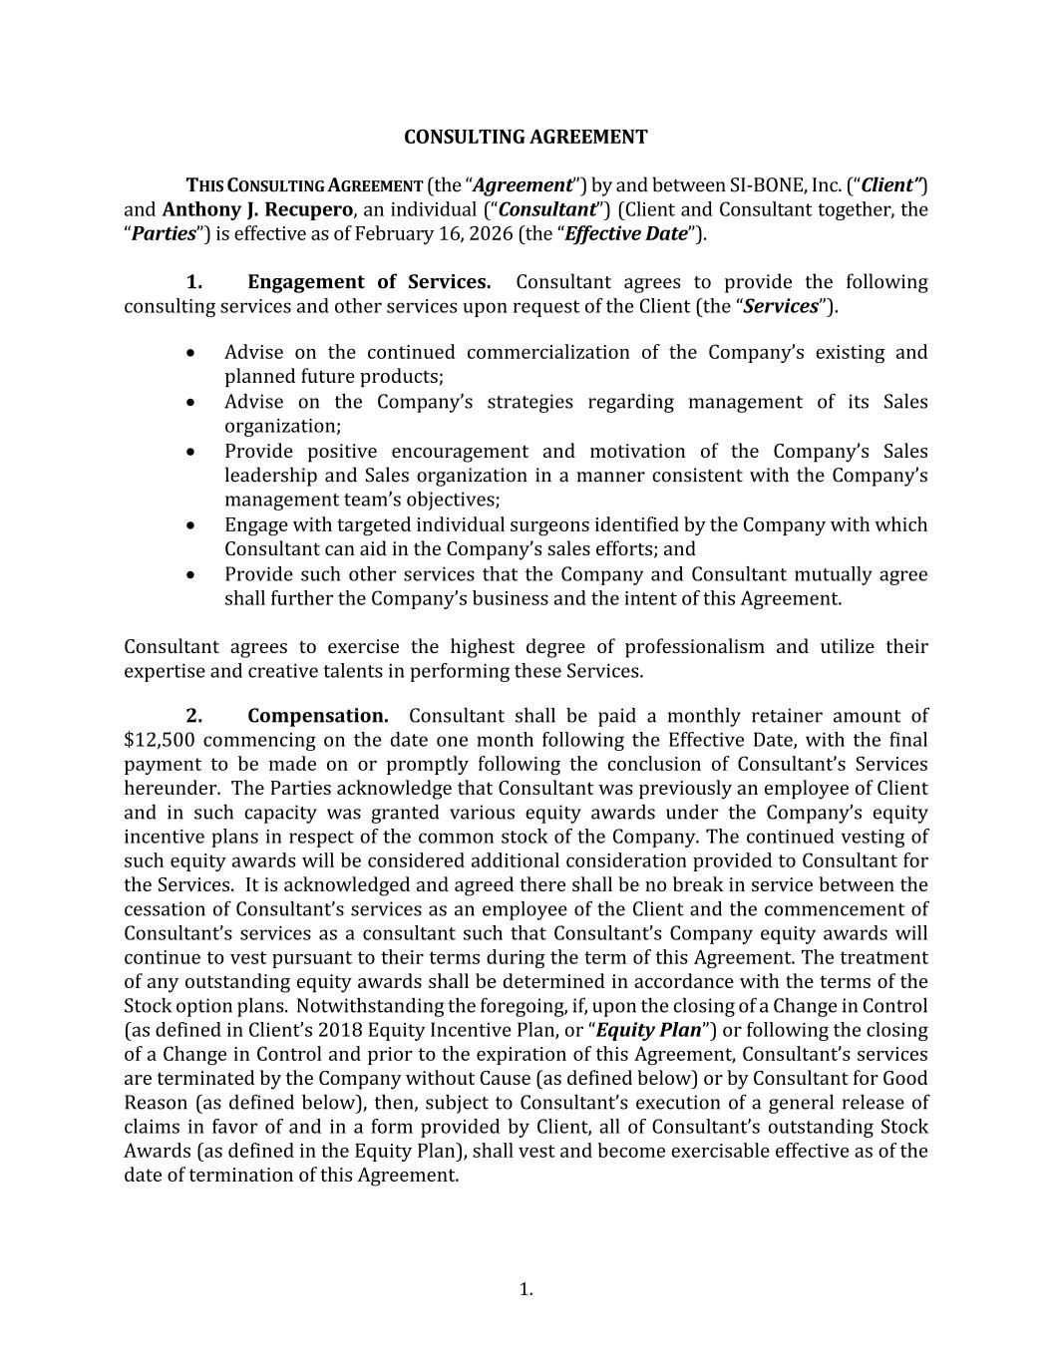
3.
1. CONSULTING AGREEMENT THIS CONSULTING AGREEMENT (the “Agreement”) by and between SI-BONE, Inc. (“Client”) and Anthony J. Recupero, an individual (“Consultant”) (Client and Consultant together, the “Parties”) is effective as of February 16, 2026 (the “Effective Date”). 1. Engagement of Services. Consultant agrees to provide the following consulting services and other services upon request of the Client (the “Services”). • Advise on the continued commercialization of the Company’s existing and planned future products; • Advise on the Company’s strategies regarding management of its Sales organization; • Provide positive encouragement and motivation of the Company’s Sales leadership and Sales organization in a manner consistent with the Company’s management team’s objectives; • Engage with targeted individual surgeons identified by the Company with which Consultant can aid in the Company’s sales efforts; and • Provide such other services that the Company and Consultant mutually agree shall further the Company’s business and the intent of this Agreement. Consultant agrees to exercise the highest degree of professionalism and utilize their expertise and creative talents in performing these Services. 2. Compensation. Consultant shall be paid a monthly retainer amount of $12,500 commencing on the date one month following the Effective Date, with the final payment to be made on or promptly following the conclusion of Consultant’s Services hereunder. The Parties acknowledge that Consultant was previously an employee of Client and in such capacity was granted various equity awards under the Company’s equity incentive plans in respect of the common stock of the Company. The continued vesting of such equity awards will be considered additional consideration provided to Consultant for the Services. It is acknowledged and agreed there shall be no break in service between the cessation of Consultant’s services as an employee of the Client and the commencement of Consultant’s services as a consultant such that Consultant’s Company equity awards will continue to vest pursuant to their terms during the term of this Agreement. The treatment of any outstanding equity awards shall be determined in accordance with the terms of the Stock option plans. Notwithstanding the foregoing, if, upon the closing of a Change in Control (as defined in Client’s 2018 Equity Incentive Plan, or “Equity Plan”) or following the closing of a Change in Control and prior to the expiration of this Agreement, Consultant’s services are terminated by the Company without Cause (as defined below) or by Consultant for Good Reason (as defined below), then, subject to Consultant’s execution of a general release of claims in favor of and in a form provided by Client, all of Consultant’s outstanding Stock Awards (as defined in the Equity Plan), shall vest and become exercisable effective as of the date of termination of this Agreement.

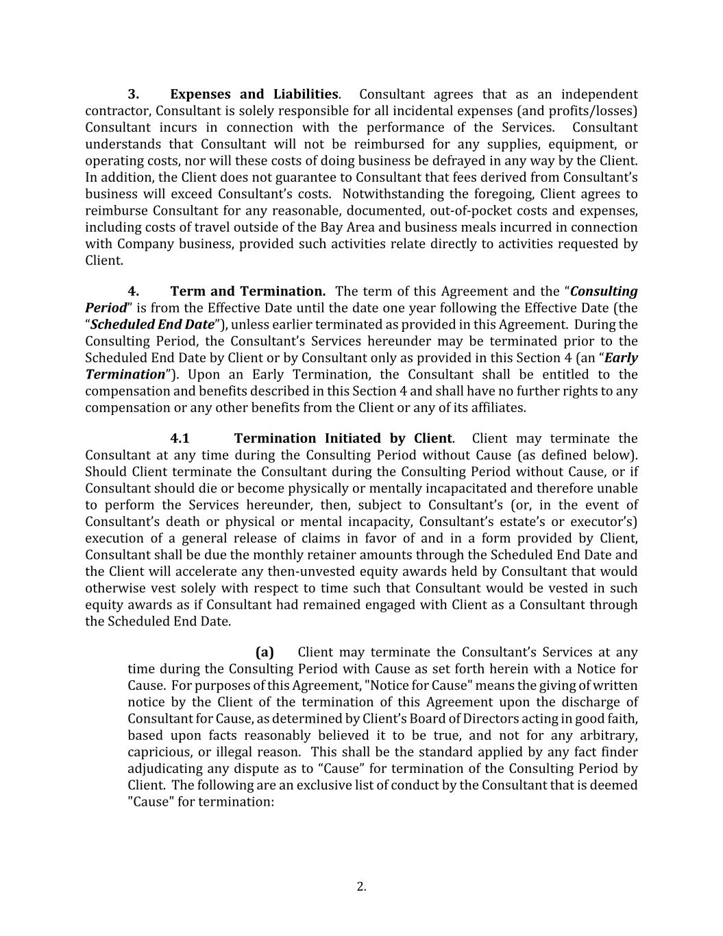
2. 3. Expenses and Liabilities. Consultant agrees that as an independent contractor, Consultant is solely responsible for all incidental expenses (and profits/losses) Consultant incurs in connection with the performance of the Services. Consultant understands that Consultant will not be reimbursed for any supplies, equipment, or operating costs, nor will these costs of doing business be defrayed in any way by the Client. In addition, the Client does not guarantee to Consultant that fees derived from Consultant’s business will exceed Consultant’s costs. Notwithstanding the foregoing, Client agrees to reimburse Consultant for any reasonable, documented, out-of-pocket costs and expenses, including costs of travel outside of the Bay Area and business meals incurred in connection with Company business, provided such activities relate directly to activities requested by Client. 4. Term and Termination. The term of this Agreement and the “Consulting Period” is from the Effective Date until the date one year following the Effective Date (the “Scheduled End Date”), unless earlier terminated as provided in this Agreement. During the Consulting Period, the Consultant’s Services hereunder may be terminated prior to the Scheduled End Date by Client or by Consultant only as provided in this Section 4 (an “Early Termination”). Upon an Early Termination, the Consultant shall be entitled to the compensation and benefits described in this Section 4 and shall have no further rights to any compensation or any other benefits from the Client or any of its affiliates. 4.1 Termination Initiated by Client. Client may terminate the Consultant at any time during the Consulting Period without Cause (as defined below). Should Client terminate the Consultant during the Consulting Period without Cause, or if Consultant should die or become physically or mentally incapacitated and therefore unable to perform the Services hereunder, then, subject to Consultant’s (or, in the event of Consultant’s death or physical or mental incapacity, Consultant’s estate’s or executor’s) execution of a general release of claims in favor of and in a form provided by Client, Consultant shall be due the monthly retainer amounts through the Scheduled End Date and the Client will accelerate any then-unvested equity awards held by Consultant that would otherwise vest solely with respect to time such that Consultant would be vested in such equity awards as if Consultant had remained engaged with Client as a Consultant through the Scheduled End Date. (a) Client may terminate the Consultant’s Services at any time during the Consulting Period with Cause as set forth herein with a Notice for Cause. For purposes of this Agreement, "Notice for Cause" means the giving of written notice by the Client of the termination of this Agreement upon the discharge of Consultant for Cause, as determined by Client’s Board of Directors acting in good faith, based upon facts reasonably believed it to be true, and not for any arbitrary, capricious, or illegal reason. This shall be the standard applied by any fact finder adjudicating any dispute as to “Cause” for termination of the Consulting Period by Client. The following are an exclusive list of conduct by the Consultant that is deemed "Cause" for termination:

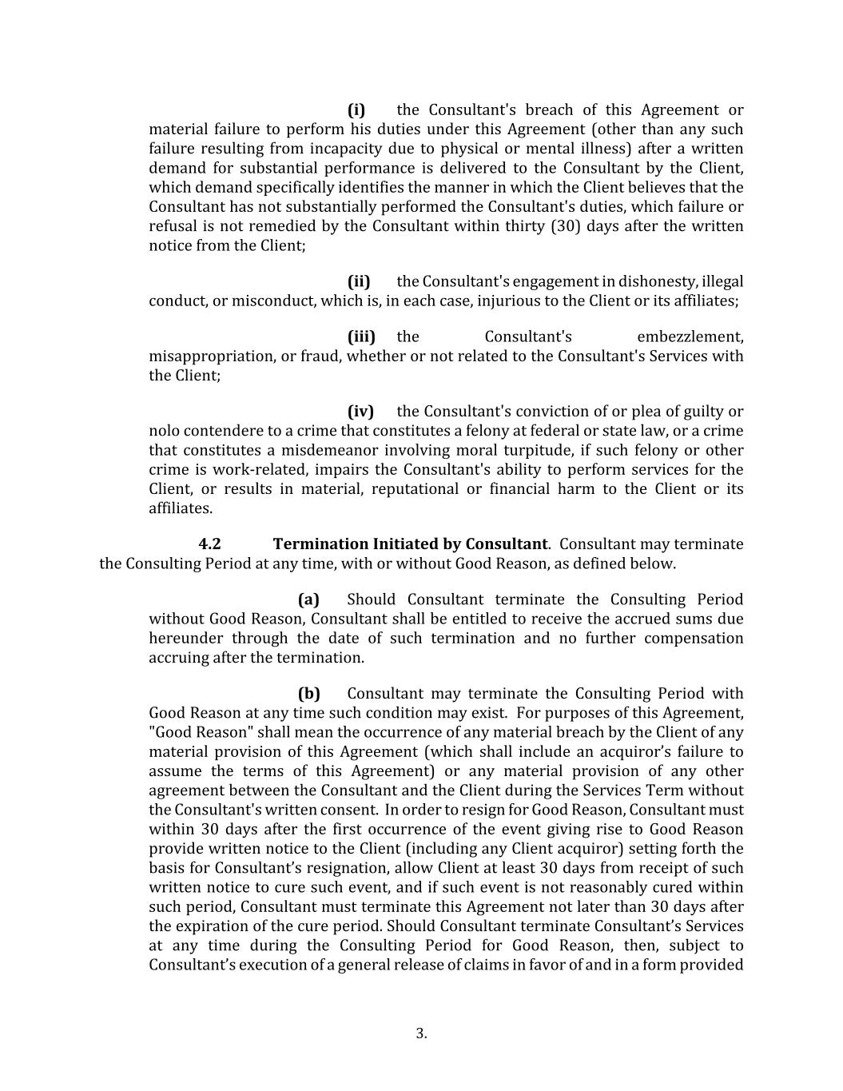
3. (i) the Consultant's breach of this Agreement or material failure to perform his duties under this Agreement (other than any such failure resulting from incapacity due to physical or mental illness) after a written demand for substantial performance is delivered to the Consultant by the Client, which demand specifically identifies the manner in which the Client believes that the Consultant has not substantially performed the Consultant's duties, which failure or refusal is not remedied by the Consultant within thirty (30) days after the written notice from the Client; (ii) the Consultant's engagement in dishonesty, illegal conduct, or misconduct, which is, in each case, injurious to the Client or its affiliates; (iii) the Consultant's embezzlement, misappropriation, or fraud, whether or not related to the Consultant's Services with the Client; (iv) the Consultant's conviction of or plea of guilty or nolo contendere to a crime that constitutes a felony at federal or state law, or a crime that constitutes a misdemeanor involving moral turpitude, if such felony or other crime is work-related, impairs the Consultant's ability to perform services for the Client, or results in material, reputational or financial harm to the Client or its affiliates. 4.2 Termination Initiated by Consultant. Consultant may terminate the Consulting Period at any time, with or without Good Reason, as defined below. (a) Should Consultant terminate the Consulting Period without Good Reason, Consultant shall be entitled to receive the accrued sums due hereunder through the date of such termination and no further compensation accruing after the termination. (b) Consultant may terminate the Consulting Period with Good Reason at any time such condition may exist. For purposes of this Agreement, "Good Reason" shall mean the occurrence of any material breach by the Client of any material provision of this Agreement (which shall include an acquiror’s failure to assume the terms of this Agreement) or any material provision of any other agreement between the Consultant and the Client during the Services Term without the Consultant's written consent. In order to resign for Good Reason, Consultant must within 30 days after the first occurrence of the event giving rise to Good Reason provide written notice to the Client (including any Client acquiror) setting forth the basis for Consultant’s resignation, allow Client at least 30 days from receipt of such written notice to cure such event, and if such event is not reasonably cured within such period, Consultant must terminate this Agreement not later than 30 days after the expiration of the cure period. Should Consultant terminate Consultant’s Services at any time during the Consulting Period for Good Reason, then, subject to Consultant’s execution of a general release of claims in favor of and in a form provided

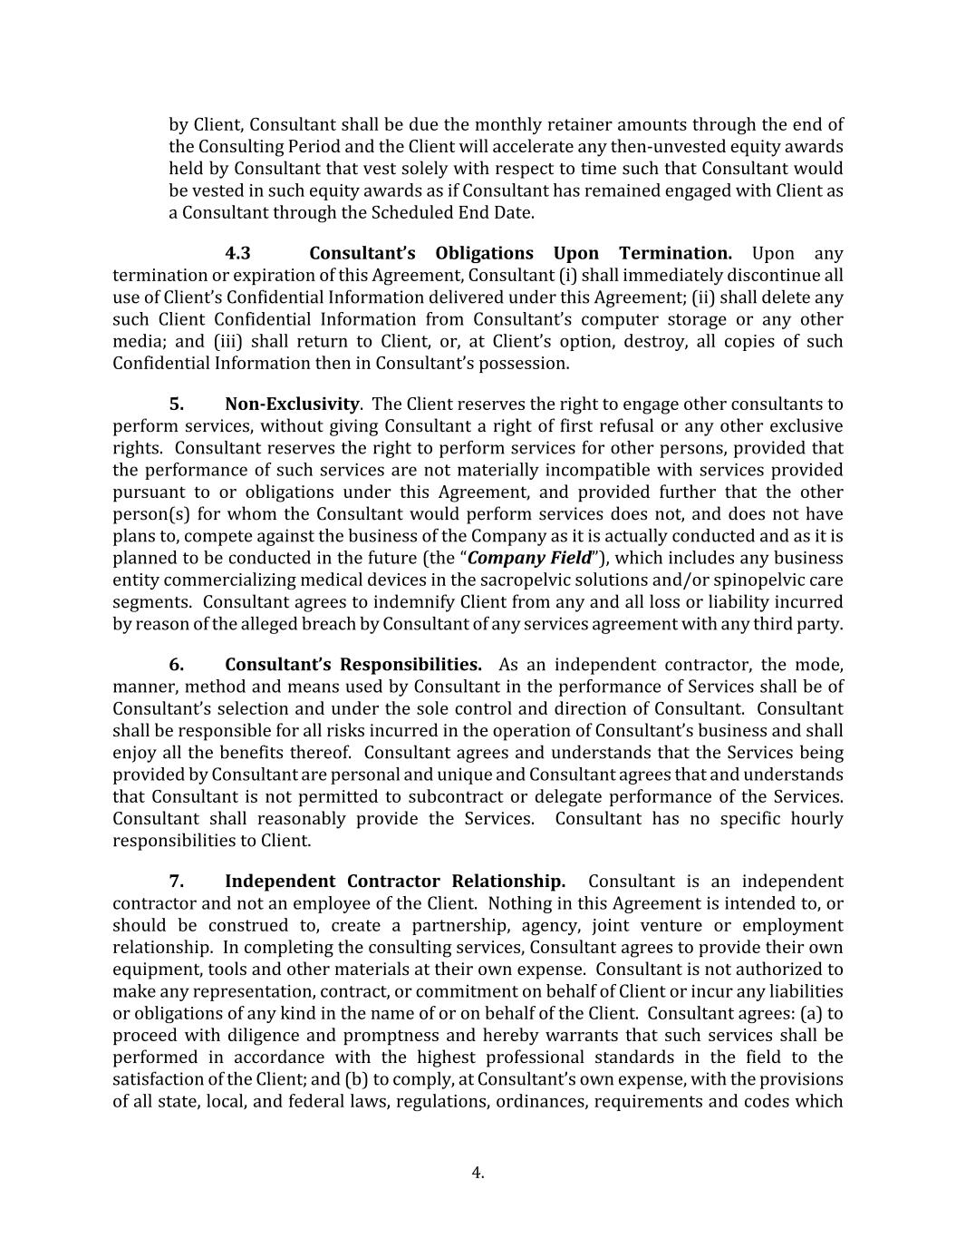
4. by Client, Consultant shall be due the monthly retainer amounts through the end of the Consulting Period and the Client will accelerate any then-unvested equity awards held by Consultant that vest solely with respect to time such that Consultant would be vested in such equity awards as if Consultant has remained engaged with Client as a Consultant through the Scheduled End Date. 4.3 Consultant’s Obligations Upon Termination. Upon any termination or expiration of this Agreement, Consultant (i) shall immediately discontinue all use of Client’s Confidential Information delivered under this Agreement; (ii) shall delete any such Client Confidential Information from Consultant’s computer storage or any other media; and (iii) shall return to Client, or, at Client’s option, destroy, all copies of such Confidential Information then in Consultant’s possession. 5. Non-Exclusivity. The Client reserves the right to engage other consultants to perform services, without giving Consultant a right of first refusal or any other exclusive rights. Consultant reserves the right to perform services for other persons, provided that the performance of such services are not materially incompatible with services provided pursuant to or obligations under this Agreement, and provided further that the other person(s) for whom the Consultant would perform services does not, and does not have plans to, compete against the business of the Company as it is actually conducted and as it is planned to be conducted in the future (the “Company Field”), which includes any business entity commercializing medical devices in the sacropelvic solutions and/or spinopelvic care segments. Consultant agrees to indemnify Client from any and all loss or liability incurred by reason of the alleged breach by Consultant of any services agreement with any third party. 6. Consultant’s Responsibilities. As an independent contractor, the mode, manner, method and means used by Consultant in the performance of Services shall be of Consultant’s selection and under the sole control and direction of Consultant. Consultant shall be responsible for all risks incurred in the operation of Consultant’s business and shall enjoy all the benefits thereof. Consultant agrees and understands that the Services being provided by Consultant are personal and unique and Consultant agrees that and understands that Consultant is not permitted to subcontract or delegate performance of the Services. Consultant shall reasonably provide the Services. Consultant has no specific hourly responsibilities to Client. 7. Independent Contractor Relationship. Consultant is an independent contractor and not an employee of the Client. Nothing in this Agreement is intended to, or should be construed to, create a partnership, agency, joint venture or employment relationship. In completing the consulting services, Consultant agrees to provide their own equipment, tools and other materials at their own expense. Consultant is not authorized to make any representation, contract, or commitment on behalf of Client or incur any liabilities or obligations of any kind in the name of or on behalf of the Client. Consultant agrees: (a) to proceed with diligence and promptness and hereby warrants that such services shall be performed in accordance with the highest professional standards in the field to the satisfaction of the Client; and (b) to comply, at Consultant’s own expense, with the provisions of all state, local, and federal laws, regulations, ordinances, requirements and codes which

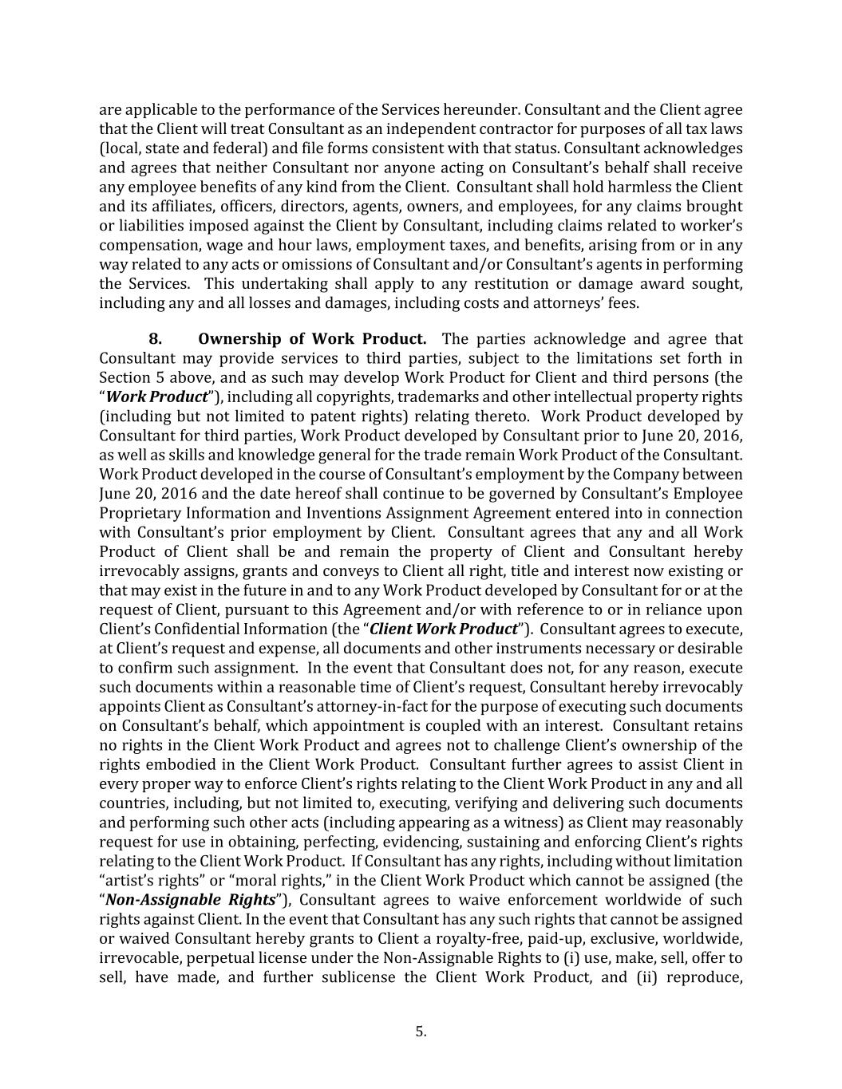
5. are applicable to the performance of the Services hereunder. Consultant and the Client agree that the Client will treat Consultant as an independent contractor for purposes of all tax laws (local, state and federal) and file forms consistent with that status. Consultant acknowledges and agrees that neither Consultant nor anyone acting on Consultant’s behalf shall receive any employee benefits of any kind from the Client. Consultant shall hold harmless the Client and its affiliates, officers, directors, agents, owners, and employees, for any claims brought or liabilities imposed against the Client by Consultant, including claims related to worker’s compensation, wage and hour laws, employment taxes, and benefits, arising from or in any way related to any acts or omissions of Consultant and/or Consultant’s agents in performing the Services. This undertaking shall apply to any restitution or damage award sought, including any and all losses and damages, including costs and attorneys’ fees. 8. Ownership of Work Product. The parties acknowledge and agree that Consultant may provide services to third parties, subject to the limitations set forth in Section 5 above, and as such may develop Work Product for Client and third persons (the “Work Product”), including all copyrights, trademarks and other intellectual property rights (including but not limited to patent rights) relating thereto. Work Product developed by Consultant for third parties, Work Product developed by Consultant prior to June 20, 2016, as well as skills and knowledge general for the trade remain Work Product of the Consultant. Work Product developed in the course of Consultant’s employment by the Company between June 20, 2016 and the date hereof shall continue to be governed by Consultant’s Employee Proprietary Information and Inventions Assignment Agreement entered into in connection with Consultant’s prior employment by Client. Consultant agrees that any and all Work Product of Client shall be and remain the property of Client and Consultant hereby irrevocably assigns, grants and conveys to Client all right, title and interest now existing or that may exist in the future in and to any Work Product developed by Consultant for or at the request of Client, pursuant to this Agreement and/or with reference to or in reliance upon Client’s Confidential Information (the “Client Work Product”). Consultant agrees to execute, at Client’s request and expense, all documents and other instruments necessary or desirable to confirm such assignment. In the event that Consultant does not, for any reason, execute such documents within a reasonable time of Client’s request, Consultant hereby irrevocably appoints Client as Consultant’s attorney-in-fact for the purpose of executing such documents on Consultant’s behalf, which appointment is coupled with an interest. Consultant retains no rights in the Client Work Product and agrees not to challenge Client’s ownership of the rights embodied in the Client Work Product. Consultant further agrees to assist Client in every proper way to enforce Client’s rights relating to the Client Work Product in any and all countries, including, but not limited to, executing, verifying and delivering such documents and performing such other acts (including appearing as a witness) as Client may reasonably request for use in obtaining, perfecting, evidencing, sustaining and enforcing Client’s rights relating to the Client Work Product. If Consultant has any rights, including without limitation “artist’s rights” or “moral rights,” in the Client Work Product which cannot be assigned (the “Non-Assignable Rights”), Consultant agrees to waive enforcement worldwide of such rights against Client. In the event that Consultant has any such rights that cannot be assigned or waived Consultant hereby grants to Client a royalty-free, paid-up, exclusive, worldwide, irrevocable, perpetual license under the Non-Assignable Rights to (i) use, make, sell, offer to sell, have made, and further sublicense the Client Work Product, and (ii) reproduce,

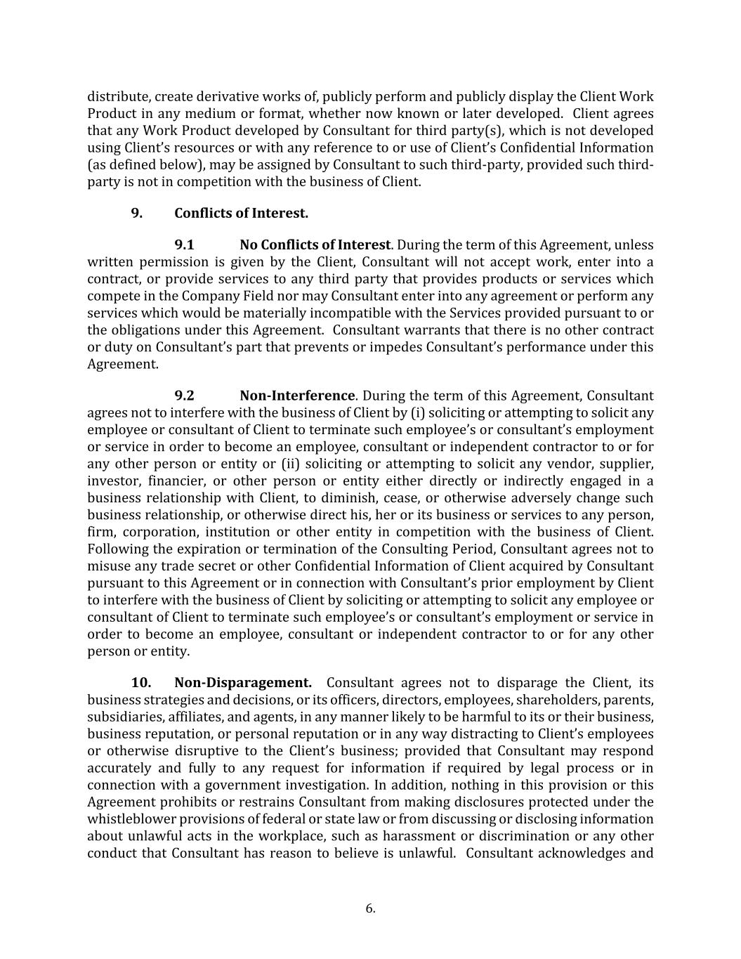
6. distribute, create derivative works of, publicly perform and publicly display the Client Work Product in any medium or format, whether now known or later developed. Client agrees that any Work Product developed by Consultant for third party(s), which is not developed using Client’s resources or with any reference to or use of Client’s Confidential Information (as defined below), may be assigned by Consultant to such third-party, provided such third- party is not in competition with the business of Client. 9. Conflicts of Interest. 9.1 No Conflicts of Interest. During the term of this Agreement, unless written permission is given by the Client, Consultant will not accept work, enter into a contract, or provide services to any third party that provides products or services which compete in the Company Field nor may Consultant enter into any agreement or perform any services which would be materially incompatible with the Services provided pursuant to or the obligations under this Agreement. Consultant warrants that there is no other contract or duty on Consultant’s part that prevents or impedes Consultant’s performance under this Agreement. 9.2 Non-Interference. During the term of this Agreement, Consultant agrees not to interfere with the business of Client by (i) soliciting or attempting to solicit any employee or consultant of Client to terminate such employee’s or consultant’s employment or service in order to become an employee, consultant or independent contractor to or for any other person or entity or (ii) soliciting or attempting to solicit any vendor, supplier, investor, financier, or other person or entity either directly or indirectly engaged in a business relationship with Client, to diminish, cease, or otherwise adversely change such business relationship, or otherwise direct his, her or its business or services to any person, firm, corporation, institution or other entity in competition with the business of Client. Following the expiration or termination of the Consulting Period, Consultant agrees not to misuse any trade secret or other Confidential Information of Client acquired by Consultant pursuant to this Agreement or in connection with Consultant’s prior employment by Client to interfere with the business of Client by soliciting or attempting to solicit any employee or consultant of Client to terminate such employee’s or consultant’s employment or service in order to become an employee, consultant or independent contractor to or for any other person or entity. 10. Non-Disparagement. Consultant agrees not to disparage the Client, its business strategies and decisions, or its officers, directors, employees, shareholders, parents, subsidiaries, affiliates, and agents, in any manner likely to be harmful to its or their business, business reputation, or personal reputation or in any way distracting to Client’s employees or otherwise disruptive to the Client’s business; provided that Consultant may respond accurately and fully to any request for information if required by legal process or in connection with a government investigation. In addition, nothing in this provision or this Agreement prohibits or restrains Consultant from making disclosures protected under the whistleblower provisions of federal or state law or from discussing or disclosing information about unlawful acts in the workplace, such as harassment or discrimination or any other conduct that Consultant has reason to believe is unlawful. Consultant acknowledges and

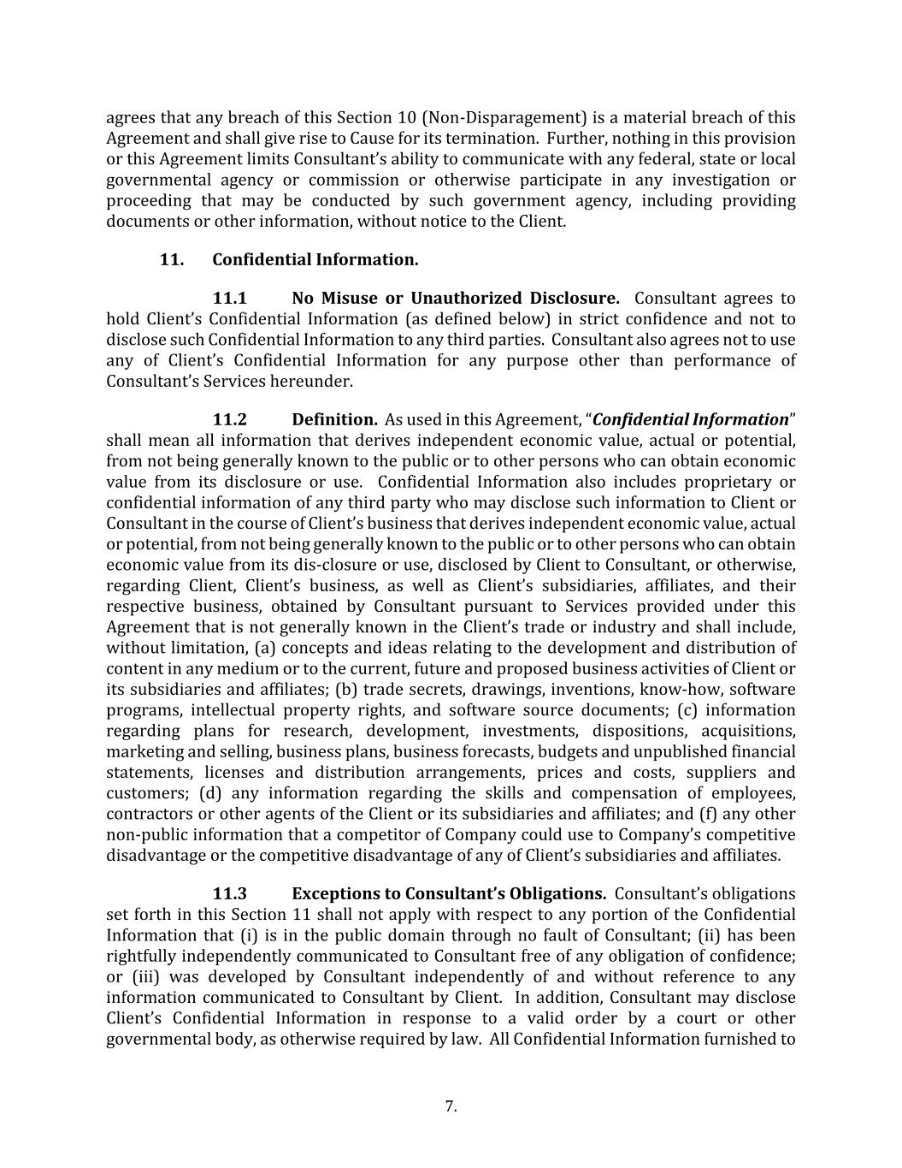
7. agrees that any breach of this Section 10 (Non-Disparagement) is a material breach of this Agreement and shall give rise to Cause for its termination. Further, nothing in this provision or this Agreement limits Consultant’s ability to communicate with any federal, state or local governmental agency or commission or otherwise participate in any investigation or proceeding that may be conducted by such government agency, including providing documents or other information, without notice to the Client. 11. Confidential Information. 11.1 No Misuse or Unauthorized Disclosure. Consultant agrees to hold Client’s Confidential Information (as defined below) in strict confidence and not to disclose such Confidential Information to any third parties. Consultant also agrees not to use any of Client’s Confidential Information for any purpose other than performance of Consultant’s Services hereunder. 11.2 Definition. As used in this Agreement, “Confidential Information” shall mean all information that derives independent economic value, actual or potential, from not being generally known to the public or to other persons who can obtain economic value from its disclosure or use. Confidential Information also includes proprietary or confidential information of any third party who may disclose such information to Client or Consultant in the course of Client’s business that derives independent economic value, actual or potential, from not being generally known to the public or to other persons who can obtain economic value from its dis-closure or use, disclosed by Client to Consultant, or otherwise, regarding Client, Client’s business, as well as Client’s subsidiaries, affiliates, and their respective business, obtained by Consultant pursuant to Services provided under this Agreement that is not generally known in the Client’s trade or industry and shall include, without limitation, (a) concepts and ideas relating to the development and distribution of content in any medium or to the current, future and proposed business activities of Client or its subsidiaries and affiliates; (b) trade secrets, drawings, inventions, know-how, software programs, intellectual property rights, and software source documents; (c) information regarding plans for research, development, investments, dispositions, acquisitions, marketing and selling, business plans, business forecasts, budgets and unpublished financial statements, licenses and distribution arrangements, prices and costs, suppliers and customers; (d) any information regarding the skills and compensation of employees, contractors or other agents of the Client or its subsidiaries and affiliates; and (f) any other non-public information that a competitor of Company could use to Company’s competitive disadvantage or the competitive disadvantage of any of Client’s subsidiaries and affiliates. 11.3 Exceptions to Consultant’s Obligations. Consultant’s obligations set forth in this Section 11 shall not apply with respect to any portion of the Confidential Information that (i) is in the public domain through no fault of Consultant; (ii) has been rightfully independently communicated to Consultant free of any obligation of confidence; or (iii) was developed by Consultant independently of and without reference to any information communicated to Consultant by Client. In addition, Consultant may disclose Client’s Confidential Information in response to a valid order by a court or other governmental body, as otherwise required by law. All Confidential Information furnished to

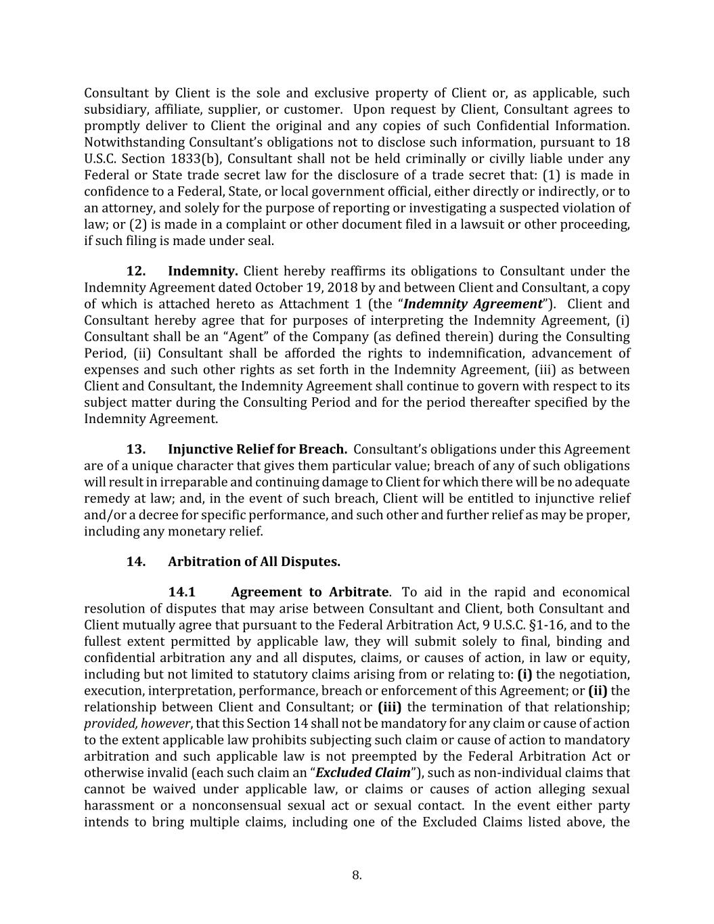
8. Consultant by Client is the sole and exclusive property of Client or, as applicable, such subsidiary, affiliate, supplier, or customer. Upon request by Client, Consultant agrees to promptly deliver to Client the original and any copies of such Confidential Information. Notwithstanding Consultant’s obligations not to disclose such information, pursuant to 18 U.S.C. Section 1833(b), Consultant shall not be held criminally or civilly liable under any Federal or State trade secret law for the disclosure of a trade secret that: (1) is made in confidence to a Federal, State, or local government official, either directly or indirectly, or to an attorney, and solely for the purpose of reporting or investigating a suspected violation of law; or (2) is made in a complaint or other document filed in a lawsuit or other proceeding, if such filing is made under seal. 12. Indemnity. Client hereby reaffirms its obligations to Consultant under the Indemnity Agreement dated October 19, 2018 by and between Client and Consultant, a copy of which is attached hereto as Attachment 1 (the “Indemnity Agreement”). Client and Consultant hereby agree that for purposes of interpreting the Indemnity Agreement, (i) Consultant shall be an “Agent” of the Company (as defined therein) during the Consulting Period, (ii) Consultant shall be afforded the rights to indemnification, advancement of expenses and such other rights as set forth in the Indemnity Agreement, (iii) as between Client and Consultant, the Indemnity Agreement shall continue to govern with respect to its subject matter during the Consulting Period and for the period thereafter specified by the Indemnity Agreement. 13. Injunctive Relief for Breach. Consultant’s obligations under this Agreement are of a unique character that gives them particular value; breach of any of such obligations will result in irreparable and continuing damage to Client for which there will be no adequate remedy at law; and, in the event of such breach, Client will be entitled to injunctive relief and/or a decree for specific performance, and such other and further relief as may be proper, including any monetary relief. 14. Arbitration of All Disputes. 14.1 Agreement to Arbitrate. To aid in the rapid and economical resolution of disputes that may arise between Consultant and Client, both Consultant and Client mutually agree that pursuant to the Federal Arbitration Act, 9 U.S.C. §1-16, and to the fullest extent permitted by applicable law, they will submit solely to final, binding and confidential arbitration any and all disputes, claims, or causes of action, in law or equity, including but not limited to statutory claims arising from or relating to: (i) the negotiation, execution, interpretation, performance, breach or enforcement of this Agreement; or (ii) the relationship between Client and Consultant; or (iii) the termination of that relationship; provided, however, that this Section 14 shall not be mandatory for any claim or cause of action to the extent applicable law prohibits subjecting such claim or cause of action to mandatory arbitration and such applicable law is not preempted by the Federal Arbitration Act or otherwise invalid (each such claim an “Excluded Claim”), such as non-individual claims that cannot be waived under applicable law, or claims or causes of action alleging sexual harassment or a nonconsensual sexual act or sexual contact. In the event either party intends to bring multiple claims, including one of the Excluded Claims listed above, the

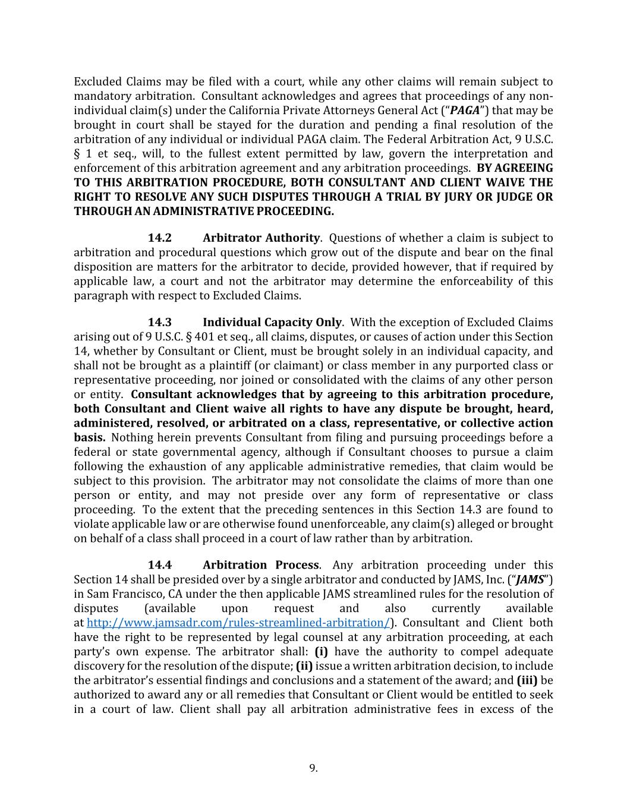
9. Excluded Claims may be filed with a court, while any other claims will remain subject to mandatory arbitration. Consultant acknowledges and agrees that proceedings of any non- individual claim(s) under the California Private Attorneys General Act (“PAGA”) that may be brought in court shall be stayed for the duration and pending a final resolution of the arbitration of any individual or individual PAGA claim. The Federal Arbitration Act, 9 U.S.C. § 1 et seq., will, to the fullest extent permitted by law, govern the interpretation and enforcement of this arbitration agreement and any arbitration proceedings. BY AGREEING TO THIS ARBITRATION PROCEDURE, BOTH CONSULTANT AND CLIENT WAIVE THE RIGHT TO RESOLVE ANY SUCH DISPUTES THROUGH A TRIAL BY JURY OR JUDGE OR THROUGH AN ADMINISTRATIVE PROCEEDING. 14.2 Arbitrator Authority. Questions of whether a claim is subject to arbitration and procedural questions which grow out of the dispute and bear on the final disposition are matters for the arbitrator to decide, provided however, that if required by applicable law, a court and not the arbitrator may determine the enforceability of this paragraph with respect to Excluded Claims. 14.3 Individual Capacity Only. With the exception of Excluded Claims arising out of 9 U.S.C. § 401 et seq., all claims, disputes, or causes of action under this Section 14, whether by Consultant or Client, must be brought solely in an individual capacity, and shall not be brought as a plaintiff (or claimant) or class member in any purported class or representative proceeding, nor joined or consolidated with the claims of any other person or entity. Consultant acknowledges that by agreeing to this arbitration procedure, both Consultant and Client waive all rights to have any dispute be brought, heard, administered, resolved, or arbitrated on a class, representative, or collective action basis. Nothing herein prevents Consultant from filing and pursuing proceedings before a federal or state governmental agency, although if Consultant chooses to pursue a claim following the exhaustion of any applicable administrative remedies, that claim would be subject to this provision. The arbitrator may not consolidate the claims of more than one person or entity, and may not preside over any form of representative or class proceeding. To the extent that the preceding sentences in this Section 14.3 are found to violate applicable law or are otherwise found unenforceable, any claim(s) alleged or brought on behalf of a class shall proceed in a court of law rather than by arbitration. 14.4 Arbitration Process. Any arbitration proceeding under this Section 14 shall be presided over by a single arbitrator and conducted by JAMS, Inc. (“JAMS”) in Sam Francisco, CA under the then applicable JAMS streamlined rules for the resolution of disputes (available upon request and also currently available at http://www.jamsadr.com/rules-streamlined-arbitration/). Consultant and Client both have the right to be represented by legal counsel at any arbitration proceeding, at each party’s own expense. The arbitrator shall: (i) have the authority to compel adequate discovery for the resolution of the dispute; (ii) issue a written arbitration decision, to include the arbitrator’s essential findings and conclusions and a statement of the award; and (iii) be authorized to award any or all remedies that Consultant or Client would be entitled to seek in a court of law. Client shall pay all arbitration administrative fees in excess of the

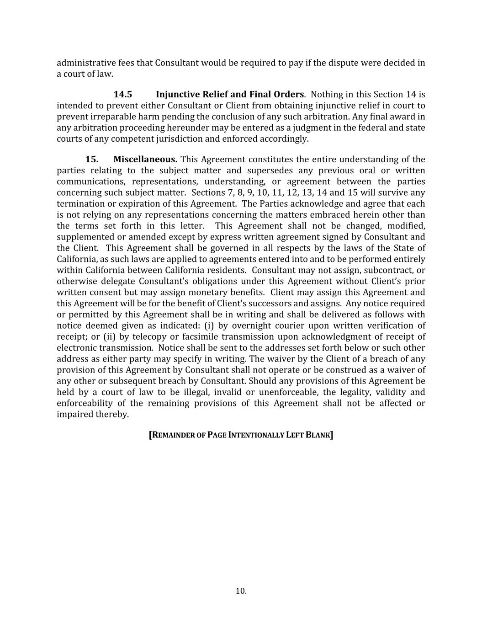
10. administrative fees that Consultant would be required to pay if the dispute were decided in a court of law. 14.5 Injunctive Relief and Final Orders. Nothing in this Section 14 is intended to prevent either Consultant or Client from obtaining injunctive relief in court to prevent irreparable harm pending the conclusion of any such arbitration. Any final award in any arbitration proceeding hereunder may be entered as a judgment in the federal and state courts of any competent jurisdiction and enforced accordingly. 15. Miscellaneous. This Agreement constitutes the entire understanding of the parties relating to the subject matter and supersedes any previous oral or written communications, representations, understanding, or agreement between the parties concerning such subject matter. Sections 7, 8, 9, 10, 11, 12, 13, 14 and 15 will survive any termination or expiration of this Agreement. The Parties acknowledge and agree that each is not relying on any representations concerning the matters embraced herein other than the terms set forth in this letter. This Agreement shall not be changed, modified, supplemented or amended except by express written agreement signed by Consultant and the Client. This Agreement shall be governed in all respects by the laws of the State of California, as such laws are applied to agreements entered into and to be performed entirely within California between California residents. Consultant may not assign, subcontract, or otherwise delegate Consultant’s obligations under this Agreement without Client’s prior written consent but may assign monetary benefits. Client may assign this Agreement and this Agreement will be for the benefit of Client’s successors and assigns. Any notice required or permitted by this Agreement shall be in writing and shall be delivered as follows with notice deemed given as indicated: (i) by overnight courier upon written verification of receipt; or (ii) by telecopy or facsimile transmission upon acknowledgment of receipt of electronic transmission. Notice shall be sent to the addresses set forth below or such other address as either party may specify in writing. The waiver by the Client of a breach of any provision of this Agreement by Consultant shall not operate or be construed as a waiver of any other or subsequent breach by Consultant. Should any provisions of this Agreement be held by a court of law to be illegal, invalid or unenforceable, the legality, validity and enforceability of the remaining provisions of this Agreement shall not be affected or impaired thereby. [REMAINDER OF PAGE INTENTIONALLY LEFT BLANK]

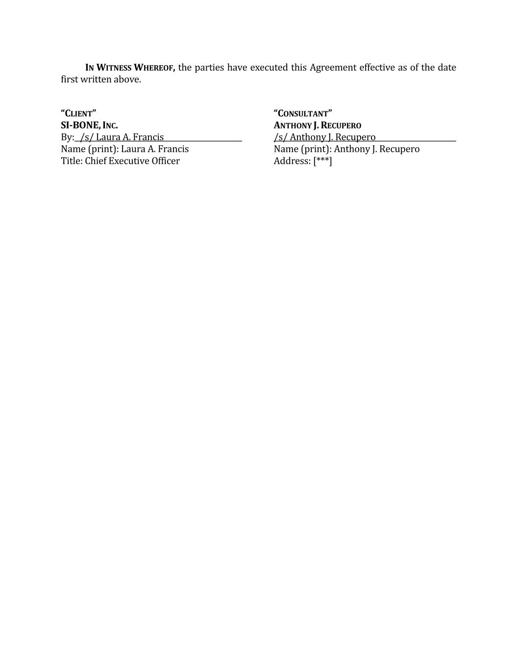
IN WITNESS WHEREOF, the parties have executed this Agreement effective as of the date first written above. “CLIENT” “CONSULTANT” SI-BONE, INC. ANTHONY J. RECUPERO By: /s/ Laura A. Francis /s/ Anthony J. Recupero Name (print): Laura A. Francis Name (print): Anthony J. Recupero Title: Chief Executive Officer Address: [***]


ATTACHMENT 1 INDEMNITY AGREEMENT DATED OCTOBER 19, 2018 BETWEEN CLIENT AND CONSULTANT

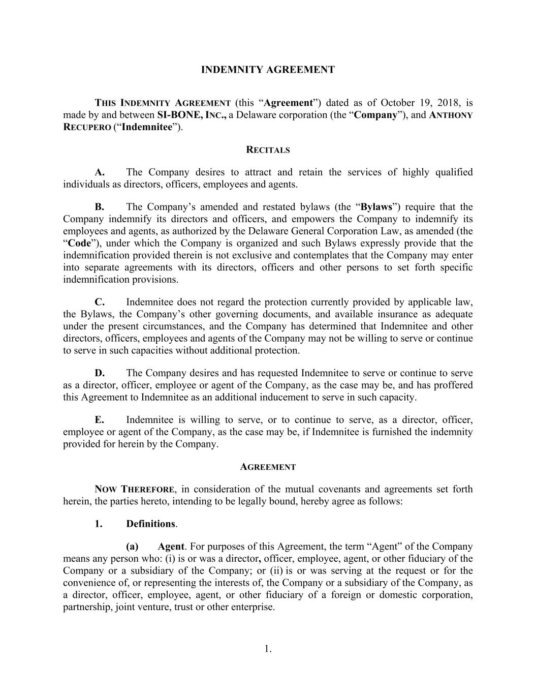
1. INDEMNITY AGREEMENT THIS INDEMNITY AGREEMENT (this “Agreement”) dated as of October 19, 2018, is made by and between SI-BONE, INC., a Delaware corporation (the “Company”), and ANTHONY RECUPERO (“Indemnitee”). RECITALS A. The Company desires to attract and retain the services of highly qualified individuals as directors, officers, employees and agents. B. The Company’s amended and restated bylaws (the “Bylaws”) require that the Company indemnify its directors and officers, and empowers the Company to indemnify its employees and agents, as authorized by the Delaware General Corporation Law, as amended (the “Code”), under which the Company is organized and such Bylaws expressly provide that the indemnification provided therein is not exclusive and contemplates that the Company may enter into separate agreements with its directors, officers and other persons to set forth specific indemnification provisions. C. Indemnitee does not regard the protection currently provided by applicable law, the Bylaws, the Company’s other governing documents, and available insurance as adequate under the present circumstances, and the Company has determined that Indemnitee and other directors, officers, employees and agents of the Company may not be willing to serve or continue to serve in such capacities without additional protection. D. The Company desires and has requested Indemnitee to serve or continue to serve as a director, officer, employee or agent of the Company, as the case may be, and has proffered this Agreement to Indemnitee as an additional inducement to serve in such capacity. E. Indemnitee is willing to serve, or to continue to serve, as a director, officer, employee or agent of the Company, as the case may be, if Indemnitee is furnished the indemnity provided for herein by the Company. AGREEMENT NOW THEREFORE, in consideration of the mutual covenants and agreements set forth herein, the parties hereto, intending to be legally bound, hereby agree as follows: 1. Definitions. (a) Agent. For purposes of this Agreement, the term “Agent” of the Company means any person who: (i) is or was a director, officer, employee, agent, or other fiduciary of the Company or a subsidiary of the Company; or (ii) is or was serving at the request or for the convenience of, or representing the interests of, the Company or a subsidiary of the Company, as a director, officer, employee, agent, or other fiduciary of a foreign or domestic corporation, partnership, joint venture, trust or other enterprise.

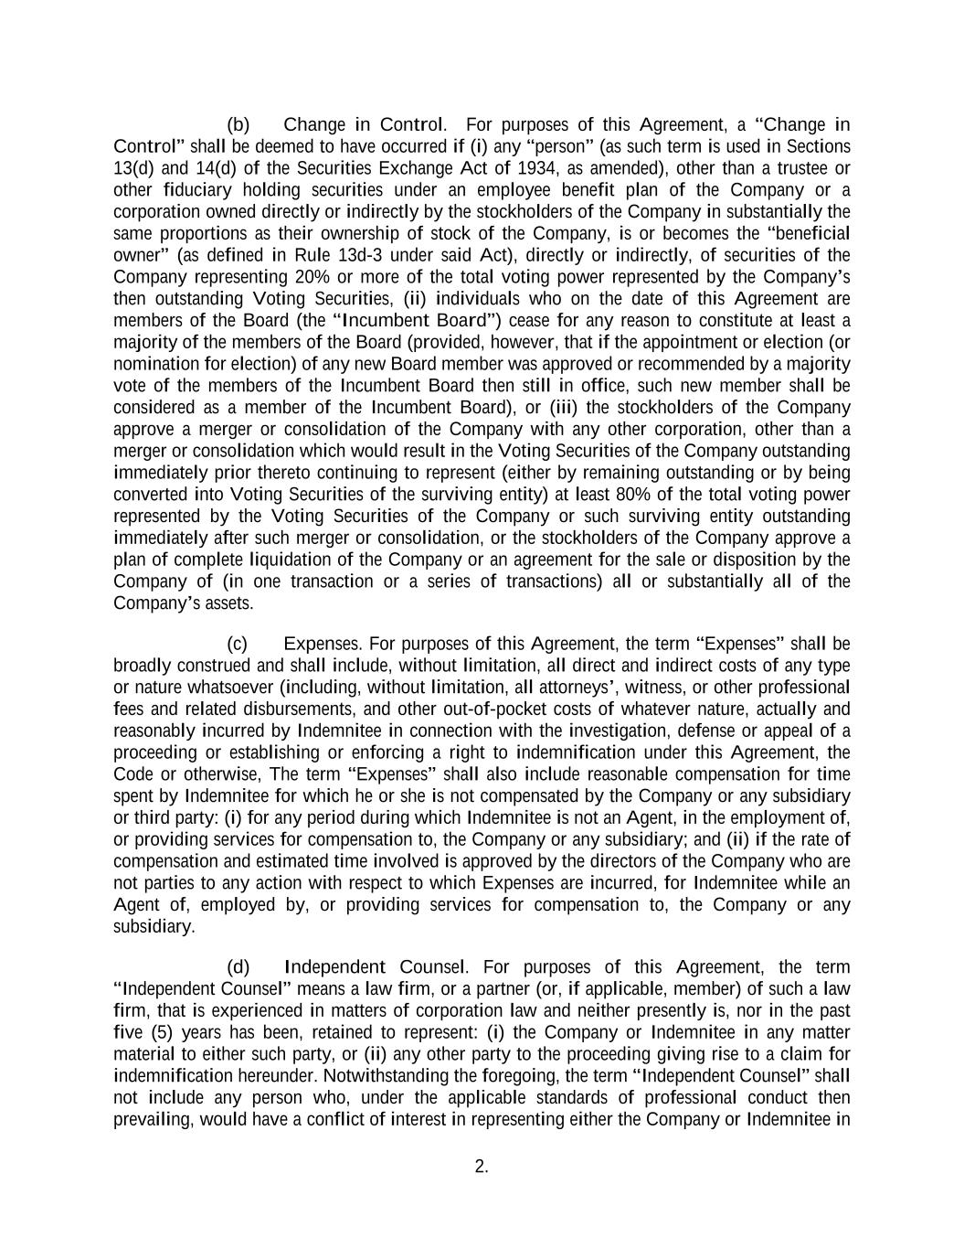
2. (b) Change in Control. For purposes of this Agreement, a “Change in Control” shall be deemed to have occurred if (i) any “person” (as such term is used in Sections 13(d) and 14(d) of the Securities Exchange Act of 1934, as amended), other than a trustee or other fiduciary holding securities under an employee benefit plan of the Company or a corporation owned directly or indirectly by the stockholders of the Company in substantially the same proportions as their ownership of stock of the Company, is or becomes the “beneficial owner” (as defined in Rule 13d-3 under said Act), directly or indirectly, of securities of the Company representing 20% or more of the total voting power represented by the Company’s then outstanding Voting Securities, (ii) individuals who on the date of this Agreement are members of the Board (the “Incumbent Board”) cease for any reason to constitute at least a majority of the members of the Board (provided, however, that if the appointment or election (or nomination for election) of any new Board member was approved or recommended by a majority vote of the members of the Incumbent Board then still in office, such new member shall be considered as a member of the Incumbent Board), or (iii) the stockholders of the Company approve a merger or consolidation of the Company with any other corporation, other than a merger or consolidation which would result in the Voting Securities of the Company outstanding immediately prior thereto continuing to represent (either by remaining outstanding or by being converted into Voting Securities of the surviving entity) at least 80% of the total voting power represented by the Voting Securities of the Company or such surviving entity outstanding immediately after such merger or consolidation, or the stockholders of the Company approve a plan of complete liquidation of the Company or an agreement for the sale or disposition by the Company of (in one transaction or a series of transactions) all or substantially all of the Company’s assets. (c) Expenses. For purposes of this Agreement, the term “Expenses” shall be broadly construed and shall include, without limitation, all direct and indirect costs of any type or nature whatsoever (including, without limitation, all attorneys’, witness, or other professional fees and related disbursements, and other out-of-pocket costs of whatever nature, actually and reasonably incurred by Indemnitee in connection with the investigation, defense or appeal of a proceeding or establishing or enforcing a right to indemnification under this Agreement, the Code or otherwise, The term “Expenses” shall also include reasonable compensation for time spent by Indemnitee for which he or she is not compensated by the Company or any subsidiary or third party: (i) for any period during which Indemnitee is not an Agent, in the employment of, or providing services for compensation to, the Company or any subsidiary; and (ii) if the rate of compensation and estimated time involved is approved by the directors of the Company who are not parties to any action with respect to which Expenses are incurred, for Indemnitee while an Agent of, employed by, or providing services for compensation to, the Company or any subsidiary. (d) Independent Counsel. For purposes of this Agreement, the term “Independent Counsel” means a law firm, or a partner (or, if applicable, member) of such a law firm, that is experienced in matters of corporation law and neither presently is, nor in the past five (5) years has been, retained to represent: (i) the Company or Indemnitee in any matter material to either such party, or (ii) any other party to the proceeding giving rise to a claim for indemnification hereunder. Notwithstanding the foregoing, the term “Independent Counsel” shall not include any person who, under the applicable standards of professional conduct then prevailing, would have a conflict of interest in representing either the Company or Indemnitee in

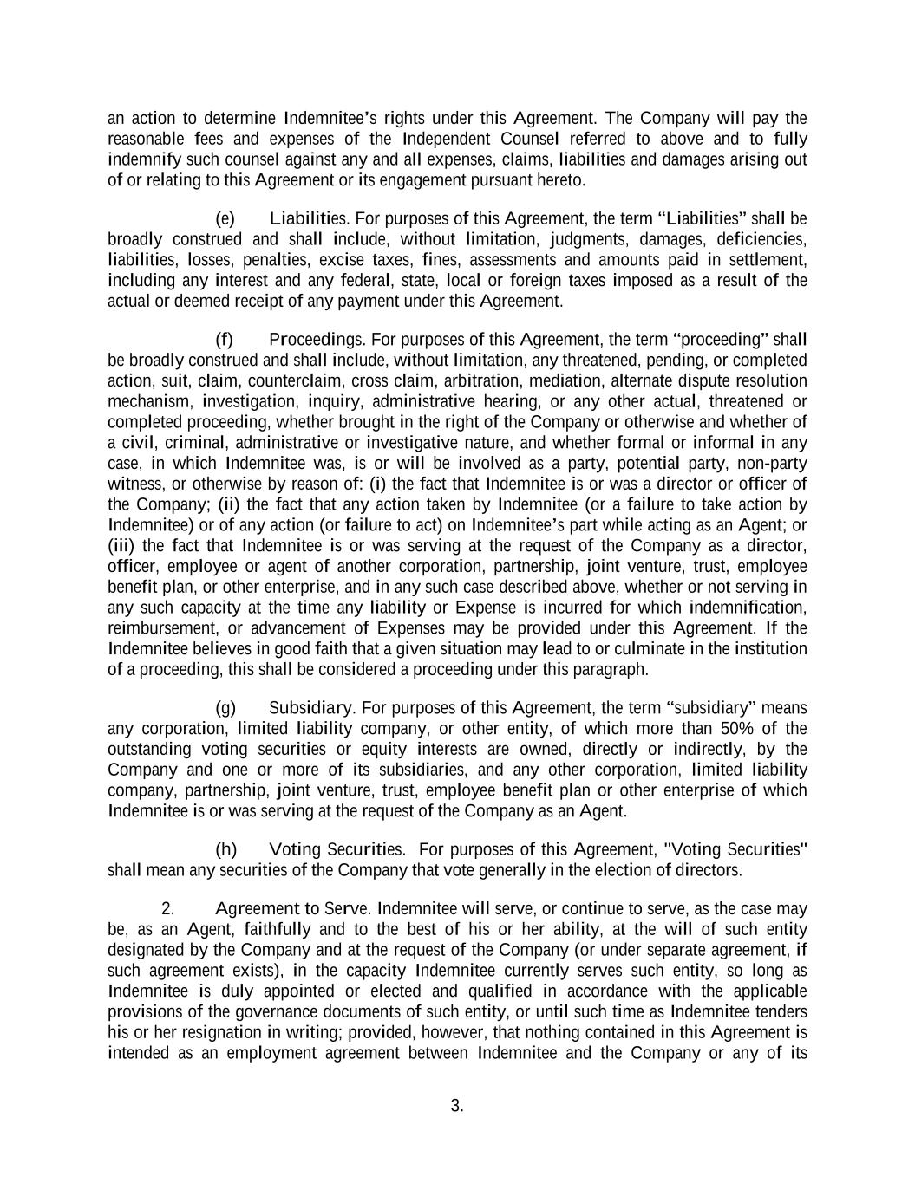
3. an action to determine Indemnitee’s rights under this Agreement. The Company will pay the reasonable fees and expenses of the Independent Counsel referred to above and to fully indemnify such counsel against any and all expenses, claims, liabilities and damages arising out of or relating to this Agreement or its engagement pursuant hereto. (e) Liabilities. For purposes of this Agreement, the term “Liabilities” shall be broadly construed and shall include, without limitation, judgments, damages, deficiencies, liabilities, losses, penalties, excise taxes, fines, assessments and amounts paid in settlement, including any interest and any federal, state, local or foreign taxes imposed as a result of the actual or deemed receipt of any payment under this Agreement. (f) Proceedings. For purposes of this Agreement, the term “proceeding” shall be broadly construed and shall include, without limitation, any threatened, pending, or completed action, suit, claim, counterclaim, cross claim, arbitration, mediation, alternate dispute resolution mechanism, investigation, inquiry, administrative hearing, or any other actual, threatened or completed proceeding, whether brought in the right of the Company or otherwise and whether of a civil, criminal, administrative or investigative nature, and whether formal or informal in any case, in which Indemnitee was, is or will be involved as a party, potential party, non-party witness, or otherwise by reason of: (i) the fact that Indemnitee is or was a director or officer of the Company; (ii) the fact that any action taken by Indemnitee (or a failure to take action by Indemnitee) or of any action (or failure to act) on Indemnitee’s part while acting as an Agent; or (iii) the fact that Indemnitee is or was serving at the request of the Company as a director, officer, employee or agent of another corporation, partnership, joint venture, trust, employee benefit plan, or other enterprise, and in any such case described above, whether or not serving in any such capacity at the time any liability or Expense is incurred for which indemnification, reimbursement, or advancement of Expenses may be provided under this Agreement. If the Indemnitee believes in good faith that a given situation may lead to or culminate in the institution of a proceeding, this shall be considered a proceeding under this paragraph. (g) Subsidiary. For purposes of this Agreement, the term “subsidiary” means any corporation, limited liability company, or other entity, of which more than 50% of the outstanding voting securities or equity interests are owned, directly or indirectly, by the Company and one or more of its subsidiaries, and any other corporation, limited liability company, partnership, joint venture, trust, employee benefit plan or other enterprise of which Indemnitee is or was serving at the request of the Company as an Agent. (h) Voting Securities. For purposes of this Agreement, "Voting Securities" shall mean any securities of the Company that vote generally in the election of directors. 2. Agreement to Serve. Indemnitee will serve, or continue to serve, as the case may be, as an Agent, faithfully and to the best of his or her ability, at the will of such entity designated by the Company and at the request of the Company (or under separate agreement, if such agreement exists), in the capacity Indemnitee currently serves such entity, so long as Indemnitee is duly appointed or elected and qualified in accordance with the applicable provisions of the governance documents of such entity, or until such time as Indemnitee tenders his or her resignation in writing; provided, however, that nothing contained in this Agreement is intended as an employment agreement between Indemnitee and the Company or any of its

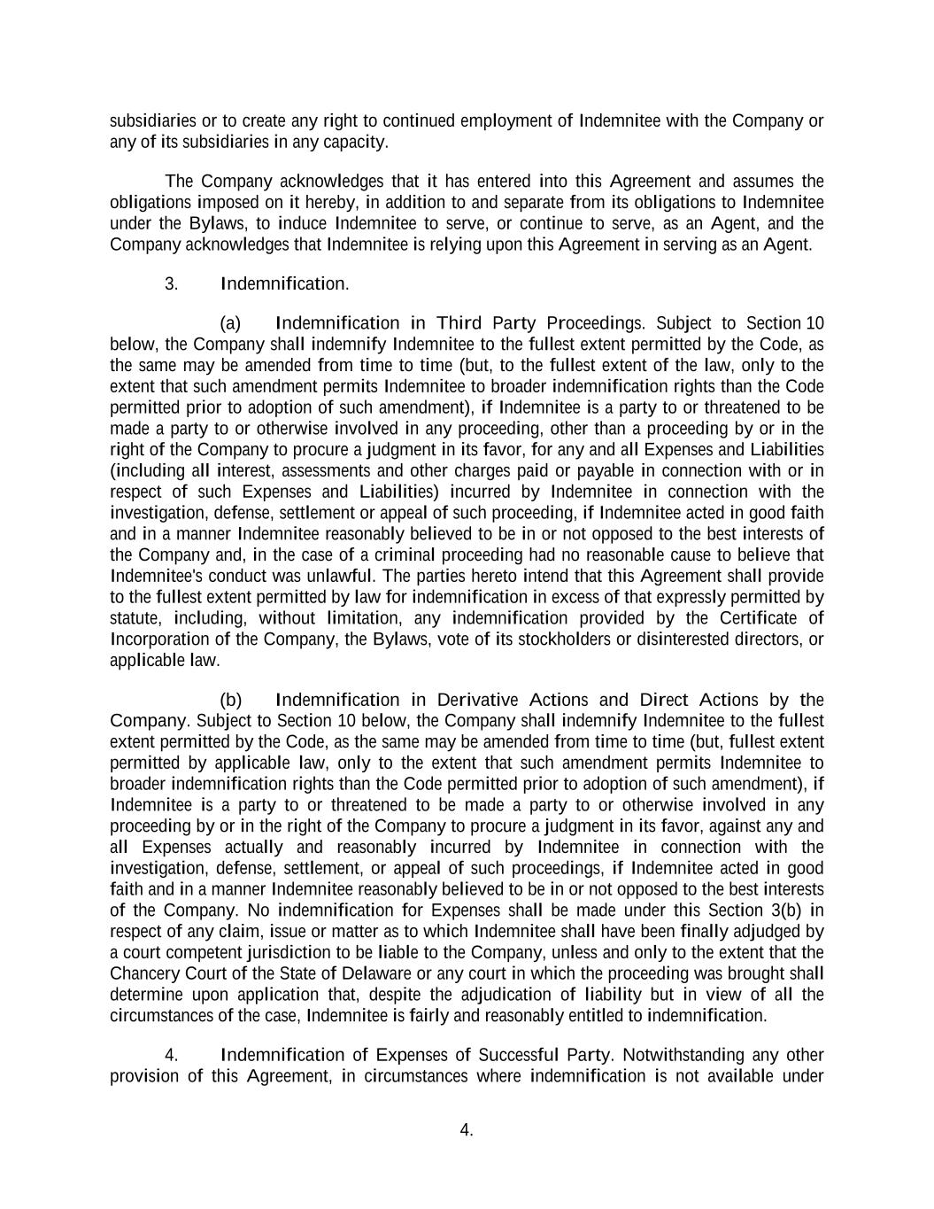
4. subsidiaries or to create any right to continued employment of Indemnitee with the Company or any of its subsidiaries in any capacity. The Company acknowledges that it has entered into this Agreement and assumes the obligations imposed on it hereby, in addition to and separate from its obligations to Indemnitee under the Bylaws, to induce Indemnitee to serve, or continue to serve, as an Agent, and the Company acknowledges that Indemnitee is relying upon this Agreement in serving as an Agent. 3. Indemnification. (a) Indemnification in Third Party Proceedings. Subject to Section 10 below, the Company shall indemnify Indemnitee to the fullest extent permitted by the Code, as the same may be amended from time to time (but, to the fullest extent of the law, only to the extent that such amendment permits Indemnitee to broader indemnification rights than the Code permitted prior to adoption of such amendment), if Indemnitee is a party to or threatened to be made a party to or otherwise involved in any proceeding, other than a proceeding by or in the right of the Company to procure a judgment in its favor, for any and all Expenses and Liabilities (including all interest, assessments and other charges paid or payable in connection with or in respect of such Expenses and Liabilities) incurred by Indemnitee in connection with the investigation, defense, settlement or appeal of such proceeding, if Indemnitee acted in good faith and in a manner Indemnitee reasonably believed to be in or not opposed to the best interests of the Company and, in the case of a criminal proceeding had no reasonable cause to believe that Indemnitee's conduct was unlawful. The parties hereto intend that this Agreement shall provide to the fullest extent permitted by law for indemnification in excess of that expressly permitted by statute, including, without limitation, any indemnification provided by the Certificate of Incorporation of the Company, the Bylaws, vote of its stockholders or disinterested directors, or applicable law. (b) Indemnification in Derivative Actions and Direct Actions by the Company. Subject to Section 10 below, the Company shall indemnify Indemnitee to the fullest extent permitted by the Code, as the same may be amended from time to time (but, fullest extent permitted by applicable law, only to the extent that such amendment permits Indemnitee to broader indemnification rights than the Code permitted prior to adoption of such amendment), if Indemnitee is a party to or threatened to be made a party to or otherwise involved in any proceeding by or in the right of the Company to procure a judgment in its favor, against any and all Expenses actually and reasonably incurred by Indemnitee in connection with the investigation, defense, settlement, or appeal of such proceedings, if Indemnitee acted in good faith and in a manner Indemnitee reasonably believed to be in or not opposed to the best interests of the Company. No indemnification for Expenses shall be made under this Section 3(b) in respect of any claim, issue or matter as to which Indemnitee shall have been finally adjudged by a court competent jurisdiction to be liable to the Company, unless and only to the extent that the Chancery Court of the State of Delaware or any court in which the proceeding was brought shall determine upon application that, despite the adjudication of liability but in view of all the circumstances of the case, Indemnitee is fairly and reasonably entitled to indemnification. 4. Indemnification of Expenses of Successful Party. Notwithstanding any other provision of this Agreement, in circumstances where indemnification is not available under

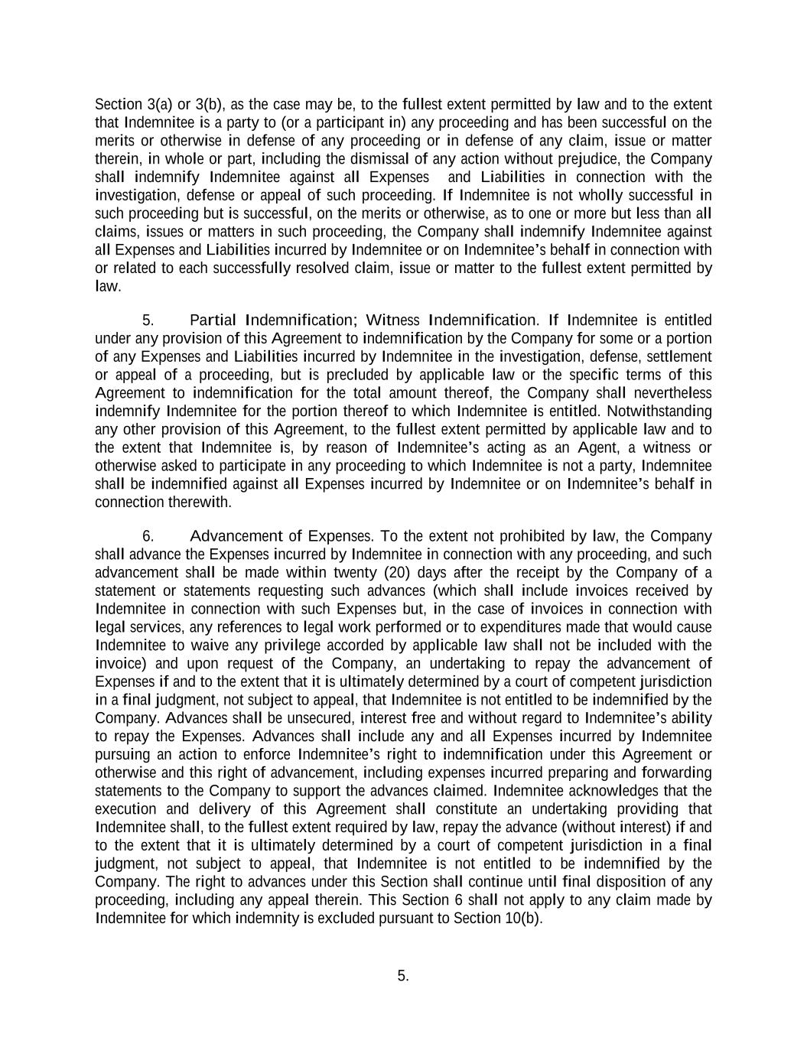
5. Section 3(a) or 3(b), as the case may be, to the fullest extent permitted by law and to the extent that Indemnitee is a party to (or a participant in) any proceeding and has been successful on the merits or otherwise in defense of any proceeding or in defense of any claim, issue or matter therein, in whole or part, including the dismissal of any action without prejudice, the Company shall indemnify Indemnitee against all Expenses and Liabilities in connection with the investigation, defense or appeal of such proceeding. If Indemnitee is not wholly successful in such proceeding but is successful, on the merits or otherwise, as to one or more but less than all claims, issues or matters in such proceeding, the Company shall indemnify Indemnitee against all Expenses and Liabilities incurred by Indemnitee or on Indemnitee’s behalf in connection with or related to each successfully resolved claim, issue or matter to the fullest extent permitted by law. 5. Partial Indemnification; Witness Indemnification. If Indemnitee is entitled under any provision of this Agreement to indemnification by the Company for some or a portion of any Expenses and Liabilities incurred by Indemnitee in the investigation, defense, settlement or appeal of a proceeding, but is precluded by applicable law or the specific terms of this Agreement to indemnification for the total amount thereof, the Company shall nevertheless indemnify Indemnitee for the portion thereof to which Indemnitee is entitled. Notwithstanding any other provision of this Agreement, to the fullest extent permitted by applicable law and to the extent that Indemnitee is, by reason of Indemnitee’s acting as an Agent, a witness or otherwise asked to participate in any proceeding to which Indemnitee is not a party, Indemnitee shall be indemnified against all Expenses incurred by Indemnitee or on Indemnitee’s behalf in connection therewith. 6. Advancement of Expenses. To the extent not prohibited by law, the Company shall advance the Expenses incurred by Indemnitee in connection with any proceeding, and such advancement shall be made within twenty (20) days after the receipt by the Company of a statement or statements requesting such advances (which shall include invoices received by Indemnitee in connection with such Expenses but, in the case of invoices in connection with legal services, any references to legal work performed or to expenditures made that would cause Indemnitee to waive any privilege accorded by applicable law shall not be included with the invoice) and upon request of the Company, an undertaking to repay the advancement of Expenses if and to the extent that it is ultimately determined by a court of competent jurisdiction in a final judgment, not subject to appeal, that Indemnitee is not entitled to be indemnified by the Company. Advances shall be unsecured, interest free and without regard to Indemnitee’s ability to repay the Expenses. Advances shall include any and all Expenses incurred by Indemnitee pursuing an action to enforce Indemnitee’s right to indemnification under this Agreement or otherwise and this right of advancement, including expenses incurred preparing and forwarding statements to the Company to support the advances claimed. Indemnitee acknowledges that the execution and delivery of this Agreement shall constitute an undertaking providing that Indemnitee shall, to the fullest extent required by law, repay the advance (without interest) if and to the extent that it is ultimately determined by a court of competent jurisdiction in a final judgment, not subject to appeal, that Indemnitee is not entitled to be indemnified by the Company. The right to advances under this Section shall continue until final disposition of any proceeding, including any appeal therein. This Section 6 shall not apply to any claim made by Indemnitee for which indemnity is excluded pursuant to Section 10(b).

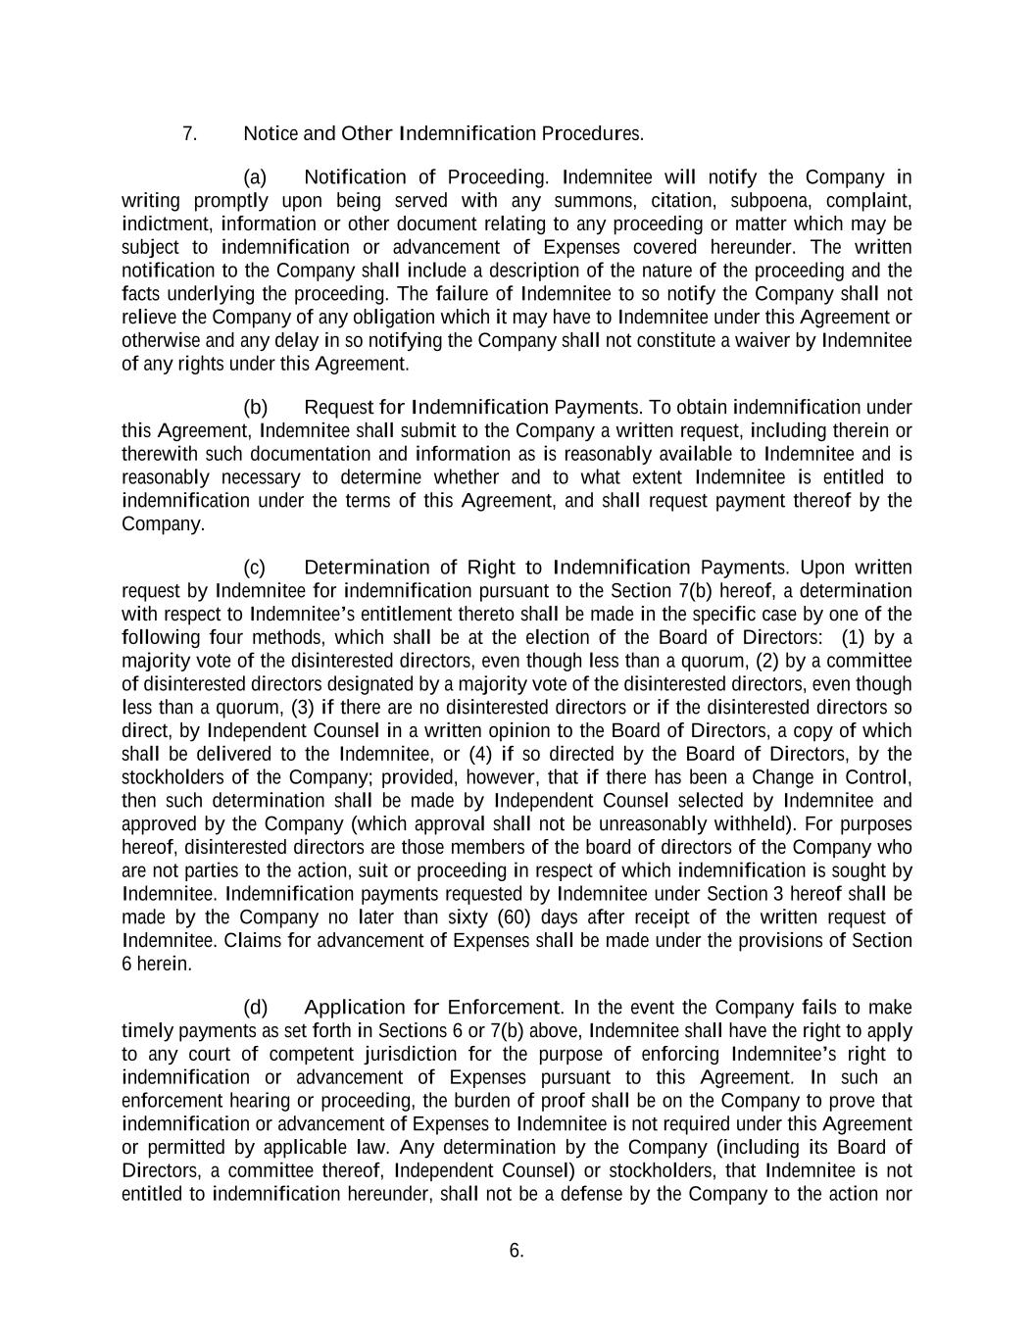
6. 7. Notice and Other Indemnification Procedures. (a) Notification of Proceeding. Indemnitee will notify the Company in writing promptly upon being served with any summons, citation, subpoena, complaint, indictment, information or other document relating to any proceeding or matter which may be subject to indemnification or advancement of Expenses covered hereunder. The written notification to the Company shall include a description of the nature of the proceeding and the facts underlying the proceeding. The failure of Indemnitee to so notify the Company shall not relieve the Company of any obligation which it may have to Indemnitee under this Agreement or otherwise and any delay in so notifying the Company shall not constitute a waiver by Indemnitee of any rights under this Agreement. (b) Request for Indemnification Payments. To obtain indemnification under this Agreement, Indemnitee shall submit to the Company a written request, including therein or therewith such documentation and information as is reasonably available to Indemnitee and is reasonably necessary to determine whether and to what extent Indemnitee is entitled to indemnification under the terms of this Agreement, and shall request payment thereof by the Company. (c) Determination of Right to Indemnification Payments. Upon written request by Indemnitee for indemnification pursuant to the Section 7(b) hereof, a determination with respect to Indemnitee’s entitlement thereto shall be made in the specific case by one of the following four methods, which shall be at the election of the Board of Directors: (1) by a majority vote of the disinterested directors, even though less than a quorum, (2) by a committee of disinterested directors designated by a majority vote of the disinterested directors, even though less than a quorum, (3) if there are no disinterested directors or if the disinterested directors so direct, by Independent Counsel in a written opinion to the Board of Directors, a copy of which shall be delivered to the Indemnitee, or (4) if so directed by the Board of Directors, by the stockholders of the Company; provided, however, that if there has been a Change in Control, then such determination shall be made by Independent Counsel selected by Indemnitee and approved by the Company (which approval shall not be unreasonably withheld). For purposes hereof, disinterested directors are those members of the board of directors of the Company who are not parties to the action, suit or proceeding in respect of which indemnification is sought by Indemnitee. Indemnification payments requested by Indemnitee under Section 3 hereof shall be made by the Company no later than sixty (60) days after receipt of the written request of Indemnitee. Claims for advancement of Expenses shall be made under the provisions of Section 6 herein. (d) Application for Enforcement. In the event the Company fails to make timely payments as set forth in Sections 6 or 7(b) above, Indemnitee shall have the right to apply to any court of competent jurisdiction for the purpose of enforcing Indemnitee’s right to indemnification or advancement of Expenses pursuant to this Agreement. In such an enforcement hearing or proceeding, the burden of proof shall be on the Company to prove that indemnification or advancement of Expenses to Indemnitee is not required under this Agreement or permitted by applicable law. Any determination by the Company (including its Board of Directors, a committee thereof, Independent Counsel) or stockholders, that Indemnitee is not entitled to indemnification hereunder, shall not be a defense by the Company to the action nor

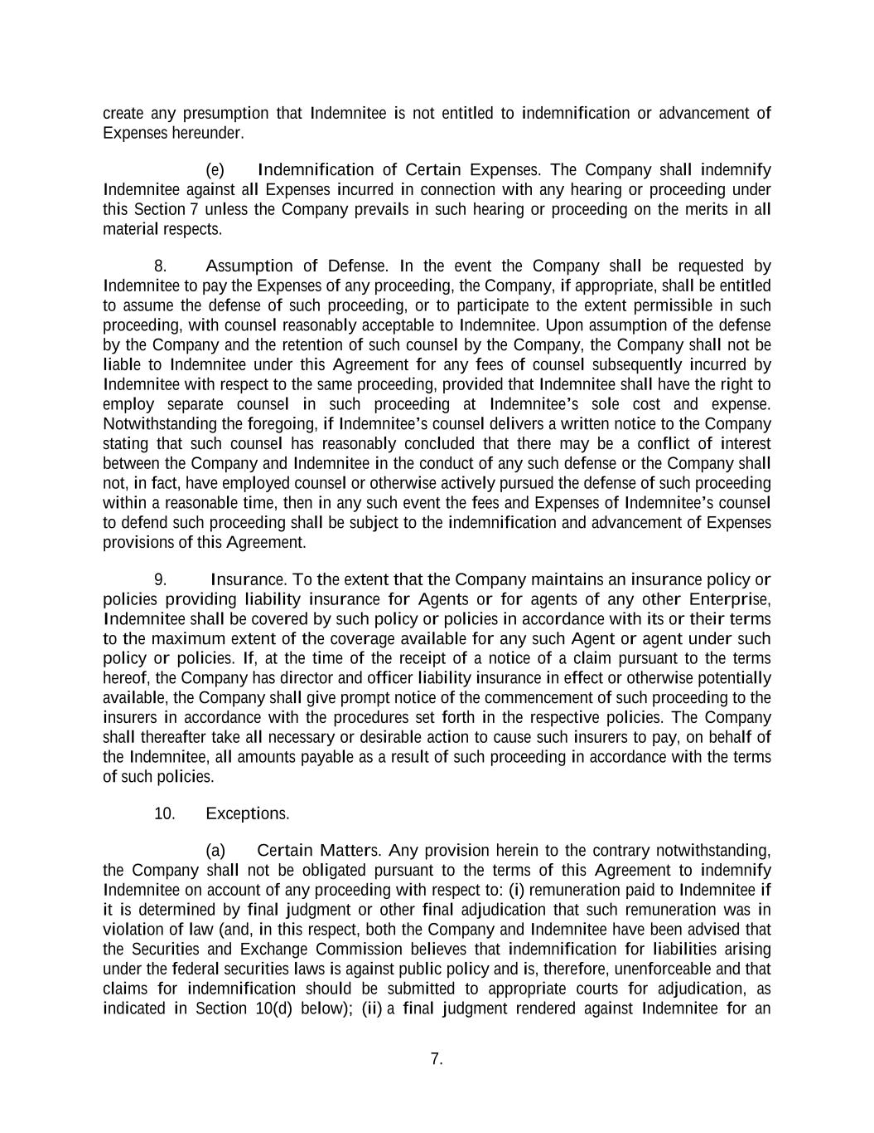
7. create any presumption that Indemnitee is not entitled to indemnification or advancement of Expenses hereunder. (e) Indemnification of Certain Expenses. The Company shall indemnify Indemnitee against all Expenses incurred in connection with any hearing or proceeding under this Section 7 unless the Company prevails in such hearing or proceeding on the merits in all material respects. 8. Assumption of Defense. In the event the Company shall be requested by Indemnitee to pay the Expenses of any proceeding, the Company, if appropriate, shall be entitled to assume the defense of such proceeding, or to participate to the extent permissible in such proceeding, with counsel reasonably acceptable to Indemnitee. Upon assumption of the defense by the Company and the retention of such counsel by the Company, the Company shall not be liable to Indemnitee under this Agreement for any fees of counsel subsequently incurred by Indemnitee with respect to the same proceeding, provided that Indemnitee shall have the right to employ separate counsel in such proceeding at Indemnitee’s sole cost and expense. Notwithstanding the foregoing, if Indemnitee’s counsel delivers a written notice to the Company stating that such counsel has reasonably concluded that there may be a conflict of interest between the Company and Indemnitee in the conduct of any such defense or the Company shall not, in fact, have employed counsel or otherwise actively pursued the defense of such proceeding within a reasonable time, then in any such event the fees and Expenses of Indemnitee’s counsel to defend such proceeding shall be subject to the indemnification and advancement of Expenses provisions of this Agreement. 9. Insurance. To the extent that the Company maintains an insurance policy or policies providing liability insurance for Agents or for agents of any other Enterprise, Indemnitee shall be covered by such policy or policies in accordance with its or their terms to the maximum extent of the coverage available for any such Agent or agent under such policy or policies. If, at the time of the receipt of a notice of a claim pursuant to the terms hereof, the Company has director and officer liability insurance in effect or otherwise potentially available, the Company shall give prompt notice of the commencement of such proceeding to the insurers in accordance with the procedures set forth in the respective policies. The Company shall thereafter take all necessary or desirable action to cause such insurers to pay, on behalf of the Indemnitee, all amounts payable as a result of such proceeding in accordance with the terms of such policies. 10. Exceptions. (a) Certain Matters. Any provision herein to the contrary notwithstanding, the Company shall not be obligated pursuant to the terms of this Agreement to indemnify Indemnitee on account of any proceeding with respect to: (i) remuneration paid to Indemnitee if it is determined by final judgment or other final adjudication that such remuneration was in violation of law (and, in this respect, both the Company and Indemnitee have been advised that the Securities and Exchange Commission believes that indemnification for liabilities arising under the federal securities laws is against public policy and is, therefore, unenforceable and that claims for indemnification should be submitted to appropriate courts for adjudication, as indicated in Section 10(d) below); (ii) a final judgment rendered against Indemnitee for an

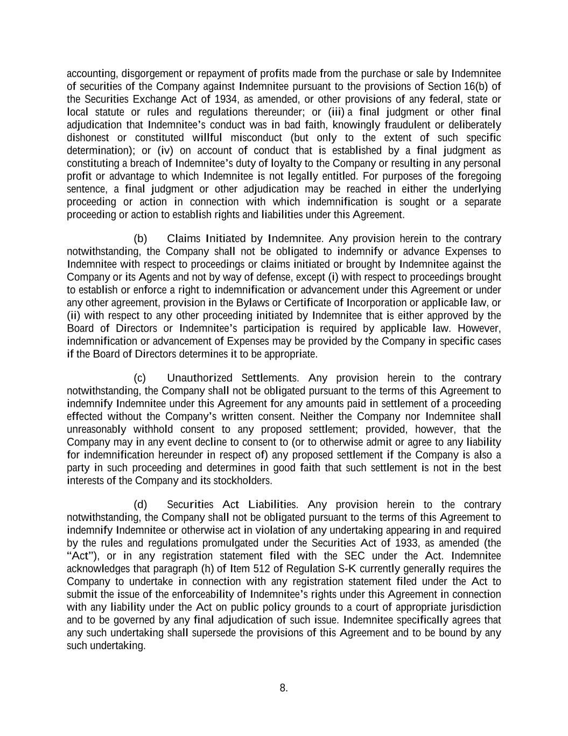
8. accounting, disgorgement or repayment of profits made from the purchase or sale by Indemnitee of securities of the Company against Indemnitee pursuant to the provisions of Section 16(b) of the Securities Exchange Act of 1934, as amended, or other provisions of any federal, state or local statute or rules and regulations thereunder; or (iii) a final judgment or other final adjudication that Indemnitee’s conduct was in bad faith, knowingly fraudulent or deliberately dishonest or constituted willful misconduct (but only to the extent of such specific determination); or (iv) on account of conduct that is established by a final judgment as constituting a breach of Indemnitee’s duty of loyalty to the Company or resulting in any personal profit or advantage to which Indemnitee is not legally entitled. For purposes of the foregoing sentence, a final judgment or other adjudication may be reached in either the underlying proceeding or action in connection with which indemnification is sought or a separate proceeding or action to establish rights and liabilities under this Agreement. (b) Claims Initiated by Indemnitee. Any provision herein to the contrary notwithstanding, the Company shall not be obligated to indemnify or advance Expenses to Indemnitee with respect to proceedings or claims initiated or brought by Indemnitee against the Company or its Agents and not by way of defense, except (i) with respect to proceedings brought to establish or enforce a right to indemnification or advancement under this Agreement or under any other agreement, provision in the Bylaws or Certificate of Incorporation or applicable law, or (ii) with respect to any other proceeding initiated by Indemnitee that is either approved by the Board of Directors or Indemnitee’s participation is required by applicable law. However, indemnification or advancement of Expenses may be provided by the Company in specific cases if the Board of Directors determines it to be appropriate. (c) Unauthorized Settlements. Any provision herein to the contrary notwithstanding, the Company shall not be obligated pursuant to the terms of this Agreement to indemnify Indemnitee under this Agreement for any amounts paid in settlement of a proceeding effected without the Company’s written consent. Neither the Company nor Indemnitee shall unreasonably withhold consent to any proposed settlement; provided, however, that the Company may in any event decline to consent to (or to otherwise admit or agree to any liability for indemnification hereunder in respect of) any proposed settlement if the Company is also a party in such proceeding and determines in good faith that such settlement is not in the best interests of the Company and its stockholders. (d) Securities Act Liabilities. Any provision herein to the contrary notwithstanding, the Company shall not be obligated pursuant to the terms of this Agreement to indemnify Indemnitee or otherwise act in violation of any undertaking appearing in and required by the rules and regulations promulgated under the Securities Act of 1933, as amended (the “Act”), or in any registration statement filed with the SEC under the Act. Indemnitee acknowledges that paragraph (h) of Item 512 of Regulation S-K currently generally requires the Company to undertake in connection with any registration statement filed under the Act to submit the issue of the enforceability of Indemnitee’s rights under this Agreement in connection with any liability under the Act on public policy grounds to a court of appropriate jurisdiction and to be governed by any final adjudication of such issue. Indemnitee specifically agrees that any such undertaking shall supersede the provisions of this Agreement and to be bound by any such undertaking.

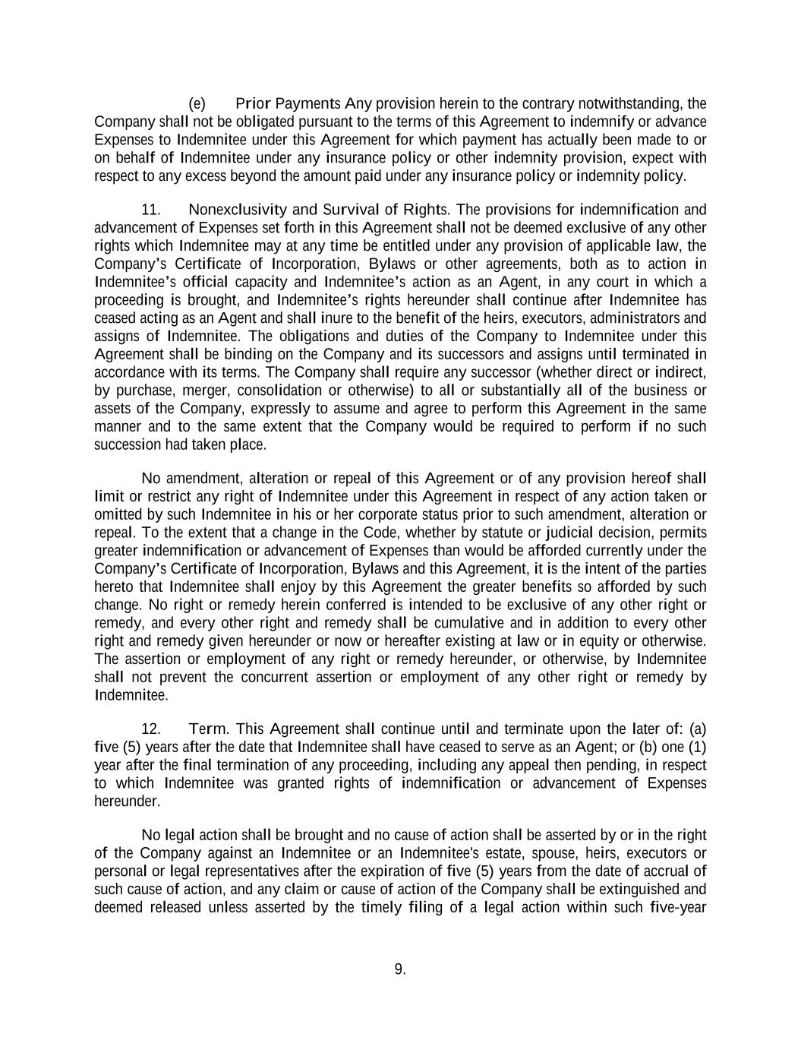
9. (e) Prior Payments Any provision herein to the contrary notwithstanding, the Company shall not be obligated pursuant to the terms of this Agreement to indemnify or advance Expenses to Indemnitee under this Agreement for which payment has actually been made to or on behalf of Indemnitee under any insurance policy or other indemnity provision, expect with respect to any excess beyond the amount paid under any insurance policy or indemnity policy. 11. Nonexclusivity and Survival of Rights. The provisions for indemnification and advancement of Expenses set forth in this Agreement shall not be deemed exclusive of any other rights which Indemnitee may at any time be entitled under any provision of applicable law, the Company’s Certificate of Incorporation, Bylaws or other agreements, both as to action in Indemnitee’s official capacity and Indemnitee’s action as an Agent, in any court in which a proceeding is brought, and Indemnitee’s rights hereunder shall continue after Indemnitee has ceased acting as an Agent and shall inure to the benefit of the heirs, executors, administrators and assigns of Indemnitee. The obligations and duties of the Company to Indemnitee under this Agreement shall be binding on the Company and its successors and assigns until terminated in accordance with its terms. The Company shall require any successor (whether direct or indirect, by purchase, merger, consolidation or otherwise) to all or substantially all of the business or assets of the Company, expressly to assume and agree to perform this Agreement in the same manner and to the same extent that the Company would be required to perform if no such succession had taken place. No amendment, alteration or repeal of this Agreement or of any provision hereof shall limit or restrict any right of Indemnitee under this Agreement in respect of any action taken or omitted by such Indemnitee in his or her corporate status prior to such amendment, alteration or repeal. To the extent that a change in the Code, whether by statute or judicial decision, permits greater indemnification or advancement of Expenses than would be afforded currently under the Company’s Certificate of Incorporation, Bylaws and this Agreement, it is the intent of the parties hereto that Indemnitee shall enjoy by this Agreement the greater benefits so afforded by such change. No right or remedy herein conferred is intended to be exclusive of any other right or remedy, and every other right and remedy shall be cumulative and in addition to every other right and remedy given hereunder or now or hereafter existing at law or in equity or otherwise. The assertion or employment of any right or remedy hereunder, or otherwise, by Indemnitee shall not prevent the concurrent assertion or employment of any other right or remedy by Indemnitee. 12. Term. This Agreement shall continue until and terminate upon the later of: (a) five (5) years after the date that Indemnitee shall have ceased to serve as an Agent; or (b) one (1) year after the final termination of any proceeding, including any appeal then pending, in respect to which Indemnitee was granted rights of indemnification or advancement of Expenses hereunder. No legal action shall be brought and no cause of action shall be asserted by or in the right of the Company against an Indemnitee or an Indemnitee's estate, spouse, heirs, executors or personal or legal representatives after the expiration of five (5) years from the date of accrual of such cause of action, and any claim or cause of action of the Company shall be extinguished and deemed released unless asserted by the timely filing of a legal action within such five-year

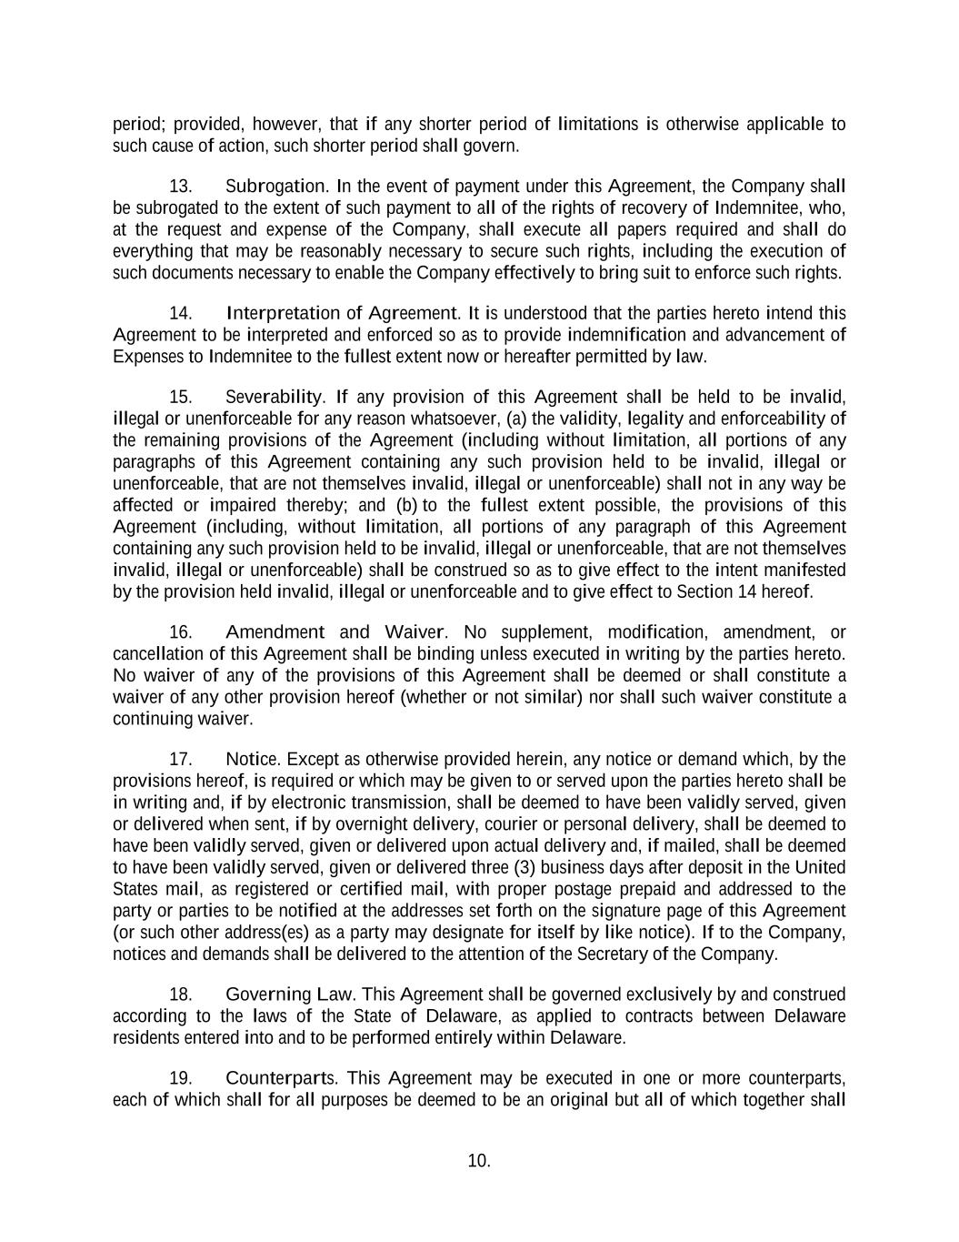
10. period; provided, however, that if any shorter period of limitations is otherwise applicable to such cause of action, such shorter period shall govern. 13. Subrogation. In the event of payment under this Agreement, the Company shall be subrogated to the extent of such payment to all of the rights of recovery of Indemnitee, who, at the request and expense of the Company, shall execute all papers required and shall do everything that may be reasonably necessary to secure such rights, including the execution of such documents necessary to enable the Company effectively to bring suit to enforce such rights. 14. Interpretation of Agreement. It is understood that the parties hereto intend this Agreement to be interpreted and enforced so as to provide indemnification and advancement of Expenses to Indemnitee to the fullest extent now or hereafter permitted by law. 15. Severability. If any provision of this Agreement shall be held to be invalid, illegal or unenforceable for any reason whatsoever, (a) the validity, legality and enforceability of the remaining provisions of the Agreement (including without limitation, all portions of any paragraphs of this Agreement containing any such provision held to be invalid, illegal or unenforceable, that are not themselves invalid, illegal or unenforceable) shall not in any way be affected or impaired thereby; and (b) to the fullest extent possible, the provisions of this Agreement (including, without limitation, all portions of any paragraph of this Agreement containing any such provision held to be invalid, illegal or unenforceable, that are not themselves invalid, illegal or unenforceable) shall be construed so as to give effect to the intent manifested by the provision held invalid, illegal or unenforceable and to give effect to Section 14 hereof. 16. Amendment and Waiver. No supplement, modification, amendment, or cancellation of this Agreement shall be binding unless executed in writing by the parties hereto. No waiver of any of the provisions of this Agreement shall be deemed or shall constitute a waiver of any other provision hereof (whether or not similar) nor shall such waiver constitute a continuing waiver. 17. Notice. Except as otherwise provided herein, any notice or demand which, by the provisions hereof, is required or which may be given to or served upon the parties hereto shall be in writing and, if by electronic transmission, shall be deemed to have been validly served, given or delivered when sent, if by overnight delivery, courier or personal delivery, shall be deemed to have been validly served, given or delivered upon actual delivery and, if mailed, shall be deemed to have been validly served, given or delivered three (3) business days after deposit in the United States mail, as registered or certified mail, with proper postage prepaid and addressed to the party or parties to be notified at the addresses set forth on the signature page of this Agreement (or such other address(es) as a party may designate for itself by like notice). If to the Company, notices and demands shall be delivered to the attention of the Secretary of the Company. 18. Governing Law. This Agreement shall be governed exclusively by and construed according to the laws of the State of Delaware, as applied to contracts between Delaware residents entered into and to be performed entirely within Delaware. 19. Counterparts. This Agreement may be executed in one or more counterparts, each of which shall for all purposes be deemed to be an original but all of which together shall

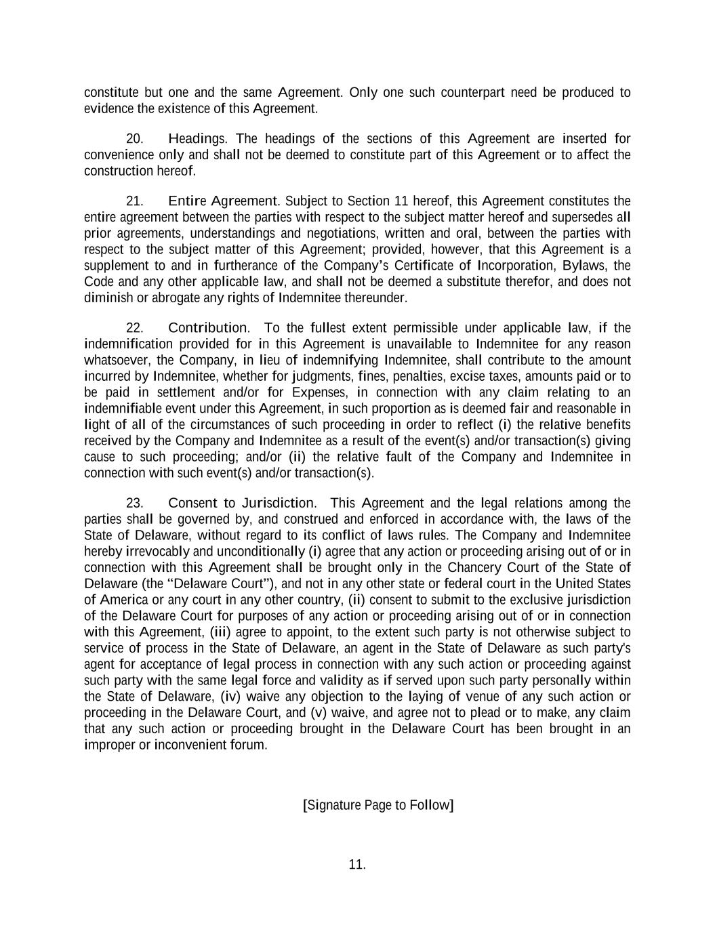
11. constitute but one and the same Agreement. Only one such counterpart need be produced to evidence the existence of this Agreement. 20. Headings. The headings of the sections of this Agreement are inserted for convenience only and shall not be deemed to constitute part of this Agreement or to affect the construction hereof. 21. Entire Agreement. Subject to Section 11 hereof, this Agreement constitutes the entire agreement between the parties with respect to the subject matter hereof and supersedes all prior agreements, understandings and negotiations, written and oral, between the parties with respect to the subject matter of this Agreement; provided, however, that this Agreement is a supplement to and in furtherance of the Company’s Certificate of Incorporation, Bylaws, the Code and any other applicable law, and shall not be deemed a substitute therefor, and does not diminish or abrogate any rights of Indemnitee thereunder. 22. Contribution. To the fullest extent permissible under applicable law, if the indemnification provided for in this Agreement is unavailable to Indemnitee for any reason whatsoever, the Company, in lieu of indemnifying Indemnitee, shall contribute to the amount incurred by Indemnitee, whether for judgments, fines, penalties, excise taxes, amounts paid or to be paid in settlement and/or for Expenses, in connection with any claim relating to an indemnifiable event under this Agreement, in such proportion as is deemed fair and reasonable in light of all of the circumstances of such proceeding in order to reflect (i) the relative benefits received by the Company and Indemnitee as a result of the event(s) and/or transaction(s) giving cause to such proceeding; and/or (ii) the relative fault of the Company and Indemnitee in connection with such event(s) and/or transaction(s). 23. Consent to Jurisdiction. This Agreement and the legal relations among the parties shall be governed by, and construed and enforced in accordance with, the laws of the State of Delaware, without regard to its conflict of laws rules. The Company and Indemnitee hereby irrevocably and unconditionally (i) agree that any action or proceeding arising out of or in connection with this Agreement shall be brought only in the Chancery Court of the State of Delaware (the “Delaware Court”), and not in any other state or federal court in the United States of America or any court in any other country, (ii) consent to submit to the exclusive jurisdiction of the Delaware Court for purposes of any action or proceeding arising out of or in connection with this Agreement, (iii) agree to appoint, to the extent such party is not otherwise subject to service of process in the State of Delaware, an agent in the State of Delaware as such party's agent for acceptance of legal process in connection with any such action or proceeding against such party with the same legal force and validity as if served upon such party personally within the State of Delaware, (iv) waive any objection to the laying of venue of any such action or proceeding in the Delaware Court, and (v) waive, and agree not to plead or to make, any claim that any such action or proceeding brought in the Delaware Court has been brought in an improper or inconvenient forum. [Signature Page to Follow]

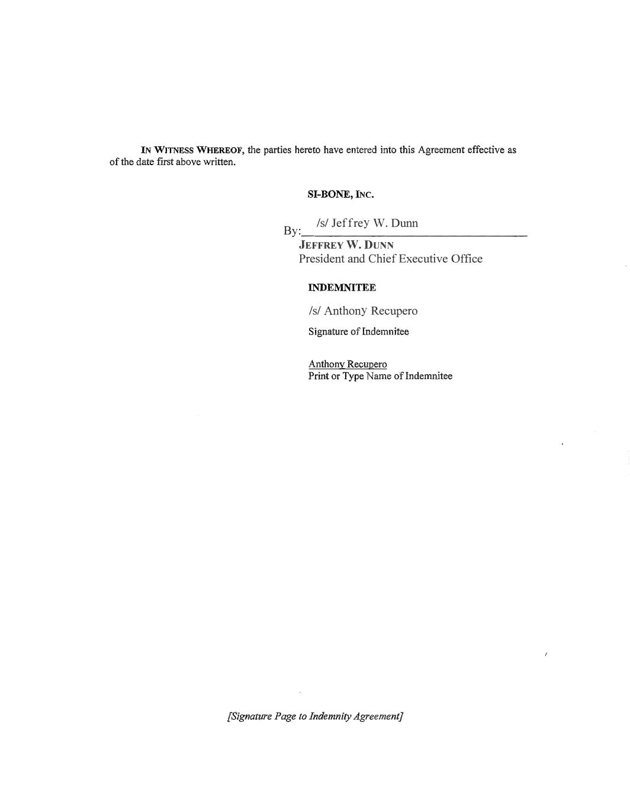
IN WITNESS WHEREOF, the parties hereto have entered into this Agreement effective as of the date first above written. SI-BONE, INC. INDEMNITEE Signature of Indem11itee Anthony Recupero Print or Type Name oflndemnitee [Signature Page to Indemnity Agreement] By: _______________ _ JEFFREY W. DUNN President and Chief Executive Office /s/ Jeffrey W. Dunn /s/ Anthony Recupero

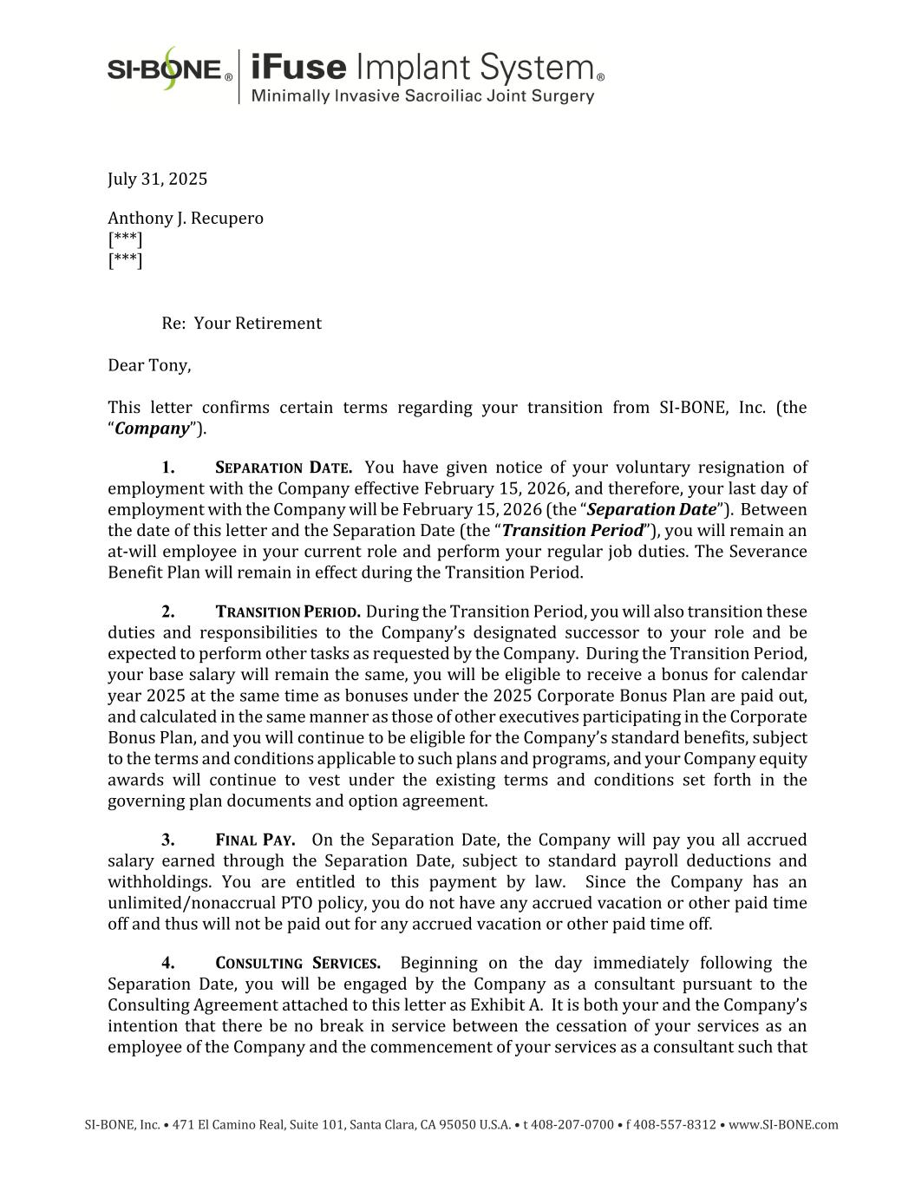
SI-BONE, Inc. • 471 El Camino Real, Suite 101, Santa Clara, CA 95050 U.S.A. • t 408-207-0700 • f 408-557-8312 • www.SI-BONE.com July 31, 2025 Anthony J. Recupero [***] [***] Re: Your Retirement Dear Tony, This letter confirms certain terms regarding your transition from SI-BONE, Inc. (the “Company”). 1. SEPARATION DATE. You have given notice of your voluntary resignation of employment with the Company effective February 15, 2026, and therefore, your last day of employment with the Company will be February 15, 2026 (the “Separation Date”). Between the date of this letter and the Separation Date (the “Transition Period”), you will remain an at-will employee in your current role and perform your regular job duties. The Severance Benefit Plan will remain in effect during the Transition Period. 2. TRANSITION PERIOD. During the Transition Period, you will also transition these duties and responsibilities to the Company’s designated successor to your role and be expected to perform other tasks as requested by the Company. During the Transition Period, your base salary will remain the same, you will be eligible to receive a bonus for calendar year 2025 at the same time as bonuses under the 2025 Corporate Bonus Plan are paid out, and calculated in the same manner as those of other executives participating in the Corporate Bonus Plan, and you will continue to be eligible for the Company’s standard benefits, subject to the terms and conditions applicable to such plans and programs, and your Company equity awards will continue to vest under the existing terms and conditions set forth in the governing plan documents and option agreement. 3. FINAL PAY. On the Separation Date, the Company will pay you all accrued salary earned through the Separation Date, subject to standard payroll deductions and withholdings. You are entitled to this payment by law. Since the Company has an unlimited/nonaccrual PTO policy, you do not have any accrued vacation or other paid time off and thus will not be paid out for any accrued vacation or other paid time off. 4. CONSULTING SERVICES. Beginning on the day immediately following the Separation Date, you will be engaged by the Company as a consultant pursuant to the Consulting Agreement attached to this letter as Exhibit A. It is both your and the Company’s intention that there be no break in service between the cessation of your services as an employee of the Company and the commencement of your services as a consultant such that

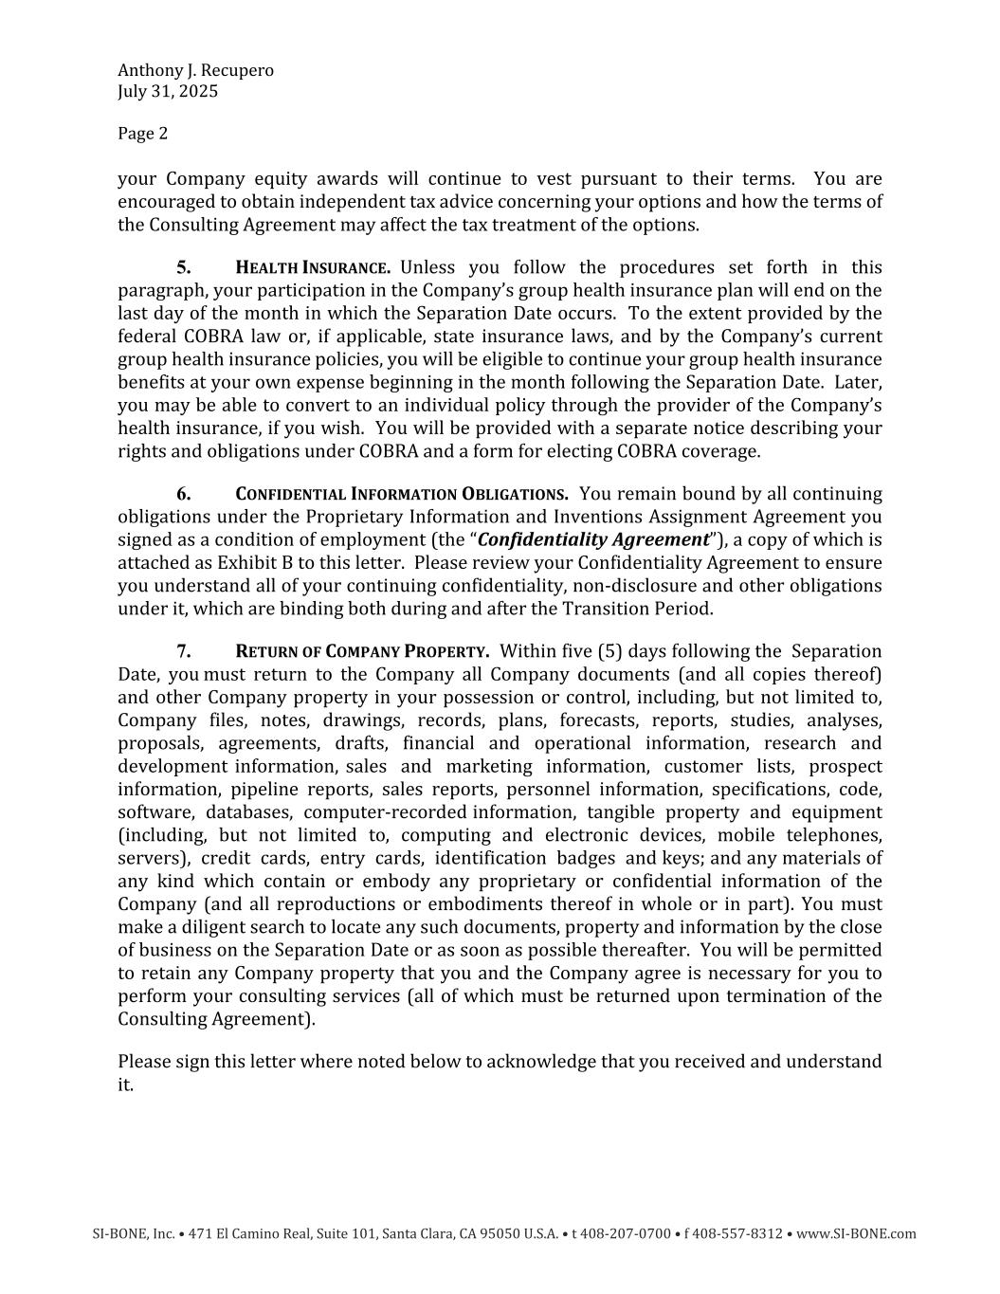
Anthony J. Recupero July 31, 2025 Page 2 SI-BONE, Inc. • 471 El Camino Real, Suite 101, Santa Clara, CA 95050 U.S.A. • t 408-207-0700 • f 408-557-8312 • www.SI-BONE.com your Company equity awards will continue to vest pursuant to their terms. You are encouraged to obtain independent tax advice concerning your options and how the terms of the Consulting Agreement may affect the tax treatment of the options. 5. HEALTH INSURANCE. Unless you follow the procedures set forth in this paragraph, your participation in the Company’s group health insurance plan will end on the last day of the month in which the Separation Date occurs. To the extent provided by the federal COBRA law or, if applicable, state insurance laws, and by the Company’s current group health insurance policies, you will be eligible to continue your group health insurance benefits at your own expense beginning in the month following the Separation Date. Later, you may be able to convert to an individual policy through the provider of the Company’s health insurance, if you wish. You will be provided with a separate notice describing your rights and obligations under COBRA and a form for electing COBRA coverage. 6. CONFIDENTIAL INFORMATION OBLIGATIONS. You remain bound by all continuing obligations under the Proprietary Information and Inventions Assignment Agreement you signed as a condition of employment (the “Confidentiality Agreement”), a copy of which is attached as Exhibit B to this letter. Please review your Confidentiality Agreement to ensure you understand all of your continuing confidentiality, non-disclosure and other obligations under it, which are binding both during and after the Transition Period. 7. RETURN OF COMPANY PROPERTY. Within five (5) days following the Separation Date, you must return to the Company all Company documents (and all copies thereof) and other Company property in your possession or control, including, but not limited to, Company files, notes, drawings, records, plans, forecasts, reports, studies, analyses, proposals, agreements, drafts, financial and operational information, research and development information, sales and marketing information, customer lists, prospect information, pipeline reports, sales reports, personnel information, specifications, code, software, databases, computer-recorded information, tangible property and equipment (including, but not limited to, computing and electronic devices, mobile telephones, servers), credit cards, entry cards, identification badges and keys; and any materials of any kind which contain or embody any proprietary or confidential information of the Company (and all reproductions or embodiments thereof in whole or in part). You must make a diligent search to locate any such documents, property and information by the close of business on the Separation Date or as soon as possible thereafter. You will be permitted to retain any Company property that you and the Company agree is necessary for you to perform your consulting services (all of which must be returned upon termination of the Consulting Agreement). Please sign this letter where noted below to acknowledge that you received and understand it.

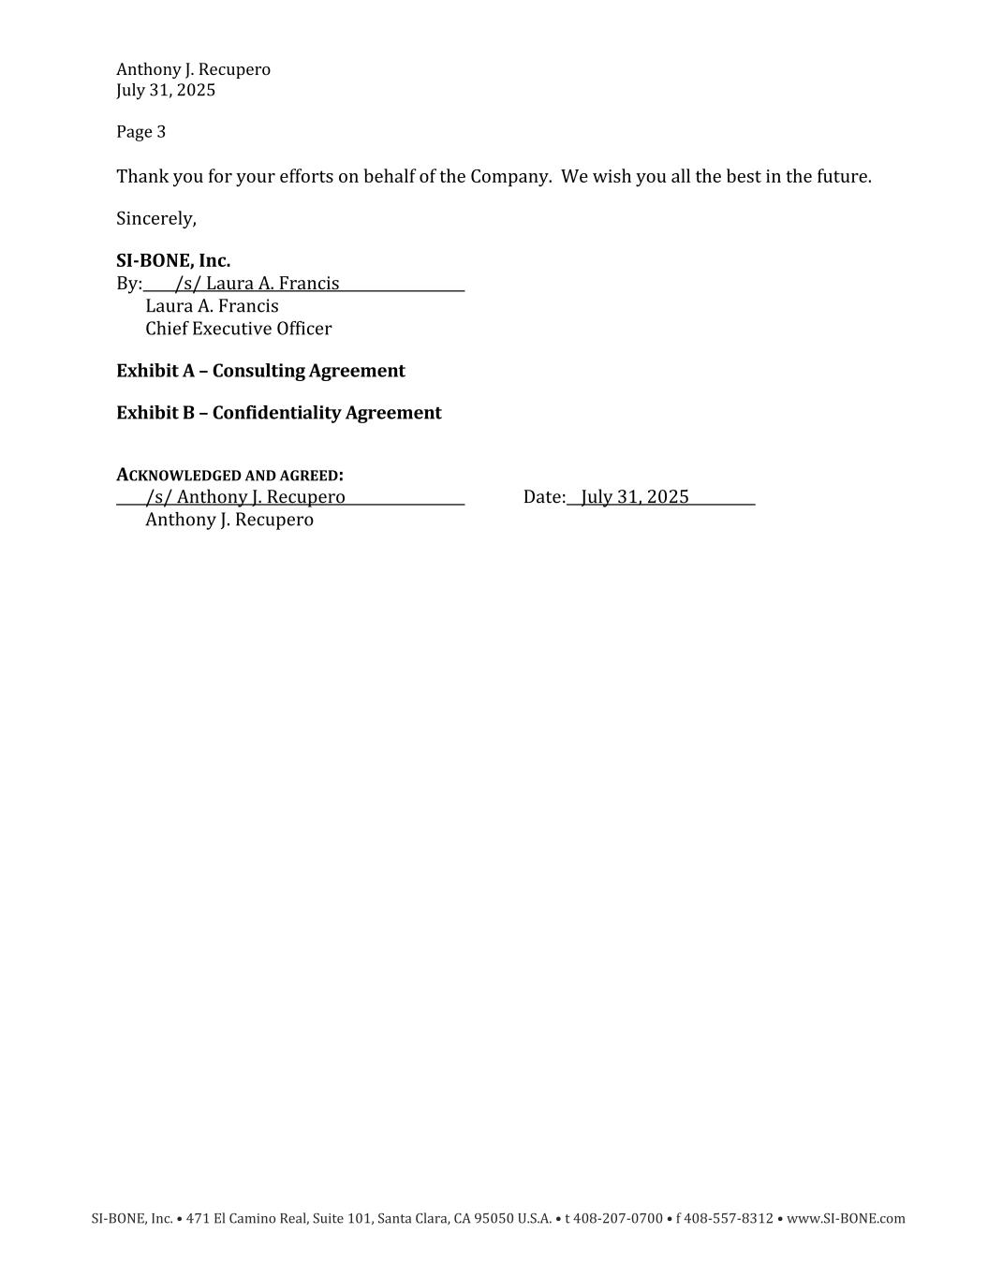
Anthony J. Recupero July 31, 2025 Page 3 SI-BONE, Inc. • 471 El Camino Real, Suite 101, Santa Clara, CA 95050 U.S.A. • t 408-207-0700 • f 408-557-8312 • www.SI-BONE.com Thank you for your efforts on behalf of the Company. We wish you all the best in the future. Sincerely, SI-BONE, Inc. By: /s/ Laura A. Francis Laura A. Francis Chief Executive Officer Exhibit A – Consulting Agreement Exhibit B – Confidentiality Agreement ACKNOWLEDGED AND AGREED: /s/ Anthony J. Recupero Date: July 31, 2025 Anthony J. Recupero


Exhibit A Consulting Agreement

1. CONSULTING AGREEMENT THIS CONSULTING AGREEMENT (the “Agreement”) by and between SI-BONE, Inc. (“Client”) and Anthony J. Recupero, an individual (“Consultant”) (Client and Consultant together, the “Parties”) is effective as of February 16, 2026 (the “Effective Date”). 1. Engagement of Services. Consultant agrees to provide the following consulting services and other services upon request of the Client (the “Services”). • Advise on the continued commercialization of the Company’s existing and planned future products; • Advise on the Company’s strategies regarding management of its Sales organization; • Provide positive encouragement and motivation of the Company’s Sales leadership and Sales organization in a manner consistent with the Company’s management team’s objectives; • Engage with targeted individual surgeons identified by the Company with which Consultant can aid in the Company’s sales efforts; and • Provide such other services that the Company and Consultant mutually agree shall further the Company’s business and the intent of this Agreement. Consultant agrees to exercise the highest degree of professionalism and utilize their expertise and creative talents in performing these Services. 2. Compensation. Consultant shall be paid a monthly retainer amount of $12,500 commencing on the date one month following the Effective Date, with the final payment to be made on or promptly following the conclusion of Consultant’s Services hereunder. The Parties acknowledge that Consultant was previously an employee of Client and in such capacity was granted various equity awards under the Company’s equity incentive plans in respect of the common stock of the Company. The continued vesting of such equity awards will be considered additional consideration provided to Consultant for the Services. It is acknowledged and agreed there shall be no break in service between the cessation of Consultant’s services as an employee of the Client and the commencement of Consultant’s services as a consultant such that Consultant’s Company equity awards will continue to vest pursuant to their terms during the term of this Agreement. The treatment of any outstanding equity awards shall be determined in accordance with the terms of the Stock option plans. Notwithstanding the foregoing, if, upon the closing of a Change in Control (as defined in Client’s 2018 Equity Incentive Plan, or “Equity Plan”) or following the closing of a Change in Control and prior to the expiration of this Agreement, Consultant’s services are terminated by the Company without Cause (as defined below) or by Consultant for Good Reason (as defined below), then, subject to Consultant’s execution of a general release of claims in favor of and in a form provided by Client, all of Consultant’s outstanding Stock Awards (as defined in the Equity Plan), shall vest and become exercisable effective as of the date of termination of this Agreement.

2. 3. Expenses and Liabilities. Consultant agrees that as an independent contractor, Consultant is solely responsible for all incidental expenses (and profits/losses) Consultant incurs in connection with the performance of the Services. Consultant understands that Consultant will not be reimbursed for any supplies, equipment, or operating costs, nor will these costs of doing business be defrayed in any way by the Client. In addition, the Client does not guarantee to Consultant that fees derived from Consultant’s business will exceed Consultant’s costs. Notwithstanding the foregoing, Client agrees to reimburse Consultant for any reasonable, documented, out-of-pocket costs and expenses, including costs of travel outside of the Bay Area and business meals incurred in connection with Company business, provided such activities relate directly to activities requested by Client. 4. Term and Termination. The term of this Agreement and the “Consulting Period” is from the Effective Date until the date one year following the Effective Date (the “Scheduled End Date”), unless earlier terminated as provided in this Agreement. During the Consulting Period, the Consultant’s Services hereunder may be terminated prior to the Scheduled End Date by Client or by Consultant only as provided in this Section 4 (an “Early Termination”). Upon an Early Termination, the Consultant shall be entitled to the compensation and benefits described in this Section 4 and shall have no further rights to any compensation or any other benefits from the Client or any of its affiliates. 4.1 Termination Initiated by Client. Client may terminate the Consultant at any time during the Consulting Period without Cause (as defined below). Should Client terminate the Consultant during the Consulting Period without Cause, or if Consultant should die or become physically or mentally incapacitated and therefore unable to perform the Services hereunder, then, subject to Consultant’s (or, in the event of Consultant’s death or physical or mental incapacity, Consultant’s estate’s or executor’s) execution of a general release of claims in favor of and in a form provided by Client, Consultant shall be due the monthly retainer amounts through the Scheduled End Date and the Client will accelerate any then-unvested equity awards held by Consultant that would otherwise vest solely with respect to time such that Consultant would be vested in such equity awards as if Consultant had remained engaged with Client as a Consultant through the Scheduled End Date. (a) Client may terminate the Consultant’s Services at any time during the Consulting Period with Cause as set forth herein with a Notice for Cause. For purposes of this Agreement, "Notice for Cause" means the giving of written notice by the Client of the termination of this Agreement upon the discharge of Consultant for Cause, as determined by Client’s Board of Directors acting in good faith, based upon facts reasonably believed it to be true, and not for any arbitrary, capricious, or illegal reason. This shall be the standard applied by any fact finder adjudicating any dispute as to “Cause” for termination of the Consulting Period by Client. The following are an exclusive list of conduct by the Consultant that is deemed "Cause" for termination:

3. (i) the Consultant's breach of this Agreement or material failure to perform his duties under this Agreement (other than any such failure resulting from incapacity due to physical or mental illness) after a written demand for substantial performance is delivered to the Consultant by the Client, which demand specifically identifies the manner in which the Client believes that the Consultant has not substantially performed the Consultant's duties, which failure or refusal is not remedied by the Consultant within thirty (30) days after the written notice from the Client; (ii) the Consultant's engagement in dishonesty, illegal conduct, or misconduct, which is, in each case, injurious to the Client or its affiliates; (iii) the Consultant's embezzlement, misappropriation, or fraud, whether or not related to the Consultant's Services with the Client; (iv) the Consultant's conviction of or plea of guilty or nolo contendere to a crime that constitutes a felony at federal or state law, or a crime that constitutes a misdemeanor involving moral turpitude, if such felony or other crime is work-related, impairs the Consultant's ability to perform services for the Client, or results in material, reputational or financial harm to the Client or its affiliates. 4.2 Termination Initiated by Consultant. Consultant may terminate the Consulting Period at any time, with or without Good Reason, as defined below. (a) Should Consultant terminate the Consulting Period without Good Reason, Consultant shall be entitled to receive the accrued sums due hereunder through the date of such termination and no further compensation accruing after the termination. (b) Consultant may terminate the Consulting Period with Good Reason at any time such condition may exist. For purposes of this Agreement, "Good Reason" shall mean the occurrence of any material breach by the Client of any material provision of this Agreement (which shall include an acquiror’s failure to assume the terms of this Agreement) or any material provision of any other agreement between the Consultant and the Client during the Services Term without the Consultant's written consent. In order to resign for Good Reason, Consultant must within 30 days after the first occurrence of the event giving rise to Good Reason provide written notice to the Client (including any Client acquiror) setting forth the basis for Consultant’s resignation, allow Client at least 30 days from receipt of such written notice to cure such event, and if such event is not reasonably cured within such period, Consultant must terminate this Agreement not later than 30 days after the expiration of the cure period. Should Consultant terminate Consultant’s Services at any time during the Consulting Period for Good Reason, then, subject to Consultant’s execution of a general release of claims in favor of and in a form provided

4. by Client, Consultant shall be due the monthly retainer amounts through the end of the Consulting Period and the Client will accelerate any then-unvested equity awards held by Consultant that vest solely with respect to time such that Consultant would be vested in such equity awards as if Consultant has remained engaged with Client as a Consultant through the Scheduled End Date. 4.3 Consultant’s Obligations Upon Termination. Upon any termination or expiration of this Agreement, Consultant (i) shall immediately discontinue all use of Client’s Confidential Information delivered under this Agreement; (ii) shall delete any such Client Confidential Information from Consultant’s computer storage or any other media; and (iii) shall return to Client, or, at Client’s option, destroy, all copies of such Confidential Information then in Consultant’s possession. 5. Non-Exclusivity. The Client reserves the right to engage other consultants to perform services, without giving Consultant a right of first refusal or any other exclusive rights. Consultant reserves the right to perform services for other persons, provided that the performance of such services are not materially incompatible with services provided pursuant to or obligations under this Agreement, and provided further that the other person(s) for whom the Consultant would perform services does not, and does not have plans to, compete against the business of the Company as it is actually conducted and as it is planned to be conducted in the future (the “Company Field”), which includes any business entity commercializing medical devices in the sacropelvic solutions and/or spinopelvic care segments. Consultant agrees to indemnify Client from any and all loss or liability incurred by reason of the alleged breach by Consultant of any services agreement with any third party. 6. Consultant’s Responsibilities. As an independent contractor, the mode, manner, method and means used by Consultant in the performance of Services shall be of Consultant’s selection and under the sole control and direction of Consultant. Consultant shall be responsible for all risks incurred in the operation of Consultant’s business and shall enjoy all the benefits thereof. Consultant agrees and understands that the Services being provided by Consultant are personal and unique and Consultant agrees that and understands that Consultant is not permitted to subcontract or delegate performance of the Services. Consultant shall reasonably provide the Services. Consultant has no specific hourly responsibilities to Client. 7. Independent Contractor Relationship. Consultant is an independent contractor and not an employee of the Client. Nothing in this Agreement is intended to, or should be construed to, create a partnership, agency, joint venture or employment relationship. In completing the consulting services, Consultant agrees to provide their own equipment, tools and other materials at their own expense. Consultant is not authorized to make any representation, contract, or commitment on behalf of Client or incur any liabilities or obligations of any kind in the name of or on behalf of the Client. Consultant agrees: (a) to proceed with diligence and promptness and hereby warrants that such services shall be performed in accordance with the highest professional standards in the field to the satisfaction of the Client; and (b) to comply, at Consultant’s own expense, with the provisions of all state, local, and federal laws, regulations, ordinances, requirements and codes which

5. are applicable to the performance of the Services hereunder. Consultant and the Client agree that the Client will treat Consultant as an independent contractor for purposes of all tax laws (local, state and federal) and file forms consistent with that status. Consultant acknowledges and agrees that neither Consultant nor anyone acting on Consultant’s behalf shall receive any employee benefits of any kind from the Client. Consultant shall hold harmless the Client and its affiliates, officers, directors, agents, owners, and employees, for any claims brought or liabilities imposed against the Client by Consultant, including claims related to worker’s compensation, wage and hour laws, employment taxes, and benefits, arising from or in any way related to any acts or omissions of Consultant and/or Consultant’s agents in performing the Services. This undertaking shall apply to any restitution or damage award sought, including any and all losses and damages, including costs and attorneys’ fees. 8. Ownership of Work Product. The parties acknowledge and agree that Consultant may provide services to third parties, subject to the limitations set forth in Section 5 above, and as such may develop Work Product for Client and third persons (the “Work Product”), including all copyrights, trademarks and other intellectual property rights (including but not limited to patent rights) relating thereto. Work Product developed by Consultant for third parties, Work Product developed by Consultant prior to June 20, 2016, as well as skills and knowledge general for the trade remain Work Product of the Consultant. Work Product developed in the course of Consultant’s employment by the Company between June 20, 2016 and the date hereof shall continue to be governed by Consultant’s Employee Proprietary Information and Inventions Assignment Agreement entered into in connection with Consultant’s prior employment by Client. Consultant agrees that any and all Work Product of Client shall be and remain the property of Client and Consultant hereby irrevocably assigns, grants and conveys to Client all right, title and interest now existing or that may exist in the future in and to any Work Product developed by Consultant for or at the request of Client, pursuant to this Agreement and/or with reference to or in reliance upon Client’s Confidential Information (the “Client Work Product”). Consultant agrees to execute, at Client’s request and expense, all documents and other instruments necessary or desirable to confirm such assignment. In the event that Consultant does not, for any reason, execute such documents within a reasonable time of Client’s request, Consultant hereby irrevocably appoints Client as Consultant’s attorney-in-fact for the purpose of executing such documents on Consultant’s behalf, which appointment is coupled with an interest. Consultant retains no rights in the Client Work Product and agrees not to challenge Client’s ownership of the rights embodied in the Client Work Product. Consultant further agrees to assist Client in every proper way to enforce Client’s rights relating to the Client Work Product in any and all countries, including, but not limited to, executing, verifying and delivering such documents and performing such other acts (including appearing as a witness) as Client may reasonably request for use in obtaining, perfecting, evidencing, sustaining and enforcing Client’s rights relating to the Client Work Product. If Consultant has any rights, including without limitation “artist’s rights” or “moral rights,” in the Client Work Product which cannot be assigned (the “Non-Assignable Rights”), Consultant agrees to waive enforcement worldwide of such rights against Client. In the event that Consultant has any such rights that cannot be assigned or waived Consultant hereby grants to Client a royalty-free, paid-up, exclusive, worldwide, irrevocable, perpetual license under the Non-Assignable Rights to (i) use, make, sell, offer to sell, have made, and further sublicense the Client Work Product, and (ii) reproduce,

6. distribute, create derivative works of, publicly perform and publicly display the Client Work Product in any medium or format, whether now known or later developed. Client agrees that any Work Product developed by Consultant for third party(s), which is not developed using Client’s resources or with any reference to or use of Client’s Confidential Information (as defined below), may be assigned by Consultant to such third-party, provided such third- party is not in competition with the business of Client. 9. Conflicts of Interest. 9.1 No Conflicts of Interest. During the term of this Agreement, unless written permission is given by the Client, Consultant will not accept work, enter into a contract, or provide services to any third party that provides products or services which compete in the Company Field nor may Consultant enter into any agreement or perform any services which would be materially incompatible with the Services provided pursuant to or the obligations under this Agreement. Consultant warrants that there is no other contract or duty on Consultant’s part that prevents or impedes Consultant’s performance under this Agreement. 9.2 Non-Interference. During the term of this Agreement, Consultant agrees not to interfere with the business of Client by (i) soliciting or attempting to solicit any employee or consultant of Client to terminate such employee’s or consultant’s employment or service in order to become an employee, consultant or independent contractor to or for any other person or entity or (ii) soliciting or attempting to solicit any vendor, supplier, investor, financier, or other person or entity either directly or indirectly engaged in a business relationship with Client, to diminish, cease, or otherwise adversely change such business relationship, or otherwise direct his, her or its business or services to any person, firm, corporation, institution or other entity in competition with the business of Client. Following the expiration or termination of the Consulting Period, Consultant agrees not to misuse any trade secret or other Confidential Information of Client acquired by Consultant pursuant to this Agreement or in connection with Consultant’s prior employment by Client to interfere with the business of Client by soliciting or attempting to solicit any employee or consultant of Client to terminate such employee’s or consultant’s employment or service in order to become an employee, consultant or independent contractor to or for any other person or entity. 10. Non-Disparagement. Consultant agrees not to disparage the Client, its business strategies and decisions, or its officers, directors, employees, shareholders, parents, subsidiaries, affiliates, and agents, in any manner likely to be harmful to its or their business, business reputation, or personal reputation or in any way distracting to Client’s employees or otherwise disruptive to the Client’s business; provided that Consultant may respond accurately and fully to any request for information if required by legal process or in connection with a government investigation. In addition, nothing in this provision or this Agreement prohibits or restrains Consultant from making disclosures protected under the whistleblower provisions of federal or state law or from discussing or disclosing information about unlawful acts in the workplace, such as harassment or discrimination or any other conduct that Consultant has reason to believe is unlawful. Consultant acknowledges and

7. agrees that any breach of this Section 10 (Non-Disparagement) is a material breach of this Agreement and shall give rise to Cause for its termination. Further, nothing in this provision or this Agreement limits Consultant’s ability to communicate with any federal, state or local governmental agency or commission or otherwise participate in any investigation or proceeding that may be conducted by such government agency, including providing documents or other information, without notice to the Client. 11. Confidential Information. 11.1 No Misuse or Unauthorized Disclosure. Consultant agrees to hold Client’s Confidential Information (as defined below) in strict confidence and not to disclose such Confidential Information to any third parties. Consultant also agrees not to use any of Client’s Confidential Information for any purpose other than performance of Consultant’s Services hereunder. 11.2 Definition. As used in this Agreement, “Confidential Information” shall mean all information that derives independent economic value, actual or potential, from not being generally known to the public or to other persons who can obtain economic value from its disclosure or use. Confidential Information also includes proprietary or confidential information of any third party who may disclose such information to Client or Consultant in the course of Client’s business that derives independent economic value, actual or potential, from not being generally known to the public or to other persons who can obtain economic value from its dis-closure or use, disclosed by Client to Consultant, or otherwise, regarding Client, Client’s business, as well as Client’s subsidiaries, affiliates, and their respective business, obtained by Consultant pursuant to Services provided under this Agreement that is not generally known in the Client’s trade or industry and shall include, without limitation, (a) concepts and ideas relating to the development and distribution of content in any medium or to the current, future and proposed business activities of Client or its subsidiaries and affiliates; (b) trade secrets, drawings, inventions, know-how, software programs, intellectual property rights, and software source documents; (c) information regarding plans for research, development, investments, dispositions, acquisitions, marketing and selling, business plans, business forecasts, budgets and unpublished financial statements, licenses and distribution arrangements, prices and costs, suppliers and customers; (d) any information regarding the skills and compensation of employees, contractors or other agents of the Client or its subsidiaries and affiliates; and (f) any other non-public information that a competitor of Company could use to Company’s competitive disadvantage or the competitive disadvantage of any of Client’s subsidiaries and affiliates. 11.3 Exceptions to Consultant’s Obligations. Consultant’s obligations set forth in this Section 11 shall not apply with respect to any portion of the Confidential Information that (i) is in the public domain through no fault of Consultant; (ii) has been rightfully independently communicated to Consultant free of any obligation of confidence; or (iii) was developed by Consultant independently of and without reference to any information communicated to Consultant by Client. In addition, Consultant may disclose Client’s Confidential Information in response to a valid order by a court or other governmental body, as otherwise required by law. All Confidential Information furnished to

8. Consultant by Client is the sole and exclusive property of Client or, as applicable, such subsidiary, affiliate, supplier, or customer. Upon request by Client, Consultant agrees to promptly deliver to Client the original and any copies of such Confidential Information. Notwithstanding Consultant’s obligations not to disclose such information, pursuant to 18 U.S.C. Section 1833(b), Consultant shall not be held criminally or civilly liable under any Federal or State trade secret law for the disclosure of a trade secret that: (1) is made in confidence to a Federal, State, or local government official, either directly or indirectly, or to an attorney, and solely for the purpose of reporting or investigating a suspected violation of law; or (2) is made in a complaint or other document filed in a lawsuit or other proceeding, if such filing is made under seal. 12. Indemnity. Client hereby reaffirms its obligations to Consultant under the Indemnity Agreement dated October 19, 2018 by and between Client and Consultant, a copy of which is attached hereto as Attachment 1 (the “Indemnity Agreement”). Client and Consultant hereby agree that for purposes of interpreting the Indemnity Agreement, (i) Consultant shall be an “Agent” of the Company (as defined therein) during the Consulting Period, (ii) Consultant shall be afforded the rights to indemnification, advancement of expenses and such other rights as set forth in the Indemnity Agreement, (iii) as between Client and Consultant, the Indemnity Agreement shall continue to govern with respect to its subject matter during the Consulting Period and for the period thereafter specified by the Indemnity Agreement. 13. Injunctive Relief for Breach. Consultant’s obligations under this Agreement are of a unique character that gives them particular value; breach of any of such obligations will result in irreparable and continuing damage to Client for which there will be no adequate remedy at law; and, in the event of such breach, Client will be entitled to injunctive relief and/or a decree for specific performance, and such other and further relief as may be proper, including any monetary relief. 14. Arbitration of All Disputes. 14.1 Agreement to Arbitrate. To aid in the rapid and economical resolution of disputes that may arise between Consultant and Client, both Consultant and Client mutually agree that pursuant to the Federal Arbitration Act, 9 U.S.C. §1-16, and to the fullest extent permitted by applicable law, they will submit solely to final, binding and confidential arbitration any and all disputes, claims, or causes of action, in law or equity, including but not limited to statutory claims arising from or relating to: (i) the negotiation, execution, interpretation, performance, breach or enforcement of this Agreement; or (ii) the relationship between Client and Consultant; or (iii) the termination of that relationship; provided, however, that this Section 14 shall not be mandatory for any claim or cause of action to the extent applicable law prohibits subjecting such claim or cause of action to mandatory arbitration and such applicable law is not preempted by the Federal Arbitration Act or otherwise invalid (each such claim an “Excluded Claim”), such as non-individual claims that cannot be waived under applicable law, or claims or causes of action alleging sexual harassment or a nonconsensual sexual act or sexual contact. In the event either party intends to bring multiple claims, including one of the Excluded Claims listed above, the

9. Excluded Claims may be filed with a court, while any other claims will remain subject to mandatory arbitration. Consultant acknowledges and agrees that proceedings of any non- individual claim(s) under the California Private Attorneys General Act (“PAGA”) that may be brought in court shall be stayed for the duration and pending a final resolution of the arbitration of any individual or individual PAGA claim. The Federal Arbitration Act, 9 U.S.C. § 1 et seq., will, to the fullest extent permitted by law, govern the interpretation and enforcement of this arbitration agreement and any arbitration proceedings. BY AGREEING TO THIS ARBITRATION PROCEDURE, BOTH CONSULTANT AND CLIENT WAIVE THE RIGHT TO RESOLVE ANY SUCH DISPUTES THROUGH A TRIAL BY JURY OR JUDGE OR THROUGH AN ADMINISTRATIVE PROCEEDING. 14.2 Arbitrator Authority. Questions of whether a claim is subject to arbitration and procedural questions which grow out of the dispute and bear on the final disposition are matters for the arbitrator to decide, provided however, that if required by applicable law, a court and not the arbitrator may determine the enforceability of this paragraph with respect to Excluded Claims. 14.3 Individual Capacity Only. With the exception of Excluded Claims arising out of 9 U.S.C. § 401 et seq., all claims, disputes, or causes of action under this Section 14, whether by Consultant or Client, must be brought solely in an individual capacity, and shall not be brought as a plaintiff (or claimant) or class member in any purported class or representative proceeding, nor joined or consolidated with the claims of any other person or entity. Consultant acknowledges that by agreeing to this arbitration procedure, both Consultant and Client waive all rights to have any dispute be brought, heard, administered, resolved, or arbitrated on a class, representative, or collective action basis. Nothing herein prevents Consultant from filing and pursuing proceedings before a federal or state governmental agency, although if Consultant chooses to pursue a claim following the exhaustion of any applicable administrative remedies, that claim would be subject to this provision. The arbitrator may not consolidate the claims of more than one person or entity, and may not preside over any form of representative or class proceeding. To the extent that the preceding sentences in this Section 14.3 are found to violate applicable law or are otherwise found unenforceable, any claim(s) alleged or brought on behalf of a class shall proceed in a court of law rather than by arbitration. 14.4 Arbitration Process. Any arbitration proceeding under this Section 14 shall be presided over by a single arbitrator and conducted by JAMS, Inc. (“JAMS”) in Sam Francisco, CA under the then applicable JAMS streamlined rules for the resolution of disputes (available upon request and also currently available at http://www.jamsadr.com/rules-streamlined-arbitration/). Consultant and Client both have the right to be represented by legal counsel at any arbitration proceeding, at each party’s own expense. The arbitrator shall: (i) have the authority to compel adequate discovery for the resolution of the dispute; (ii) issue a written arbitration decision, to include the arbitrator’s essential findings and conclusions and a statement of the award; and (iii) be authorized to award any or all remedies that Consultant or Client would be entitled to seek in a court of law. Client shall pay all arbitration administrative fees in excess of the

10. administrative fees that Consultant would be required to pay if the dispute were decided in a court of law. 14.5 Injunctive Relief and Final Orders. Nothing in this Section 14 is intended to prevent either Consultant or Client from obtaining injunctive relief in court to prevent irreparable harm pending the conclusion of any such arbitration. Any final award in any arbitration proceeding hereunder may be entered as a judgment in the federal and state courts of any competent jurisdiction and enforced accordingly. 15. Miscellaneous. This Agreement constitutes the entire understanding of the parties relating to the subject matter and supersedes any previous oral or written communications, representations, understanding, or agreement between the parties concerning such subject matter. Sections 7, 8, 9, 10, 11, 12, 13, 14 and 15 will survive any termination or expiration of this Agreement. The Parties acknowledge and agree that each is not relying on any representations concerning the matters embraced herein other than the terms set forth in this letter. This Agreement shall not be changed, modified, supplemented or amended except by express written agreement signed by Consultant and the Client. This Agreement shall be governed in all respects by the laws of the State of California, as such laws are applied to agreements entered into and to be performed entirely within California between California residents. Consultant may not assign, subcontract, or otherwise delegate Consultant’s obligations under this Agreement without Client’s prior written consent but may assign monetary benefits. Client may assign this Agreement and this Agreement will be for the benefit of Client’s successors and assigns. Any notice required or permitted by this Agreement shall be in writing and shall be delivered as follows with notice deemed given as indicated: (i) by overnight courier upon written verification of receipt; or (ii) by telecopy or facsimile transmission upon acknowledgment of receipt of electronic transmission. Notice shall be sent to the addresses set forth below or such other address as either party may specify in writing. The waiver by the Client of a breach of any provision of this Agreement by Consultant shall not operate or be construed as a waiver of any other or subsequent breach by Consultant. Should any provisions of this Agreement be held by a court of law to be illegal, invalid or unenforceable, the legality, validity and enforceability of the remaining provisions of this Agreement shall not be affected or impaired thereby. [REMAINDER OF PAGE INTENTIONALLY LEFT BLANK]

IN WITNESS WHEREOF, the parties have executed this Agreement effective as of the date first written above. “CLIENT” “CONSULTANT” SI-BONE, INC. ANTHONY J. RECUPERO By: /s/ Laura A. Francis /s/ Anthony J. Recupero Name (print): Laura A. Francis Name (print): Anthony J. Recupero Title: Chief Executive Officer Address: [***]

ATTACHMENT 1 INDEMNITY AGREEMENT DATED OCTOBER 19, 2018 BETWEEN CLIENT AND CONSULTANT

1. INDEMNITY AGREEMENT THIS INDEMNITY AGREEMENT (this “Agreement”) dated as of October 19, 2018, is made by and between SI-BONE, INC., a Delaware corporation (the “Company”), and ANTHONY RECUPERO (“Indemnitee”). RECITALS A. The Company desires to attract and retain the services of highly qualified individuals as directors, officers, employees and agents. B. The Company’s amended and restated bylaws (the “Bylaws”) require that the Company indemnify its directors and officers, and empowers the Company to indemnify its employees and agents, as authorized by the Delaware General Corporation Law, as amended (the “Code”), under which the Company is organized and such Bylaws expressly provide that the indemnification provided therein is not exclusive and contemplates that the Company may enter into separate agreements with its directors, officers and other persons to set forth specific indemnification provisions. C. Indemnitee does not regard the protection currently provided by applicable law, the Bylaws, the Company’s other governing documents, and available insurance as adequate under the present circumstances, and the Company has determined that Indemnitee and other directors, officers, employees and agents of the Company may not be willing to serve or continue to serve in such capacities without additional protection. D. The Company desires and has requested Indemnitee to serve or continue to serve as a director, officer, employee or agent of the Company, as the case may be, and has proffered this Agreement to Indemnitee as an additional inducement to serve in such capacity. E. Indemnitee is willing to serve, or to continue to serve, as a director, officer, employee or agent of the Company, as the case may be, if Indemnitee is furnished the indemnity provided for herein by the Company. AGREEMENT NOW THEREFORE, in consideration of the mutual covenants and agreements set forth herein, the parties hereto, intending to be legally bound, hereby agree as follows: 1. Definitions. (a) Agent. For purposes of this Agreement, the term “Agent” of the Company means any person who: (i) is or was a director, officer, employee, agent, or other fiduciary of the Company or a subsidiary of the Company; or (ii) is or was serving at the request or for the convenience of, or representing the interests of, the Company or a subsidiary of the Company, as a director, officer, employee, agent, or other fiduciary of a foreign or domestic corporation, partnership, joint venture, trust or other enterprise.

2. (b) Change in Control. For purposes of this Agreement, a “Change in Control” shall be deemed to have occurred if (i) any “person” (as such term is used in Sections 13(d) and 14(d) of the Securities Exchange Act of 1934, as amended), other than a trustee or other fiduciary holding securities under an employee benefit plan of the Company or a corporation owned directly or indirectly by the stockholders of the Company in substantially the same proportions as their ownership of stock of the Company, is or becomes the “beneficial owner” (as defined in Rule 13d-3 under said Act), directly or indirectly, of securities of the Company representing 20% or more of the total voting power represented by the Company’s then outstanding Voting Securities, (ii) individuals who on the date of this Agreement are members of the Board (the “Incumbent Board”) cease for any reason to constitute at least a majority of the members of the Board (provided, however, that if the appointment or election (or nomination for election) of any new Board member was approved or recommended by a majority vote of the members of the Incumbent Board then still in office, such new member shall be considered as a member of the Incumbent Board), or (iii) the stockholders of the Company approve a merger or consolidation of the Company with any other corporation, other than a merger or consolidation which would result in the Voting Securities of the Company outstanding immediately prior thereto continuing to represent (either by remaining outstanding or by being converted into Voting Securities of the surviving entity) at least 80% of the total voting power represented by the Voting Securities of the Company or such surviving entity outstanding immediately after such merger or consolidation, or the stockholders of the Company approve a plan of complete liquidation of the Company or an agreement for the sale or disposition by the Company of (in one transaction or a series of transactions) all or substantially all of the Company’s assets. (c) Expenses. For purposes of this Agreement, the term “Expenses” shall be broadly construed and shall include, without limitation, all direct and indirect costs of any type or nature whatsoever (including, without limitation, all attorneys’, witness, or other professional fees and related disbursements, and other out-of-pocket costs of whatever nature, actually and reasonably incurred by Indemnitee in connection with the investigation, defense or appeal of a proceeding or establishing or enforcing a right to indemnification under this Agreement, the Code or otherwise, The term “Expenses” shall also include reasonable compensation for time spent by Indemnitee for which he or she is not compensated by the Company or any subsidiary or third party: (i) for any period during which Indemnitee is not an Agent, in the employment of, or providing services for compensation to, the Company or any subsidiary; and (ii) if the rate of compensation and estimated time involved is approved by the directors of the Company who are not parties to any action with respect to which Expenses are incurred, for Indemnitee while an Agent of, employed by, or providing services for compensation to, the Company or any subsidiary. (d) Independent Counsel. For purposes of this Agreement, the term “Independent Counsel” means a law firm, or a partner (or, if applicable, member) of such a law firm, that is experienced in matters of corporation law and neither presently is, nor in the past five (5) years has been, retained to represent: (i) the Company or Indemnitee in any matter material to either such party, or (ii) any other party to the proceeding giving rise to a claim for indemnification hereunder. Notwithstanding the foregoing, the term “Independent Counsel” shall not include any person who, under the applicable standards of professional conduct then prevailing, would have a conflict of interest in representing either the Company or Indemnitee in

3. an action to determine Indemnitee’s rights under this Agreement. The Company will pay the reasonable fees and expenses of the Independent Counsel referred to above and to fully indemnify such counsel against any and all expenses, claims, liabilities and damages arising out of or relating to this Agreement or its engagement pursuant hereto. (e) Liabilities. For purposes of this Agreement, the term “Liabilities” shall be broadly construed and shall include, without limitation, judgments, damages, deficiencies, liabilities, losses, penalties, excise taxes, fines, assessments and amounts paid in settlement, including any interest and any federal, state, local or foreign taxes imposed as a result of the actual or deemed receipt of any payment under this Agreement. (f) Proceedings. For purposes of this Agreement, the term “proceeding” shall be broadly construed and shall include, without limitation, any threatened, pending, or completed action, suit, claim, counterclaim, cross claim, arbitration, mediation, alternate dispute resolution mechanism, investigation, inquiry, administrative hearing, or any other actual, threatened or completed proceeding, whether brought in the right of the Company or otherwise and whether of a civil, criminal, administrative or investigative nature, and whether formal or informal in any case, in which Indemnitee was, is or will be involved as a party, potential party, non-party witness, or otherwise by reason of: (i) the fact that Indemnitee is or was a director or officer of the Company; (ii) the fact that any action taken by Indemnitee (or a failure to take action by Indemnitee) or of any action (or failure to act) on Indemnitee’s part while acting as an Agent; or (iii) the fact that Indemnitee is or was serving at the request of the Company as a director, officer, employee or agent of another corporation, partnership, joint venture, trust, employee benefit plan, or other enterprise, and in any such case described above, whether or not serving in any such capacity at the time any liability or Expense is incurred for which indemnification, reimbursement, or advancement of Expenses may be provided under this Agreement. If the Indemnitee believes in good faith that a given situation may lead to or culminate in the institution of a proceeding, this shall be considered a proceeding under this paragraph. (g) Subsidiary. For purposes of this Agreement, the term “subsidiary” means any corporation, limited liability company, or other entity, of which more than 50% of the outstanding voting securities or equity interests are owned, directly or indirectly, by the Company and one or more of its subsidiaries, and any other corporation, limited liability company, partnership, joint venture, trust, employee benefit plan or other enterprise of which Indemnitee is or was serving at the request of the Company as an Agent. (h) Voting Securities. For purposes of this Agreement, "Voting Securities" shall mean any securities of the Company that vote generally in the election of directors. 2. Agreement to Serve. Indemnitee will serve, or continue to serve, as the case may be, as an Agent, faithfully and to the best of his or her ability, at the will of such entity designated by the Company and at the request of the Company (or under separate agreement, if such agreement exists), in the capacity Indemnitee currently serves such entity, so long as Indemnitee is duly appointed or elected and qualified in accordance with the applicable provisions of the governance documents of such entity, or until such time as Indemnitee tenders his or her resignation in writing; provided, however, that nothing contained in this Agreement is intended as an employment agreement between Indemnitee and the Company or any of its

4. subsidiaries or to create any right to continued employment of Indemnitee with the Company or any of its subsidiaries in any capacity. The Company acknowledges that it has entered into this Agreement and assumes the obligations imposed on it hereby, in addition to and separate from its obligations to Indemnitee under the Bylaws, to induce Indemnitee to serve, or continue to serve, as an Agent, and the Company acknowledges that Indemnitee is relying upon this Agreement in serving as an Agent. 3. Indemnification. (a) Indemnification in Third Party Proceedings. Subject to Section 10 below, the Company shall indemnify Indemnitee to the fullest extent permitted by the Code, as the same may be amended from time to time (but, to the fullest extent of the law, only to the extent that such amendment permits Indemnitee to broader indemnification rights than the Code permitted prior to adoption of such amendment), if Indemnitee is a party to or threatened to be made a party to or otherwise involved in any proceeding, other than a proceeding by or in the right of the Company to procure a judgment in its favor, for any and all Expenses and Liabilities (including all interest, assessments and other charges paid or payable in connection with or in respect of such Expenses and Liabilities) incurred by Indemnitee in connection with the investigation, defense, settlement or appeal of such proceeding, if Indemnitee acted in good faith and in a manner Indemnitee reasonably believed to be in or not opposed to the best interests of the Company and, in the case of a criminal proceeding had no reasonable cause to believe that Indemnitee's conduct was unlawful. The parties hereto intend that this Agreement shall provide to the fullest extent permitted by law for indemnification in excess of that expressly permitted by statute, including, without limitation, any indemnification provided by the Certificate of Incorporation of the Company, the Bylaws, vote of its stockholders or disinterested directors, or applicable law. (b) Indemnification in Derivative Actions and Direct Actions by the Company. Subject to Section 10 below, the Company shall indemnify Indemnitee to the fullest extent permitted by the Code, as the same may be amended from time to time (but, fullest extent permitted by applicable law, only to the extent that such amendment permits Indemnitee to broader indemnification rights than the Code permitted prior to adoption of such amendment), if Indemnitee is a party to or threatened to be made a party to or otherwise involved in any proceeding by or in the right of the Company to procure a judgment in its favor, against any and all Expenses actually and reasonably incurred by Indemnitee in connection with the investigation, defense, settlement, or appeal of such proceedings, if Indemnitee acted in good faith and in a manner Indemnitee reasonably believed to be in or not opposed to the best interests of the Company. No indemnification for Expenses shall be made under this Section 3(b) in respect of any claim, issue or matter as to which Indemnitee shall have been finally adjudged by a court competent jurisdiction to be liable to the Company, unless and only to the extent that the Chancery Court of the State of Delaware or any court in which the proceeding was brought shall determine upon application that, despite the adjudication of liability but in view of all the circumstances of the case, Indemnitee is fairly and reasonably entitled to indemnification. 4. Indemnification of Expenses of Successful Party. Notwithstanding any other provision of this Agreement, in circumstances where indemnification is not available under

5. Section 3(a) or 3(b), as the case may be, to the fullest extent permitted by law and to the extent that Indemnitee is a party to (or a participant in) any proceeding and has been successful on the merits or otherwise in defense of any proceeding or in defense of any claim, issue or matter therein, in whole or part, including the dismissal of any action without prejudice, the Company shall indemnify Indemnitee against all Expenses and Liabilities in connection with the investigation, defense or appeal of such proceeding. If Indemnitee is not wholly successful in such proceeding but is successful, on the merits or otherwise, as to one or more but less than all claims, issues or matters in such proceeding, the Company shall indemnify Indemnitee against all Expenses and Liabilities incurred by Indemnitee or on Indemnitee’s behalf in connection with or related to each successfully resolved claim, issue or matter to the fullest extent permitted by law. 5. Partial Indemnification; Witness Indemnification. If Indemnitee is entitled under any provision of this Agreement to indemnification by the Company for some or a portion of any Expenses and Liabilities incurred by Indemnitee in the investigation, defense, settlement or appeal of a proceeding, but is precluded by applicable law or the specific terms of this Agreement to indemnification for the total amount thereof, the Company shall nevertheless indemnify Indemnitee for the portion thereof to which Indemnitee is entitled. Notwithstanding any other provision of this Agreement, to the fullest extent permitted by applicable law and to the extent that Indemnitee is, by reason of Indemnitee’s acting as an Agent, a witness or otherwise asked to participate in any proceeding to which Indemnitee is not a party, Indemnitee shall be indemnified against all Expenses incurred by Indemnitee or on Indemnitee’s behalf in connection therewith. 6. Advancement of Expenses. To the extent not prohibited by law, the Company shall advance the Expenses incurred by Indemnitee in connection with any proceeding, and such advancement shall be made within twenty (20) days after the receipt by the Company of a statement or statements requesting such advances (which shall include invoices received by Indemnitee in connection with such Expenses but, in the case of invoices in connection with legal services, any references to legal work performed or to expenditures made that would cause Indemnitee to waive any privilege accorded by applicable law shall not be included with the invoice) and upon request of the Company, an undertaking to repay the advancement of Expenses if and to the extent that it is ultimately determined by a court of competent jurisdiction in a final judgment, not subject to appeal, that Indemnitee is not entitled to be indemnified by the Company. Advances shall be unsecured, interest free and without regard to Indemnitee’s ability to repay the Expenses. Advances shall include any and all Expenses incurred by Indemnitee pursuing an action to enforce Indemnitee’s right to indemnification under this Agreement or otherwise and this right of advancement, including expenses incurred preparing and forwarding statements to the Company to support the advances claimed. Indemnitee acknowledges that the execution and delivery of this Agreement shall constitute an undertaking providing that Indemnitee shall, to the fullest extent required by law, repay the advance (without interest) if and to the extent that it is ultimately determined by a court of competent jurisdiction in a final judgment, not subject to appeal, that Indemnitee is not entitled to be indemnified by the Company. The right to advances under this Section shall continue until final disposition of any proceeding, including any appeal therein. This Section 6 shall not apply to any claim made by Indemnitee for which indemnity is excluded pursuant to Section 10(b).

6. 7. Notice and Other Indemnification Procedures. (a) Notification of Proceeding. Indemnitee will notify the Company in writing promptly upon being served with any summons, citation, subpoena, complaint, indictment, information or other document relating to any proceeding or matter which may be subject to indemnification or advancement of Expenses covered hereunder. The written notification to the Company shall include a description of the nature of the proceeding and the facts underlying the proceeding. The failure of Indemnitee to so notify the Company shall not relieve the Company of any obligation which it may have to Indemnitee under this Agreement or otherwise and any delay in so notifying the Company shall not constitute a waiver by Indemnitee of any rights under this Agreement. (b) Request for Indemnification Payments. To obtain indemnification under this Agreement, Indemnitee shall submit to the Company a written request, including therein or therewith such documentation and information as is reasonably available to Indemnitee and is reasonably necessary to determine whether and to what extent Indemnitee is entitled to indemnification under the terms of this Agreement, and shall request payment thereof by the Company. (c) Determination of Right to Indemnification Payments. Upon written request by Indemnitee for indemnification pursuant to the Section 7(b) hereof, a determination with respect to Indemnitee’s entitlement thereto shall be made in the specific case by one of the following four methods, which shall be at the election of the Board of Directors: (1) by a majority vote of the disinterested directors, even though less than a quorum, (2) by a committee of disinterested directors designated by a majority vote of the disinterested directors, even though less than a quorum, (3) if there are no disinterested directors or if the disinterested directors so direct, by Independent Counsel in a written opinion to the Board of Directors, a copy of which shall be delivered to the Indemnitee, or (4) if so directed by the Board of Directors, by the stockholders of the Company; provided, however, that if there has been a Change in Control, then such determination shall be made by Independent Counsel selected by Indemnitee and approved by the Company (which approval shall not be unreasonably withheld). For purposes hereof, disinterested directors are those members of the board of directors of the Company who are not parties to the action, suit or proceeding in respect of which indemnification is sought by Indemnitee. Indemnification payments requested by Indemnitee under Section 3 hereof shall be made by the Company no later than sixty (60) days after receipt of the written request of Indemnitee. Claims for advancement of Expenses shall be made under the provisions of Section 6 herein. (d) Application for Enforcement. In the event the Company fails to make timely payments as set forth in Sections 6 or 7(b) above, Indemnitee shall have the right to apply to any court of competent jurisdiction for the purpose of enforcing Indemnitee’s right to indemnification or advancement of Expenses pursuant to this Agreement. In such an enforcement hearing or proceeding, the burden of proof shall be on the Company to prove that indemnification or advancement of Expenses to Indemnitee is not required under this Agreement or permitted by applicable law. Any determination by the Company (including its Board of Directors, a committee thereof, Independent Counsel) or stockholders, that Indemnitee is not entitled to indemnification hereunder, shall not be a defense by the Company to the action nor

7. create any presumption that Indemnitee is not entitled to indemnification or advancement of Expenses hereunder. (e) Indemnification of Certain Expenses. The Company shall indemnify Indemnitee against all Expenses incurred in connection with any hearing or proceeding under this Section 7 unless the Company prevails in such hearing or proceeding on the merits in all material respects. 8. Assumption of Defense. In the event the Company shall be requested by Indemnitee to pay the Expenses of any proceeding, the Company, if appropriate, shall be entitled to assume the defense of such proceeding, or to participate to the extent permissible in such proceeding, with counsel reasonably acceptable to Indemnitee. Upon assumption of the defense by the Company and the retention of such counsel by the Company, the Company shall not be liable to Indemnitee under this Agreement for any fees of counsel subsequently incurred by Indemnitee with respect to the same proceeding, provided that Indemnitee shall have the right to employ separate counsel in such proceeding at Indemnitee’s sole cost and expense. Notwithstanding the foregoing, if Indemnitee’s counsel delivers a written notice to the Company stating that such counsel has reasonably concluded that there may be a conflict of interest between the Company and Indemnitee in the conduct of any such defense or the Company shall not, in fact, have employed counsel or otherwise actively pursued the defense of such proceeding within a reasonable time, then in any such event the fees and Expenses of Indemnitee’s counsel to defend such proceeding shall be subject to the indemnification and advancement of Expenses provisions of this Agreement. 9. Insurance. To the extent that the Company maintains an insurance policy or policies providing liability insurance for Agents or for agents of any other Enterprise, Indemnitee shall be covered by such policy or policies in accordance with its or their terms to the maximum extent of the coverage available for any such Agent or agent under such policy or policies. If, at the time of the receipt of a notice of a claim pursuant to the terms hereof, the Company has director and officer liability insurance in effect or otherwise potentially available, the Company shall give prompt notice of the commencement of such proceeding to the insurers in accordance with the procedures set forth in the respective policies. The Company shall thereafter take all necessary or desirable action to cause such insurers to pay, on behalf of the Indemnitee, all amounts payable as a result of such proceeding in accordance with the terms of such policies. 10. Exceptions. (a) Certain Matters. Any provision herein to the contrary notwithstanding, the Company shall not be obligated pursuant to the terms of this Agreement to indemnify Indemnitee on account of any proceeding with respect to: (i) remuneration paid to Indemnitee if it is determined by final judgment or other final adjudication that such remuneration was in violation of law (and, in this respect, both the Company and Indemnitee have been advised that the Securities and Exchange Commission believes that indemnification for liabilities arising under the federal securities laws is against public policy and is, therefore, unenforceable and that claims for indemnification should be submitted to appropriate courts for adjudication, as indicated in Section 10(d) below); (ii) a final judgment rendered against Indemnitee for an

8. accounting, disgorgement or repayment of profits made from the purchase or sale by Indemnitee of securities of the Company against Indemnitee pursuant to the provisions of Section 16(b) of the Securities Exchange Act of 1934, as amended, or other provisions of any federal, state or local statute or rules and regulations thereunder; or (iii) a final judgment or other final adjudication that Indemnitee’s conduct was in bad faith, knowingly fraudulent or deliberately dishonest or constituted willful misconduct (but only to the extent of such specific determination); or (iv) on account of conduct that is established by a final judgment as constituting a breach of Indemnitee’s duty of loyalty to the Company or resulting in any personal profit or advantage to which Indemnitee is not legally entitled. For purposes of the foregoing sentence, a final judgment or other adjudication may be reached in either the underlying proceeding or action in connection with which indemnification is sought or a separate proceeding or action to establish rights and liabilities under this Agreement. (b) Claims Initiated by Indemnitee. Any provision herein to the contrary notwithstanding, the Company shall not be obligated to indemnify or advance Expenses to Indemnitee with respect to proceedings or claims initiated or brought by Indemnitee against the Company or its Agents and not by way of defense, except (i) with respect to proceedings brought to establish or enforce a right to indemnification or advancement under this Agreement or under any other agreement, provision in the Bylaws or Certificate of Incorporation or applicable law, or (ii) with respect to any other proceeding initiated by Indemnitee that is either approved by the Board of Directors or Indemnitee’s participation is required by applicable law. However, indemnification or advancement of Expenses may be provided by the Company in specific cases if the Board of Directors determines it to be appropriate. (c) Unauthorized Settlements. Any provision herein to the contrary notwithstanding, the Company shall not be obligated pursuant to the terms of this Agreement to indemnify Indemnitee under this Agreement for any amounts paid in settlement of a proceeding effected without the Company’s written consent. Neither the Company nor Indemnitee shall unreasonably withhold consent to any proposed settlement; provided, however, that the Company may in any event decline to consent to (or to otherwise admit or agree to any liability for indemnification hereunder in respect of) any proposed settlement if the Company is also a party in such proceeding and determines in good faith that such settlement is not in the best interests of the Company and its stockholders. (d) Securities Act Liabilities. Any provision herein to the contrary notwithstanding, the Company shall not be obligated pursuant to the terms of this Agreement to indemnify Indemnitee or otherwise act in violation of any undertaking appearing in and required by the rules and regulations promulgated under the Securities Act of 1933, as amended (the “Act”), or in any registration statement filed with the SEC under the Act. Indemnitee acknowledges that paragraph (h) of Item 512 of Regulation S-K currently generally requires the Company to undertake in connection with any registration statement filed under the Act to submit the issue of the enforceability of Indemnitee’s rights under this Agreement in connection with any liability under the Act on public policy grounds to a court of appropriate jurisdiction and to be governed by any final adjudication of such issue. Indemnitee specifically agrees that any such undertaking shall supersede the provisions of this Agreement and to be bound by any such undertaking.

9. (e) Prior Payments Any provision herein to the contrary notwithstanding, the Company shall not be obligated pursuant to the terms of this Agreement to indemnify or advance Expenses to Indemnitee under this Agreement for which payment has actually been made to or on behalf of Indemnitee under any insurance policy or other indemnity provision, expect with respect to any excess beyond the amount paid under any insurance policy or indemnity policy. 11. Nonexclusivity and Survival of Rights. The provisions for indemnification and advancement of Expenses set forth in this Agreement shall not be deemed exclusive of any other rights which Indemnitee may at any time be entitled under any provision of applicable law, the Company’s Certificate of Incorporation, Bylaws or other agreements, both as to action in Indemnitee’s official capacity and Indemnitee’s action as an Agent, in any court in which a proceeding is brought, and Indemnitee’s rights hereunder shall continue after Indemnitee has ceased acting as an Agent and shall inure to the benefit of the heirs, executors, administrators and assigns of Indemnitee. The obligations and duties of the Company to Indemnitee under this Agreement shall be binding on the Company and its successors and assigns until terminated in accordance with its terms. The Company shall require any successor (whether direct or indirect, by purchase, merger, consolidation or otherwise) to all or substantially all of the business or assets of the Company, expressly to assume and agree to perform this Agreement in the same manner and to the same extent that the Company would be required to perform if no such succession had taken place. No amendment, alteration or repeal of this Agreement or of any provision hereof shall limit or restrict any right of Indemnitee under this Agreement in respect of any action taken or omitted by such Indemnitee in his or her corporate status prior to such amendment, alteration or repeal. To the extent that a change in the Code, whether by statute or judicial decision, permits greater indemnification or advancement of Expenses than would be afforded currently under the Company’s Certificate of Incorporation, Bylaws and this Agreement, it is the intent of the parties hereto that Indemnitee shall enjoy by this Agreement the greater benefits so afforded by such change. No right or remedy herein conferred is intended to be exclusive of any other right or remedy, and every other right and remedy shall be cumulative and in addition to every other right and remedy given hereunder or now or hereafter existing at law or in equity or otherwise. The assertion or employment of any right or remedy hereunder, or otherwise, by Indemnitee shall not prevent the concurrent assertion or employment of any other right or remedy by Indemnitee. 12. Term. This Agreement shall continue until and terminate upon the later of: (a) five (5) years after the date that Indemnitee shall have ceased to serve as an Agent; or (b) one (1) year after the final termination of any proceeding, including any appeal then pending, in respect to which Indemnitee was granted rights of indemnification or advancement of Expenses hereunder. No legal action shall be brought and no cause of action shall be asserted by or in the right of the Company against an Indemnitee or an Indemnitee's estate, spouse, heirs, executors or personal or legal representatives after the expiration of five (5) years from the date of accrual of such cause of action, and any claim or cause of action of the Company shall be extinguished and deemed released unless asserted by the timely filing of a legal action within such five-year

10. period; provided, however, that if any shorter period of limitations is otherwise applicable to such cause of action, such shorter period shall govern. 13. Subrogation. In the event of payment under this Agreement, the Company shall be subrogated to the extent of such payment to all of the rights of recovery of Indemnitee, who, at the request and expense of the Company, shall execute all papers required and shall do everything that may be reasonably necessary to secure such rights, including the execution of such documents necessary to enable the Company effectively to bring suit to enforce such rights. 14. Interpretation of Agreement. It is understood that the parties hereto intend this Agreement to be interpreted and enforced so as to provide indemnification and advancement of Expenses to Indemnitee to the fullest extent now or hereafter permitted by law. 15. Severability. If any provision of this Agreement shall be held to be invalid, illegal or unenforceable for any reason whatsoever, (a) the validity, legality and enforceability of the remaining provisions of the Agreement (including without limitation, all portions of any paragraphs of this Agreement containing any such provision held to be invalid, illegal or unenforceable, that are not themselves invalid, illegal or unenforceable) shall not in any way be affected or impaired thereby; and (b) to the fullest extent possible, the provisions of this Agreement (including, without limitation, all portions of any paragraph of this Agreement containing any such provision held to be invalid, illegal or unenforceable, that are not themselves invalid, illegal or unenforceable) shall be construed so as to give effect to the intent manifested by the provision held invalid, illegal or unenforceable and to give effect to Section 14 hereof. 16. Amendment and Waiver. No supplement, modification, amendment, or cancellation of this Agreement shall be binding unless executed in writing by the parties hereto. No waiver of any of the provisions of this Agreement shall be deemed or shall constitute a waiver of any other provision hereof (whether or not similar) nor shall such waiver constitute a continuing waiver. 17. Notice. Except as otherwise provided herein, any notice or demand which, by the provisions hereof, is required or which may be given to or served upon the parties hereto shall be in writing and, if by electronic transmission, shall be deemed to have been validly served, given or delivered when sent, if by overnight delivery, courier or personal delivery, shall be deemed to have been validly served, given or delivered upon actual delivery and, if mailed, shall be deemed to have been validly served, given or delivered three (3) business days after deposit in the United States mail, as registered or certified mail, with proper postage prepaid and addressed to the party or parties to be notified at the addresses set forth on the signature page of this Agreement (or such other address(es) as a party may designate for itself by like notice). If to the Company, notices and demands shall be delivered to the attention of the Secretary of the Company. 18. Governing Law. This Agreement shall be governed exclusively by and construed according to the laws of the State of Delaware, as applied to contracts between Delaware residents entered into and to be performed entirely within Delaware. 19. Counterparts. This Agreement may be executed in one or more counterparts, each of which shall for all purposes be deemed to be an original but all of which together shall

11. constitute but one and the same Agreement. Only one such counterpart need be produced to evidence the existence of this Agreement. 20. Headings. The headings of the sections of this Agreement are inserted for convenience only and shall not be deemed to constitute part of this Agreement or to affect the construction hereof. 21. Entire Agreement. Subject to Section 11 hereof, this Agreement constitutes the entire agreement between the parties with respect to the subject matter hereof and supersedes all prior agreements, understandings and negotiations, written and oral, between the parties with respect to the subject matter of this Agreement; provided, however, that this Agreement is a supplement to and in furtherance of the Company’s Certificate of Incorporation, Bylaws, the Code and any other applicable law, and shall not be deemed a substitute therefor, and does not diminish or abrogate any rights of Indemnitee thereunder. 22. Contribution. To the fullest extent permissible under applicable law, if the indemnification provided for in this Agreement is unavailable to Indemnitee for any reason whatsoever, the Company, in lieu of indemnifying Indemnitee, shall contribute to the amount incurred by Indemnitee, whether for judgments, fines, penalties, excise taxes, amounts paid or to be paid in settlement and/or for Expenses, in connection with any claim relating to an indemnifiable event under this Agreement, in such proportion as is deemed fair and reasonable in light of all of the circumstances of such proceeding in order to reflect (i) the relative benefits received by the Company and Indemnitee as a result of the event(s) and/or transaction(s) giving cause to such proceeding; and/or (ii) the relative fault of the Company and Indemnitee in connection with such event(s) and/or transaction(s). 23. Consent to Jurisdiction. This Agreement and the legal relations among the parties shall be governed by, and construed and enforced in accordance with, the laws of the State of Delaware, without regard to its conflict of laws rules. The Company and Indemnitee hereby irrevocably and unconditionally (i) agree that any action or proceeding arising out of or in connection with this Agreement shall be brought only in the Chancery Court of the State of Delaware (the “Delaware Court”), and not in any other state or federal court in the United States of America or any court in any other country, (ii) consent to submit to the exclusive jurisdiction of the Delaware Court for purposes of any action or proceeding arising out of or in connection with this Agreement, (iii) agree to appoint, to the extent such party is not otherwise subject to service of process in the State of Delaware, an agent in the State of Delaware as such party's agent for acceptance of legal process in connection with any such action or proceeding against such party with the same legal force and validity as if served upon such party personally within the State of Delaware, (iv) waive any objection to the laying of venue of any such action or proceeding in the Delaware Court, and (v) waive, and agree not to plead or to make, any claim that any such action or proceeding brought in the Delaware Court has been brought in an improper or inconvenient forum. [Signature Page to Follow]

IN WITNESS WHEREOF, the parties hereto have entered into this Agreement effective as of the date first above written. SI-BONE, INC. INDEMNITEE Signature of Indem11itee Anthony Recupero Print or Type Name oflndemnitee [Signature Page to Indemnity Agreement] By: _______________ _ JEFFREY W. DUNN President and Chief Executive Office /s/ Jeffrey W. Dunn /s/ Anthony Recupero


Exhibit B Confidentiality Agreement [***]

CERTAIN INFORMATION IDENTIFIED BY “[***]” HAS BEEN EXCLUDED FROM THE EXHIBIT BECAUSE IT IS BOTH NOT MATERIAL AND IS THE TYPE OF INFORMATION THAT THE REGISTRANT TREATS AS PRIVATE OR CONFIDENTIAL.

Exhibit 10.5

AMENDMENT NO. 1 TO MANUFACTURE AND SUPPLY AGREEMENT
THIS AMENDMENT NO. 1 TO MANUFACTURE AND SUPPLY AGREEMENT (this “Amendment”) is entered into as of August 1, 2025 (the “Amendment Effective Date”), between SI-BONE, INC., a Delaware corporation having an address of 471 El Camino Real, Suite 101, Santa Clara, CA 95050 (“Company”) and RMS COMPANY, a Minnesota corporation having an address of 8600 Evergreen Boulevard, Coon Rapids, MN 55433 (“Supplier”), and this Amendment amends that certain Manufacture and Supply Agreement, dated as of February 23, 2024 and as amended from time to time (the “Existing Agreement”, and the Existing Agreement as amended by this Amendment, the “Agreement”). Capitalized terms used and not defined herein shall have their respective meanings set forth in the Existing Agreement.
RECITALS
WHEREAS, Company and Supplier desire to amend the Existing Agreement, on the terms and conditions set forth below.
NOW THEREFORE, in consideration of the foregoing premises and the mutual covenants and agreements provided herein, the parties, intending to be legally bound, agree as follows.
AGREEMENT
1.AMENDMENTS
1.1Section 1.1 of the Existing Agreement is hereby amended and restated in its entirety to read as follows:
“1.1 Purchase and Sale. Subject to the terms of this Agreement, during the Term, Company shall purchase from Supplier, and Supplier shall supply to Company, the products listed on Exhibits A through D and other products purchased by Company from Supplier from time to time (collectively, the “Products”). Exhibits A through D shall include (a) a detailed description of the Product(s), (b) the purchase price of the Product(s), and (c) any other relevant information pertaining to the Products. From time to time, the parties may mutually agree to add additional products to Exhibits A through D pursuant to a writing signed by both parties, at which time such products will become Products for purposes of this Agreement.”
1.2Exhibits A through D of the Existing Agreement are hereby amended and restated in their entirety by Exhibits A through D attached hereto.
2.MISCELLANEOUS
2.1No Other Amendments. Except as specified above, all other terms and conditions of the Existing Agreement shall remain unchanged and in full force and effect.
2.2Entire Agreement. The Agreement (including this Amendment) contains the entire agreement of the parties hereto with respect to its subject matter, superseding all negotiations, prior discussions and preliminary agreements made prior to the date hereof.
2.3Counterparts. This Amendment may be executed manually or by facsimile by the parties, in any number of counterparts, each of which shall be considered one and the same agreement and shall become effective when a counterpart hereof shall have been signed by each of the parties and delivered to each of the other parties.
CERTAIN INFORMATION IDENTIFIED BY “[***]” HAS BEEN EXCLUDED FROM THE EXHIBIT BECAUSE IT IS BOTH NOT MATERIAL AND IS THE TYPE OF INFORMATION THAT THE REGISTRANT TREATS AS PRIVATE OR CONFIDENTIAL.
Page 1 of 2

IN WITNESS WHEREOF, the parties hereto have caused this Amendment to be executed by their respective duly authorized officers as of the Amendment Effective Date.
SI-BONE, INC.
By: /s/ Anshul Maheshwari
Name: Anshul Maheshwari
Title: Chief Financial Officer

RMS COMPANY
By: /s/ John Braun
Name: John Braun
Title: President

CERTAIN INFORMATION IDENTIFIED BY “[***]” HAS BEEN EXCLUDED FROM THE EXHIBIT BECAUSE IT IS BOTH NOT MATERIAL AND IS THE TYPE OF INFORMATION THAT THE REGISTRANT TREATS AS PRIVATE OR CONFIDENTIAL.
Page 2 of 2

PRICING ADDENDUM
[***]

EXHIBIT A
[***]

EXHIBIT B
[***]

EXHIBIT C
[***]

EXHIBIT D
[***]

Exhibit 31.1

CERTIFICATION OF PRINCIPAL EXECUTIVE OFFICER
Pursuant to Section 302 of the Sarbanes-Oxley Act of 2002
I, Laura A. Francis, certify that:

1.I have reviewed this Form 10-Q of SI-BONE, Inc.;

2.Based on my knowledge, this report does not contain any untrue statement of a material fact or omit to state a material fact necessary to make the statements made, in light of the circumstances under which such statements were made, not misleading with respect to the period covered by this report;

3.Based on my knowledge, the financial statements, and other financial information included in this report, fairly present in all material respects the financial condition, results of operations and cash flows of the registrant as of, and for, the periods presented in this report;

4.The registrant’s other certifying officer(s) and I are responsible for establishing and maintaining disclosure controls and procedures (as defined in Exchange Act Rules 13a-15(e) and 15d-15(e)) and internal control over financial reporting (as defined in Exchange Act Rules 13a-15(f) and 15d-15(f)) for the registrant and have:

a)Designed such disclosure controls and procedures, or caused such disclosure controls and procedures to be designed under our supervision, to ensure that material information relating to the registrant, including its consolidated subsidiaries, is made known to us by others within those entities, particularly during the period in which this report is being prepared;

b)Designed such internal control over financial reporting, or caused such internal control over financial reporting to be designed under our supervision, to provide reasonable assurance regarding the reliability of financial reporting and the preparation of financial statements for external purposes in accordance with generally accepted accounting principles;

c)Evaluated the effectiveness of the registrant’s disclosure controls and procedures and presented in this report our conclusions about the effectiveness of the disclosure controls and procedures, as of the end of the period covered by this report based on such evaluation; and

d)Disclosed in this report any change in the registrant’s internal control over financial reporting that occurred during the registrant’s most recent fiscal quarter that has materially affected, or is reasonably likely to materially affect, the registrant’s internal control over financial reporting; and

5.The registrant’s other certifying officer(s) and I have disclosed, based on our most recent evaluation of internal control over financial reporting, to the registrant’s auditors and the audit committee of the registrant’s board of directors (or persons performing the equivalent functions):

a)All significant deficiencies and material weaknesses in the design or operation of internal control over financial reporting which are reasonably likely to adversely affect the registrant’s ability to record, process, summarize and report financial information; and

b)Any fraud, whether or not material, that involves management or other employees who have a significant role in the registrant’s internal control over financial reporting.

 |  |  |  |  |  |  |  |  |  |  |  | /s/ Laura A. Francis
Date: |  |  | August 5, 2025 |  |  |  |  |  |  |  |  | Laura A. Francis
 |  |  |  |  |  |  |  |  |  |  |  | Chief Executive Officer
 |  |  |  |  |  |  |  |  |  |  |  | (Principal Executive Officer)

Exhibit 31.2

CERTIFICATION OF PRINCIPAL FINANCIAL OFFICER
Pursuant to Section 302 of the Sarbanes-Oxley Act of 2002
I, Anshul Maheshwari, certify that:

1.I have reviewed this Form 10-Q of SI-BONE, Inc.;

2.Based on my knowledge, this report does not contain any untrue statement of a material fact or omit to state a material fact necessary to make the statements made, in light of the circumstances under which such statements were made, not misleading with respect to the period covered by this report;

3.Based on my knowledge, the financial statements, and other financial information included in this report, fairly present in all material respects the financial condition, results of operations and cash flows of the registrant as of, and for, the periods presented in this report;

4.The registrant’s other certifying officer(s) and I are responsible for establishing and maintaining disclosure controls and procedures (as defined in Exchange Act Rules 13a-15(e) and 15d-15(e)) and internal control over financial reporting (as defined in Exchange Act Rules 13a-15(f) and 15d-15(f)) for the registrant and have:

a)Designed such disclosure controls and procedures, or caused such disclosure controls and procedures to be designed under our supervision, to ensure that material information relating to the registrant, including its consolidated subsidiaries, is made known to us by others within those entities, particularly during the period in which this report is being prepared;

b)Designed such internal control over financial reporting, or caused such internal control over financial reporting to be designed under our supervision, to provide reasonable assurance regarding the reliability of financial reporting and the preparation of financial statements for external purposes in accordance with generally accepted accounting principles;

c)Evaluated the effectiveness of the registrant’s disclosure controls and procedures and presented in this report our conclusions about the effectiveness of the disclosure controls and procedures, as of the end of the period covered by this report based on such evaluation; and

d)Disclosed in this report any change in the registrant’s internal control over financial reporting that occurred during the registrant’s most recent fiscal quarter that has materially affected, or is reasonably likely to materially affect, the registrant’s internal control over financial reporting; and

5.The registrant’s other certifying officer(s) and I have disclosed, based on our most recent evaluation of internal control over financial reporting, to the registrant’s auditors and the audit committee of the registrant’s board of directors (or persons performing the equivalent functions):

a)All significant deficiencies and material weaknesses in the design or operation of internal control over financial reporting which are reasonably likely to adversely affect the registrant’s ability to record, process, summarize and report financial information; and

b)Any fraud, whether or not material, that involves management or other employees who have a significant role in the registrant’s internal control over financial reporting.

 |  |  |  |  |  |  |  |  |  |  |  | /s/ Anshul Maheshwari
Date: |  |  | August 5, 2025 |  |  |  |  |  |  |  |  | Anshul Maheshwari
 |  |  |  |  |  |  |  |  |  |  |  | Chief Financial Officer
 |  |  |  |  |  |  |  |  |  |  |  | (Principal Financial and Accounting Officer)

Exhibit 32.1

CERTIFICATION OF PRINCIPAL EXECUTIVE OFFICER AND PRINCIPAL FINANCIAL OFFICER
Pursuant to Section 906 of the Sarbanes-Oxley Act of 2002
Pursuant to the requirement set forth in Rule 13a-14(b) of the Securities Exchange Act of 1934, as amended, (the “Exchange Act”) and Section 1350 of Chapter 63 of Title 18 of the United States Code (18 U.S.C. §1350), Laura A. Francis, Chief Executive Officer of SI-BONE, Inc. (the “Company”), and Anshul Maheshwari, Chief Financial Officer of the Company, each hereby certifies that, to the best of his or her knowledge:
1. The Company’s Quarterly Report on Form 10-Q for the period ended June 30, 2025, to which this Certification is attached as Exhibit 32.1 (the “Periodic Report”), fully complies with the requirements of Section 13(a) or Section 15(d) of the Exchange Act; and
2. The information contained in the Periodic Report fairly presents, in all material respects, the financial condition and results of operations of the Company.
 |  |  |  |  |  |  |  |  |  |  |  | /s/ Laura A. Francis
Date: |  |  | August 5, 2025 |  |  |  |  |  |  |  |  | Laura A. Francis
 |  |  |  |  |  |  |  |  |  |  |  | Chief Executive Officer
 |  |  |  |  |  |  |  |  |  |  |  |  |  |  | (Principal Executive Officer)
 |  |  |  |  |  |  |  |  |  |  |  | /s/ Anshul Maheshwari
Date: |  |  | August 5, 2025 |  |  |  |  |  |  |  |  | Anshul Maheshwari
 |  |  |  |  |  |  |  |  |  |  |  | Chief Financial Officer
 |  |  |  |  |  |  |  |  |  |  |  | (Principal Financial and Accounting Officer)
This certification accompanies the Form 10-Q to which it relates, is not deemed filed with the Securities and Exchange Commission and is not to be incorporated by reference into any filing of SI-BONE, Inc. under the Securities Act of 1933, as amended, or the Securities Exchange Act of 1934, as amended (whether made before or after the date of the Form 10-Q), irrespective of any general incorporation language contained in such filing.

